# Chapter 1 – systems of equations and matrix algebra

# Lecture 1 – 5/6/21

* 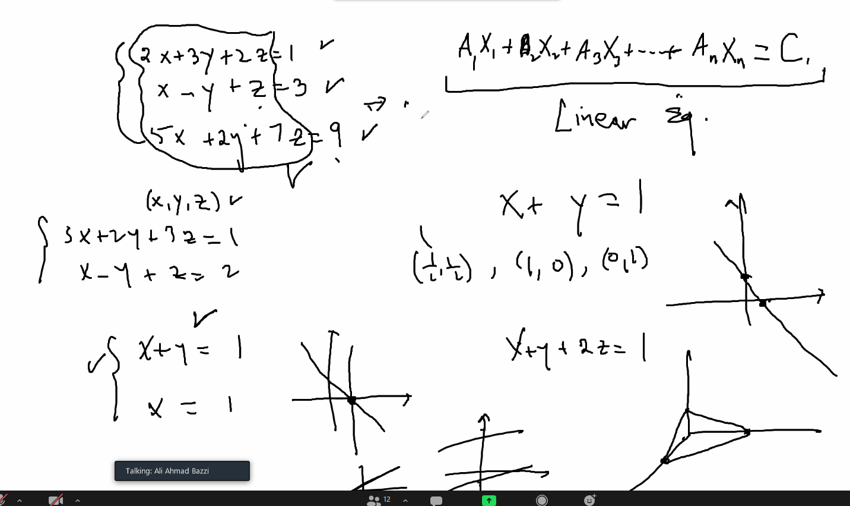
  + Above, the a1x1 syntax is a matrix form of the system of equations, it is also the computer language form of algebra; matrix language form is how computer read and solve algebraic problems!
* 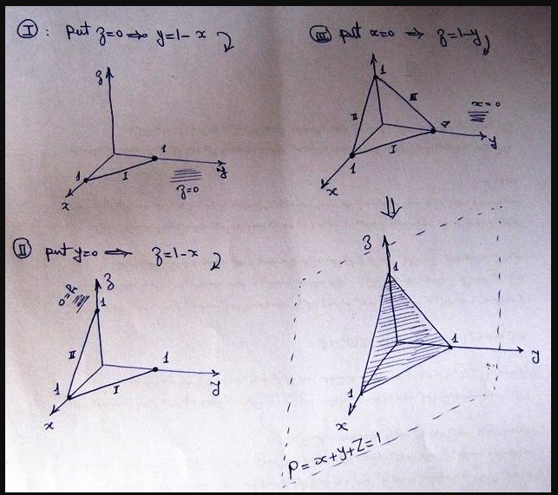

# Lecture 2 – 5/10/21

* 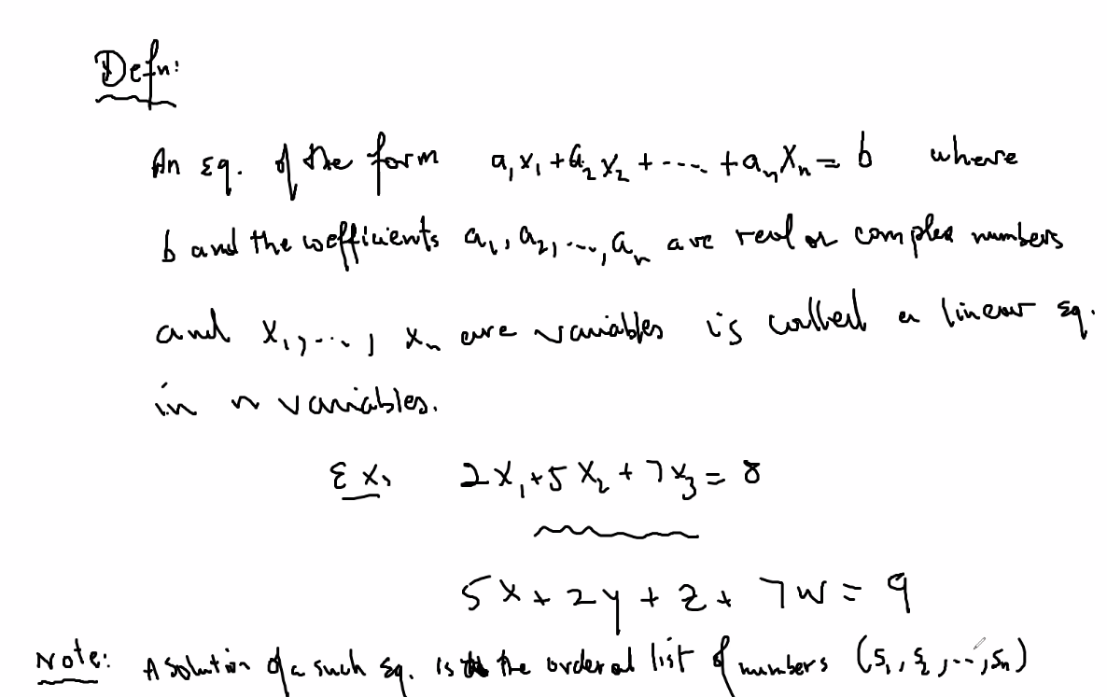
* 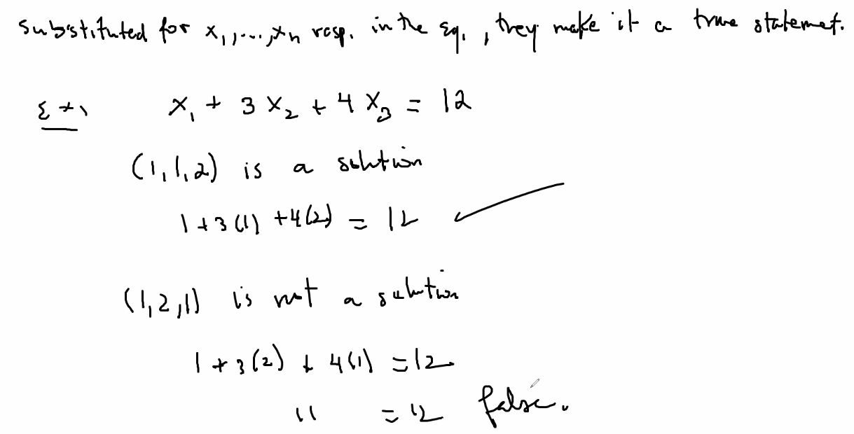
* To solve an equation is to find all of its solutions
* Any linear equation with 2 or more variables has infinitely many solutions
* 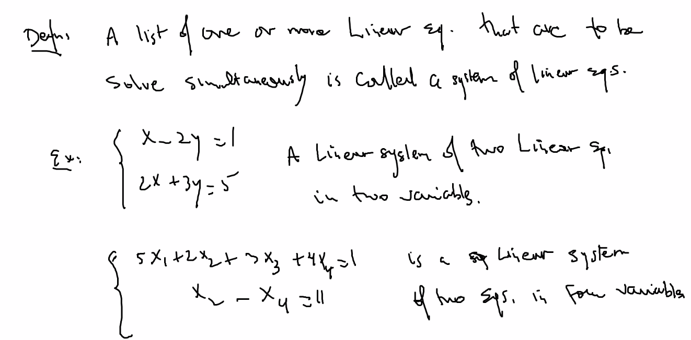
* 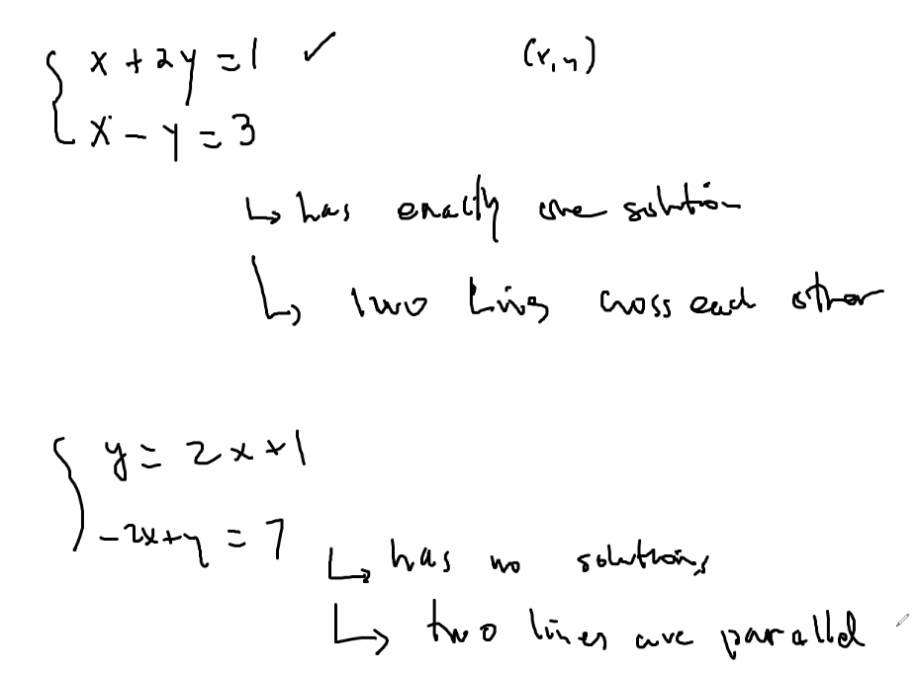
* 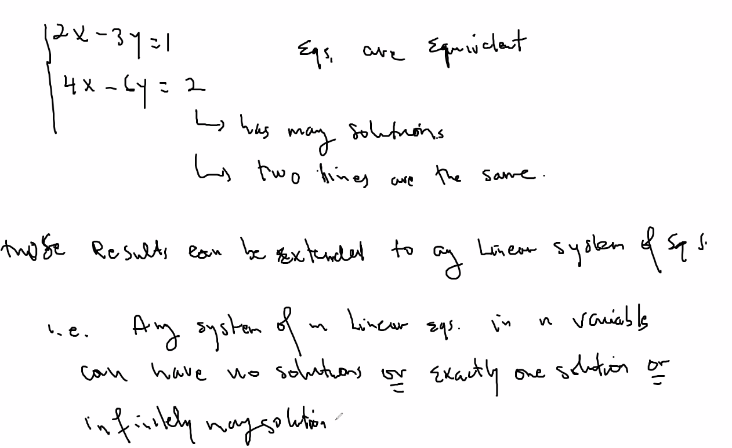
* 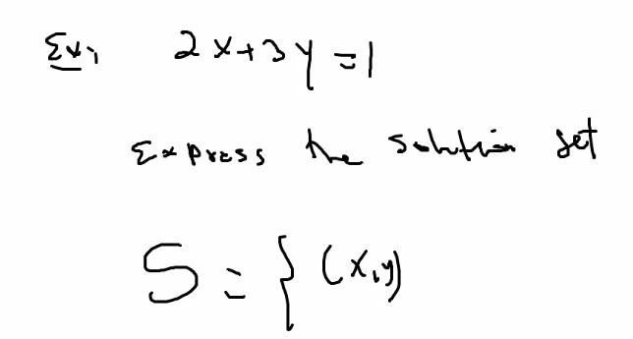
* 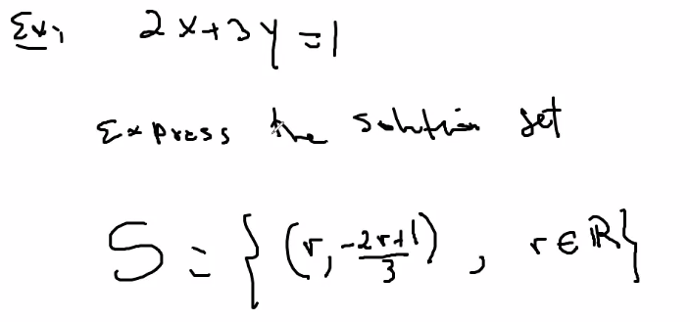
  + Above, another way to express solution set using r; here, r is in the set of R (all real numbers); you can rearrange the equation for each variable to express it in terms of r
* 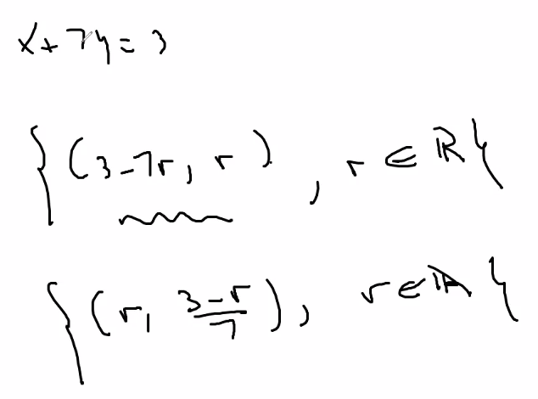
* Homogeneous linear system
  + 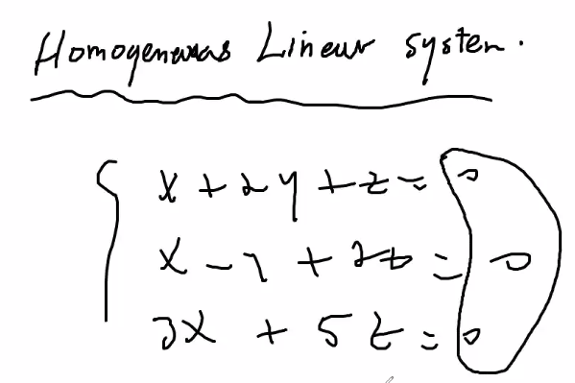
  + For homogeneous: there can only be 1 or many; impossible now to have no solution since all equations are set equal to 0; (0,0,0) is the trivial solution
* A system is consistent if it has at least 1 solution
* A system is inconsistent if it has no solutions
* Note: any homogeneous linear system is consistent since at a minimum it must have at least 1 solution
* 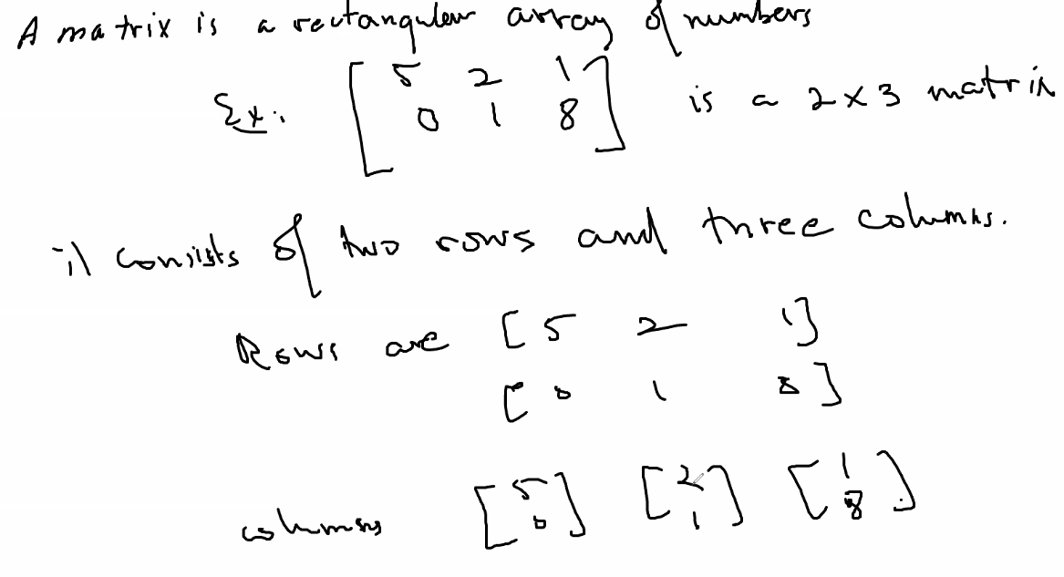
* 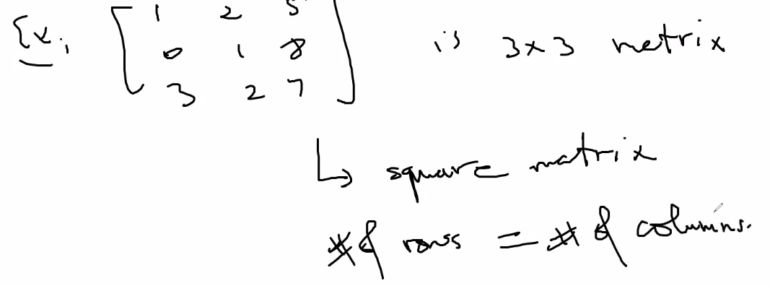
* 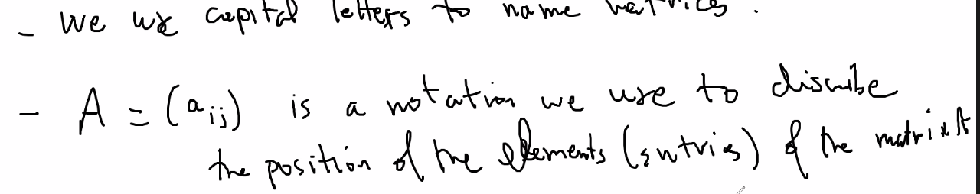
  + The i,j is row, column
* Any element out of scope of the matrix is considered not defined
* 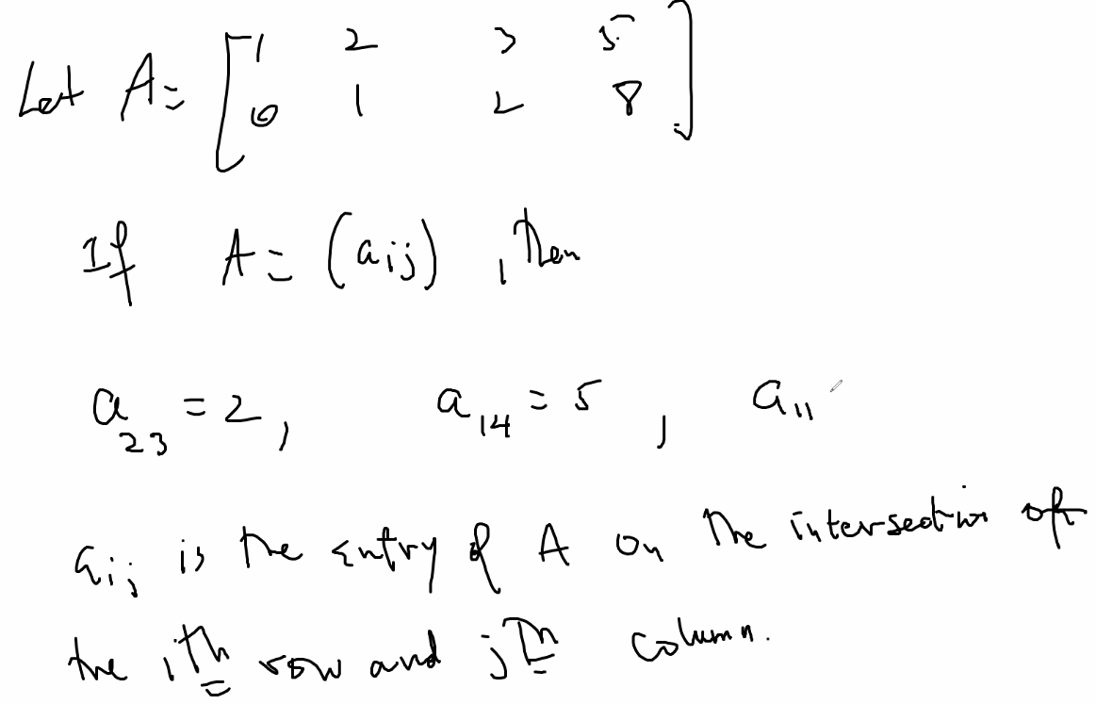
* Now we will use matrices to solve linear equations using augmented matrices
* 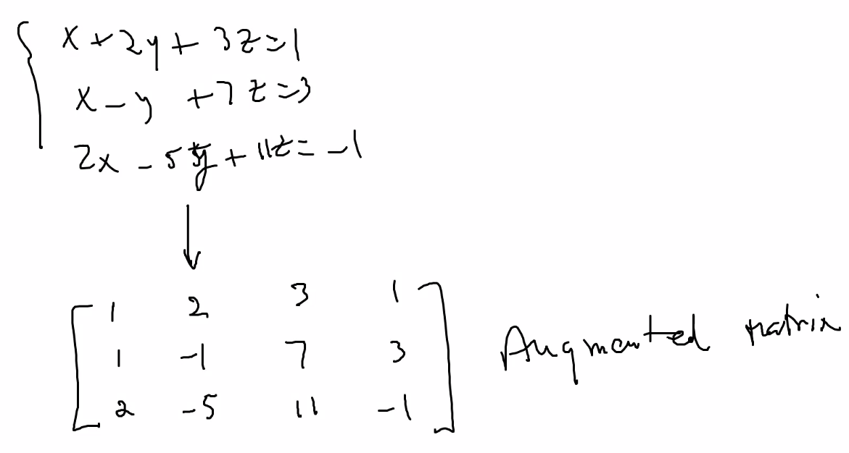
* 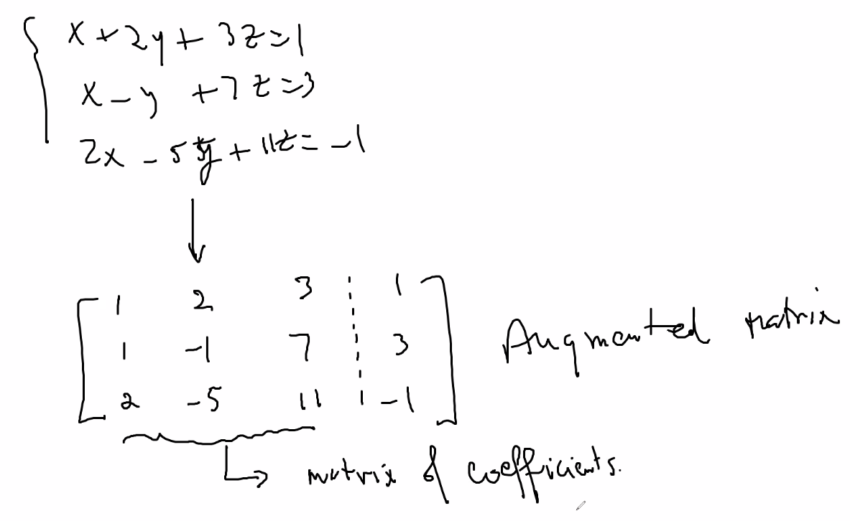
* 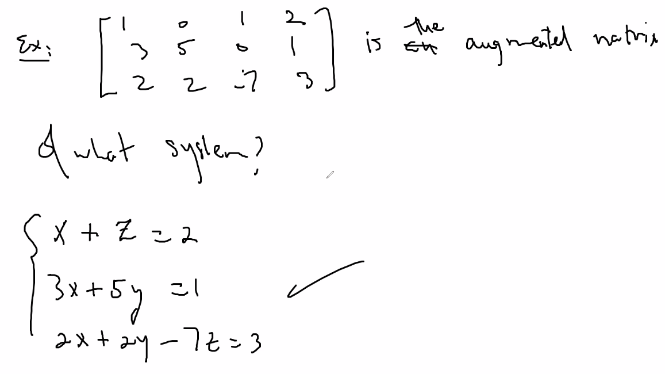
* 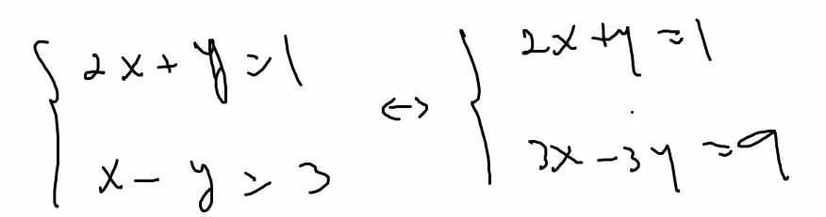
  + Note above: the two sets of system of equations have exact same solution set, just a scalars of each other
  + In fact: any scaling up or down even by different scalars of the original system of equations have the exact same solution set; and if you rearrange which equation is first or second in the system of equations also does not change the solution set:
  + 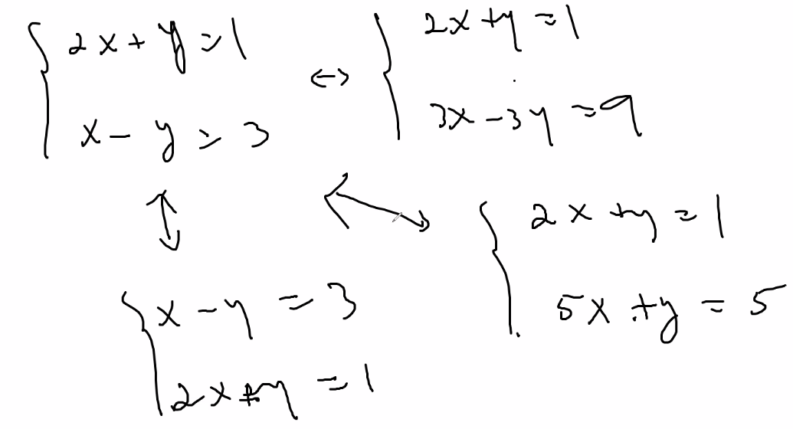
  + Above, all systems of equations have the exact same solution set
  + 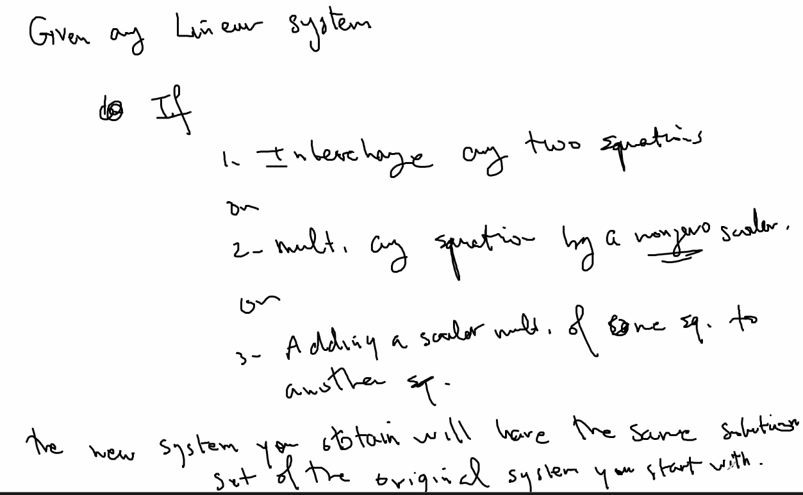
  + Also, if you apply a combination of the above operations, the resulting system will also still have the same solution set
  + Remark: when systems have the same solution set, they are said to be equivalent
  + Another example:
  + 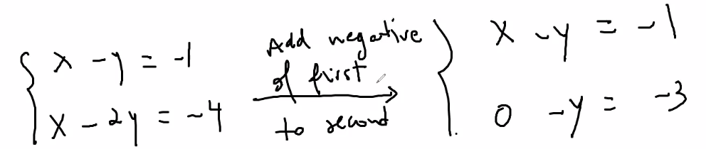
  + You can do these operations to the system of equations so that you can find solutions easier/see them easier since you are simply creating a system with the same solution but of a different form
  + As numbers get bigger it gets more difficult and work-heavy to do these operations; matrices can make it easier:
  + 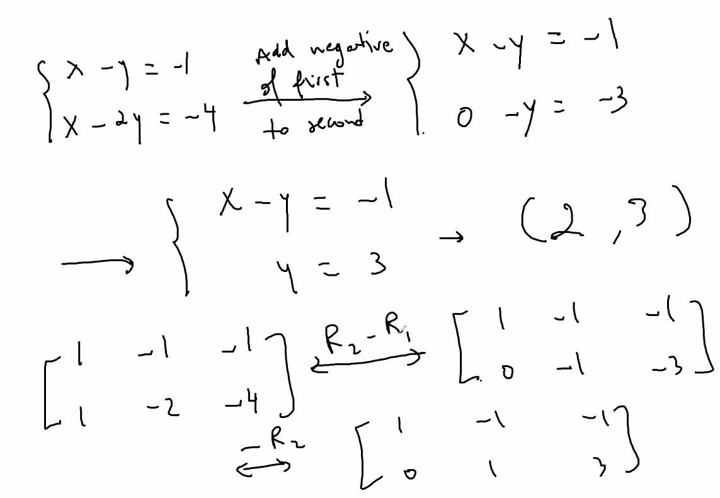
  + Also remember, matrices are good for creating algorithms, specifically ones that a computer can read (is in the form of a computer language) and calculate solutions
* Elementary row operations: 3 types
  + 1: replacement
    - Add to one row a multiple of another row while keeping the other row the same
  + 2: interchange
    - Interchange two rows
  + 3: Scaling
    - Multiplying all entries in a row by a non-zero constant
* 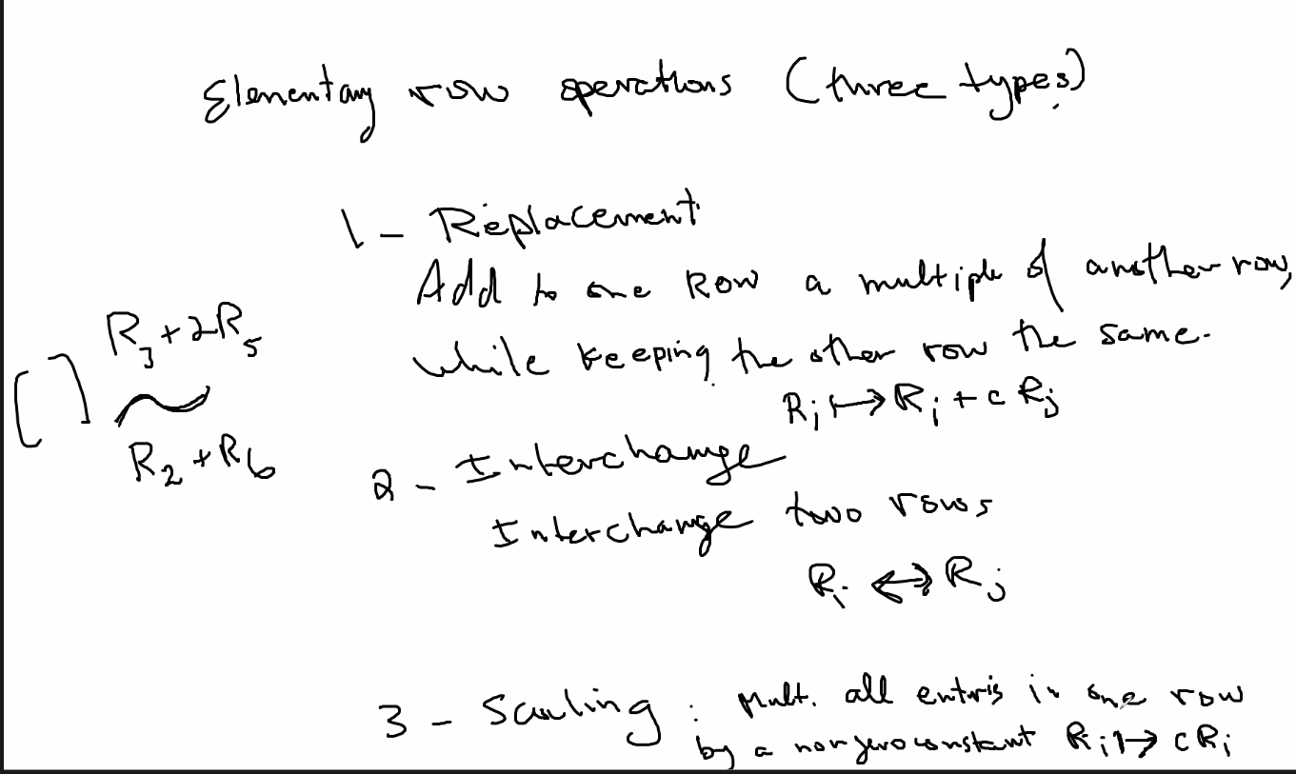
  + ~ means row-equivalent
* 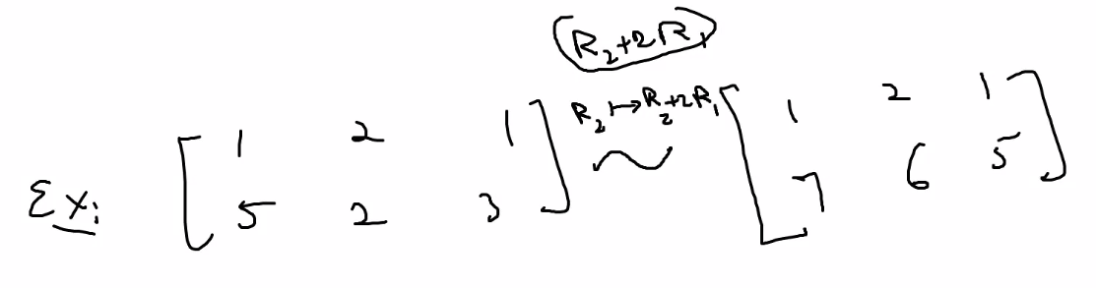
  + Above, set R2 = R2 + 2*R1
* Now using same example above: doing a series of the operations that result in a new matrix but that has same solution set as we learned about the 3 types of transformations:
* 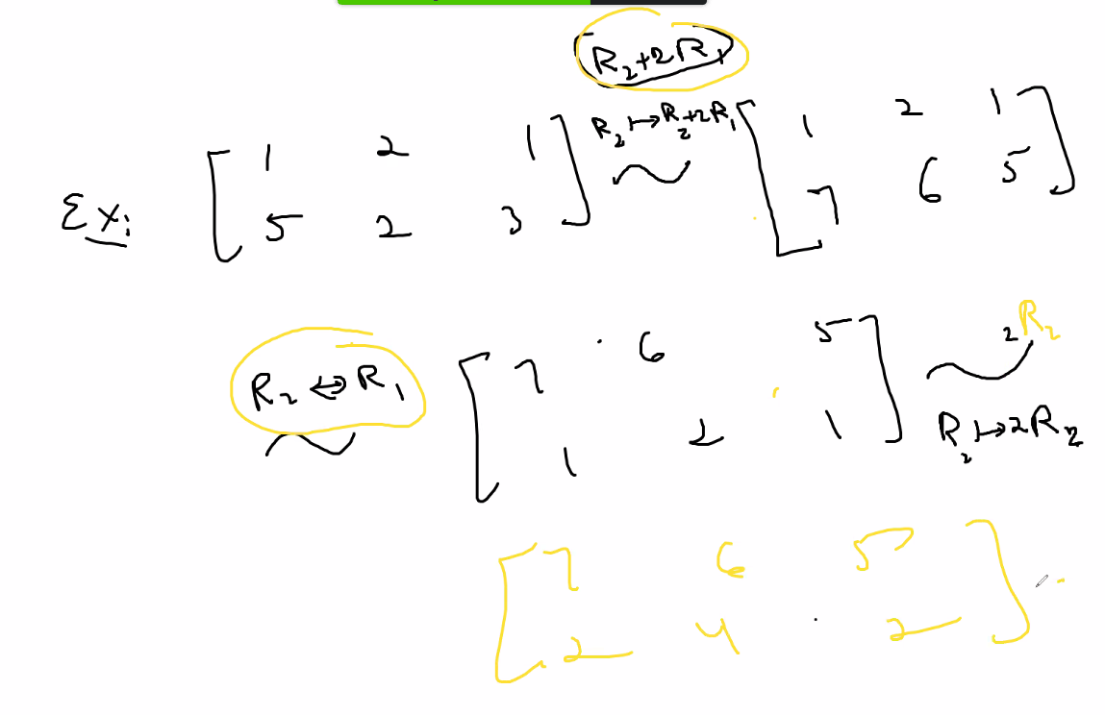

# Lecture 3 – 5/11/21

* Using simple substitution; and using a method to transform a system of equation into an optimal form for using substitution:
  + 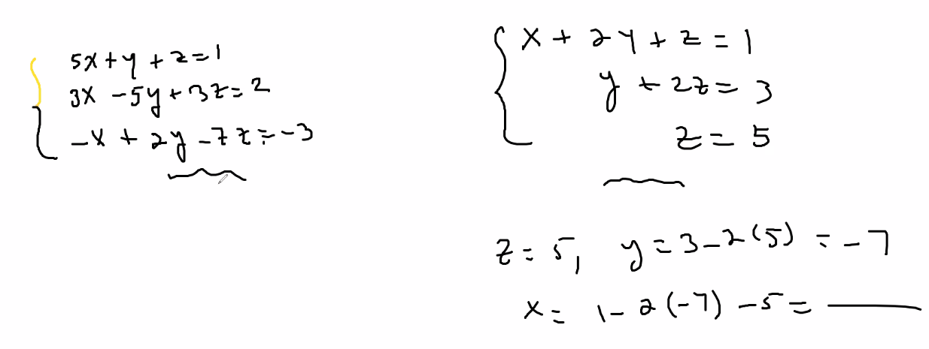
  + Notice this optimal form:
  + 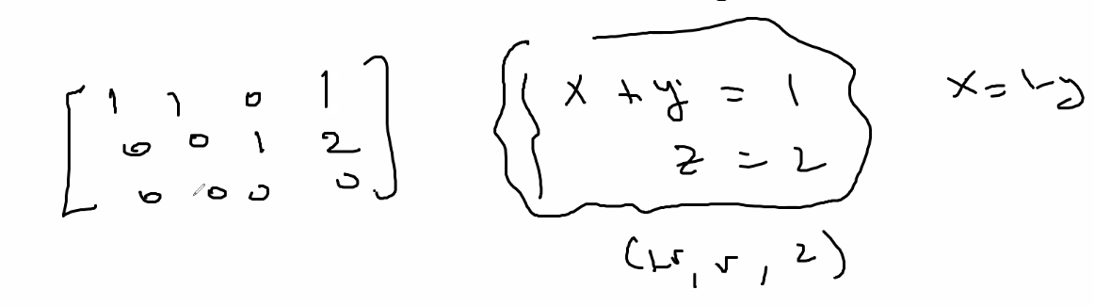
* Definition: an m x n matrix is in Row-Echelon form if it has the following properties:
  + 1: All nonzero rows are ABOVE any rows of all zeros
  + 2: each leading element of a row (first non-zero element) is in a column to the right of the leading entry of the row above it
    - Note a row of all 0s has no leading element
  + 3: all entries in a column below a leading element are zeroes
  + Example of a matrix in EF (row echelon form) form: 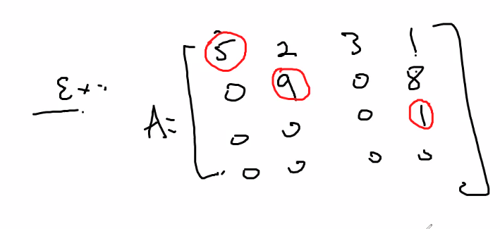
  + Example of a matrix not in EF:
  + 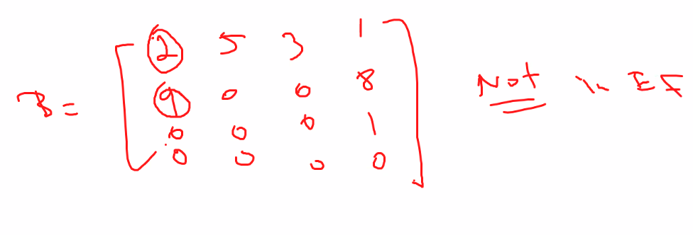
    - Above, properties 2 and 3 violated
* RREF: A matrix is in Reduced Row Echelon form if it is in Echelon form and
  + 1: each leading entry is 1
  + 2: each leading 1 is the only non-zero entry in its COLUMN
  + Ex of a matrix in RREF: 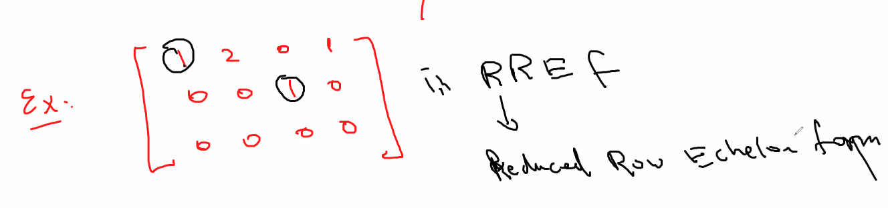
  + Note: if a matrix is not in REF, then it necessarily means it is also not in RREF
  + Fact: every matrix is row equivalent to one and only one Reduced Row Echelon Form:
  + Ex: 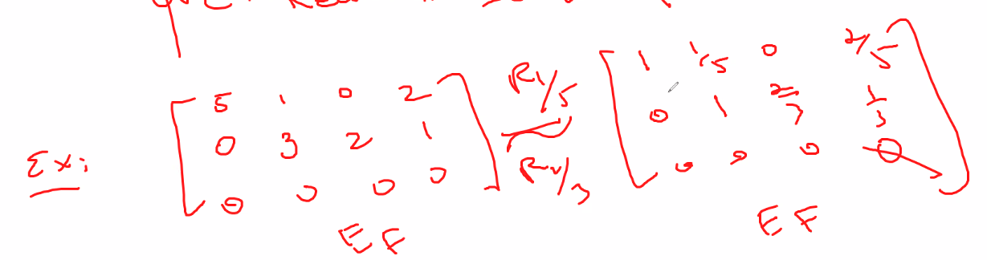
  + For REF, there can be many different possibilities, the whole point of RREF is to reduce a REF down so that the leading entries in the rows = 1; you cannot reduce anything down to get another RREF; but of course since leading entry does not have to be 1 for REF then there are many REF forms that you can derive from a REF matrix or from forming a REF form of a matrix not yet in REF.
  + Note: a pivot column in a matrix is a column containing a leading element
  + Also note: the reason why you can add one row to another row when applying a congruence transformation is because you are adjusting the left side of the equation (using variables) by the same or equivalent amount as the right side (usually using constants)
  + Example of changing a matrix to REF, the into RREF by using the elementary transformation operations:
  + 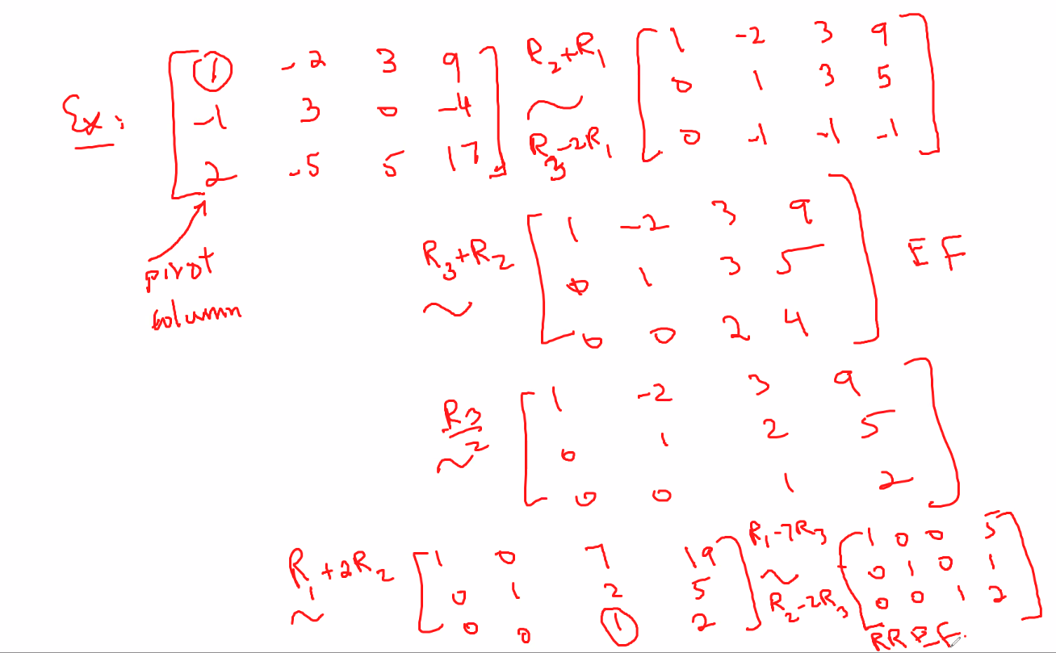
  + This is the equation form of the start matrix: 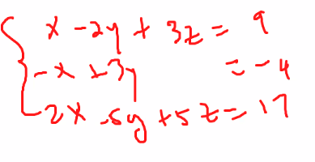
  + Now notice, the RREF that we derive will actually give us the final solution set of the system of equations (x, y, z) = (5, 1, 2) 🡪 we got this solution (also note it is a unique solution where there is only 1 solution to the system) from the RREF; we can get this from the REF matrices that we used by solving the resulting equations, but RREF will of course give us the immediate final solution because it is in the OPTIMAL form where the equations that it form are of the form x = …, y = …, and z = …
    - Its really just using elimination but using matrix form to more easily perform your operations when trying to reduce equations and find a solution
  + Another example using RREF: 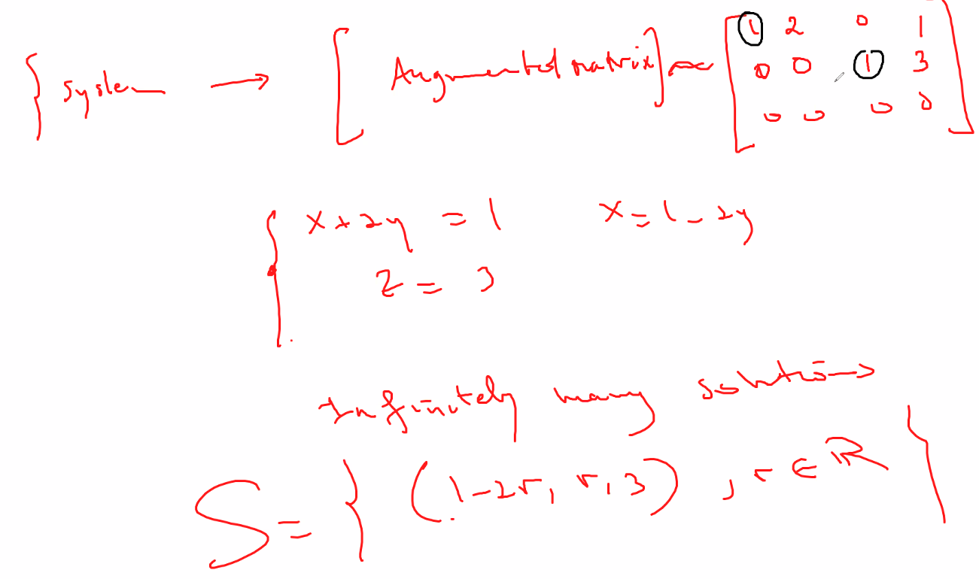
  + Above by using RREF we find: Solution set has infinitely many solutions
  + Also above: x is a leading variable (corresponds to leading element), and y is a free variable (does not correspond to a leading entry)
  + Another example using the elementary row-swap operation on the matrix to put a matrix into REF: 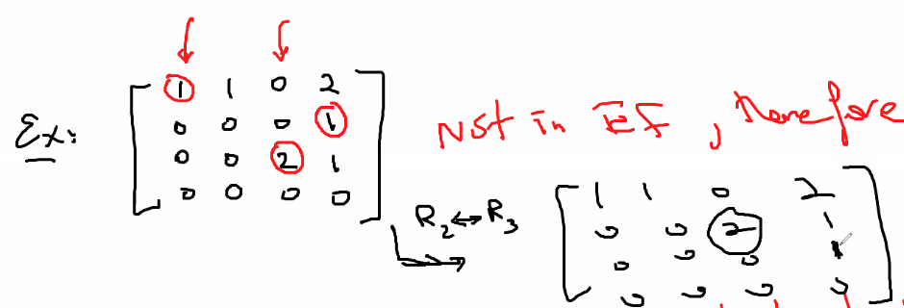
  + ABOVE: swap rows 2 and 3 to put it into REF; then from there you can further reduce it into RREF
  + Note: swap is essentially (and actually) simply rewriting a system of equations in a different order such that it you still have a equivalent system of equations (and thus equivalent matrix) so that you can use whatever advantages of that transformation that may result from doing such a swap. Its actually very SIMPLE.
    - For example: EQ1: x + y = 2, EQ2: y+ 2x = 4; now doing a swap of the “rows” will simple set y + 2x = 4 as equation 1, and x+y =2 to equation 2.
  + Also be careful when writing an augmented matrix and when you think you have it in REF or RREF with a solution: 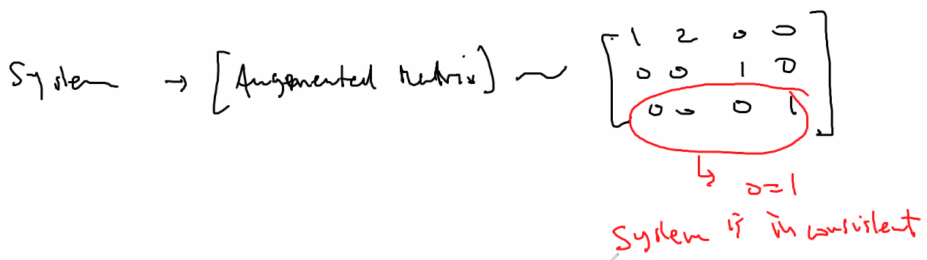
  + Notice above: the last row says 0 = 1; and thus the system is inconsistent and thus there are no solutions even though it is in RREF, but however this is useful because if the RREF of a system results in showing an inconsistent system then you can easily derive that the system has no solutions
* Existence and unquiness theorem: a **linear** system is consistent if and only if an echeleon form of the augmented matrix has no row of the form [0 0 …… 0 k], k!=0;
  + If the system is consistent, then it has
    - 1: a unique solution when there are NO FREE (basic) VARIABLES
    - 2: many solutions when there is AT LEAST ONE FREE (basic) VARIABLE
* Also, you can stop working to reduce a matrix or put it into REF if you notice an inconsistency such as 0 = k where k is a value, or k = 0; in the following example, we have an example where a transformation shows 0 = k which is impossible: 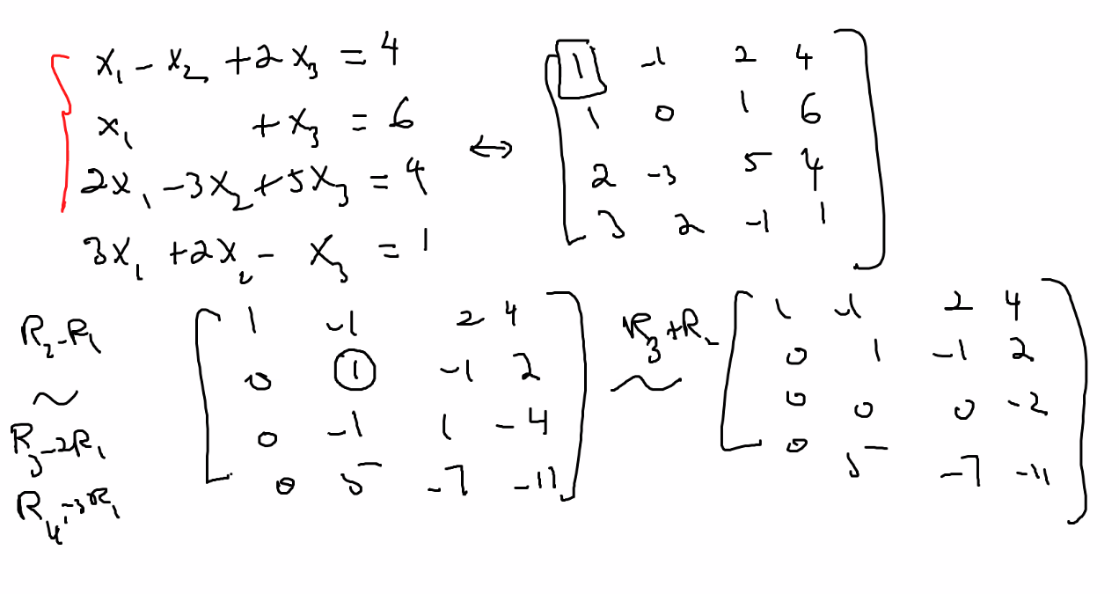
  + Notice above, the third row is [0 0 0 -2]; so 0x + 0y + 0z = -2; 0 != -2 thus the system is inconsistent
* For a Homogeneous linear system: if number of variables is more than number of equations, then the system will end up with free variables thus for sure there will be infinitely many solutions
  + It is impossible to have a unique solution; you will for sure have infinitely many solutions
* To solve a system of linear equations using matrix and row reduction algorithm, technical name of this algorithm is GUASS-JORDAN Elimination:
  + 1: write augmented matrix
  + 2: use row reduction to obtain an Echelon form of the augmented matrix; decide if system is consistent (if inconsistent then we are done: no solutions); if it is consistent then you can solve the solution set or continue to step 3 (also in step three you can determine if a system is inconsistent)
  + 3: if it makes it easier to find solutions: proceed to transform REF to RREF
  + 4: write out (if it makes it easier to see) the corresponding transformed system of equations in REF (REF = EF for shorthand notation as well) or RREF to determine solutions
* Example of leading variable and free variables; notice how since there are more variable than equations, we result in having a matrix with only one possible leading variable (and thus 1 possible pivot column) and thus the remaining variables must be free variables so as to show that if there are more variables than equation, then there must be infinitely many solutions (also try to think of practical reasons for why this is true): 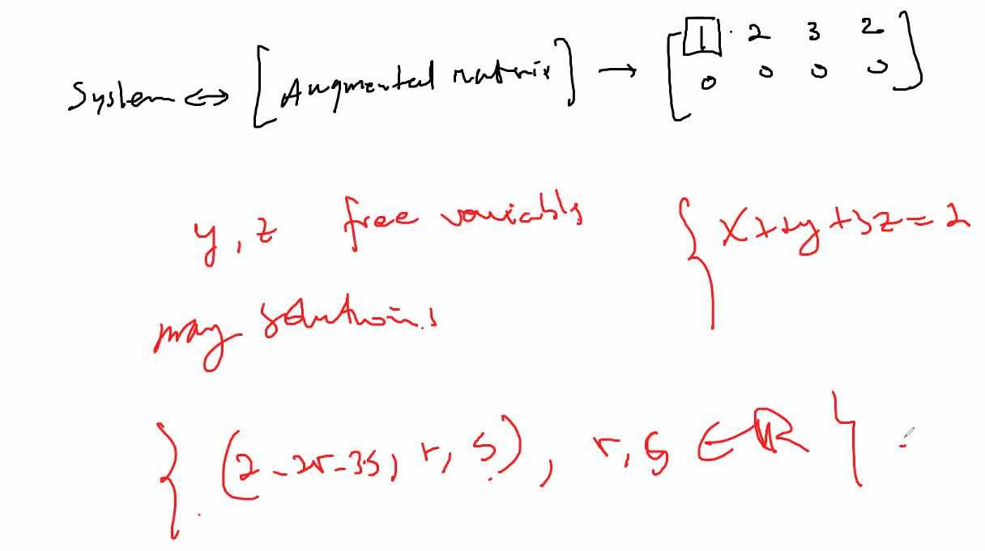
  + R and S are real numbers; above is a solution set where x = basic variable (leading) and y and z are free variables, and we use these ideas to describe the solution set

# Lecture 4 – 5/13/21: n_space : Rn (vector space) – section 1.3 from the book

* n space
* 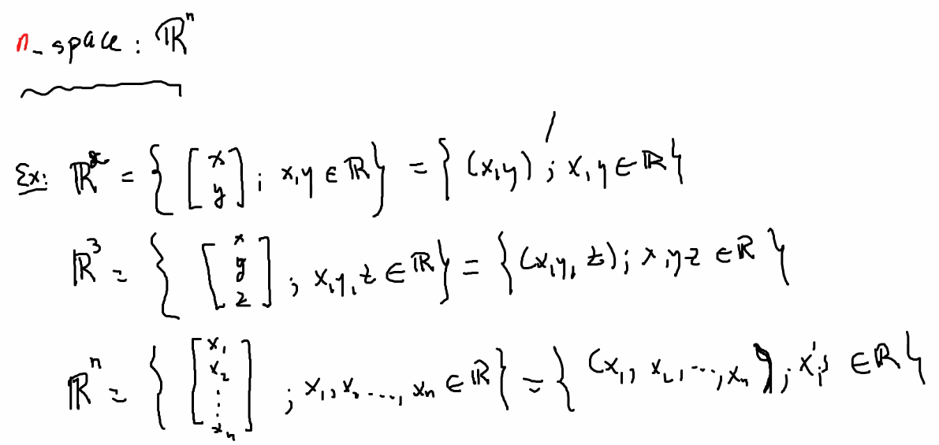
  + We usually call elements of R^n as vectors
  + Can be described as an ordered pair, and all elements are in the set of Real Numbers
  + Note: the matrix form shows that the space is a vector space (1 column only)
* (pointwise) Addition and scalar multiplication operations on R^n
  + 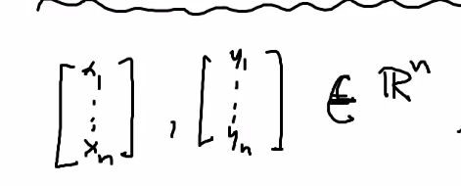
    - Above: those vector spaces belong to R^n
  + 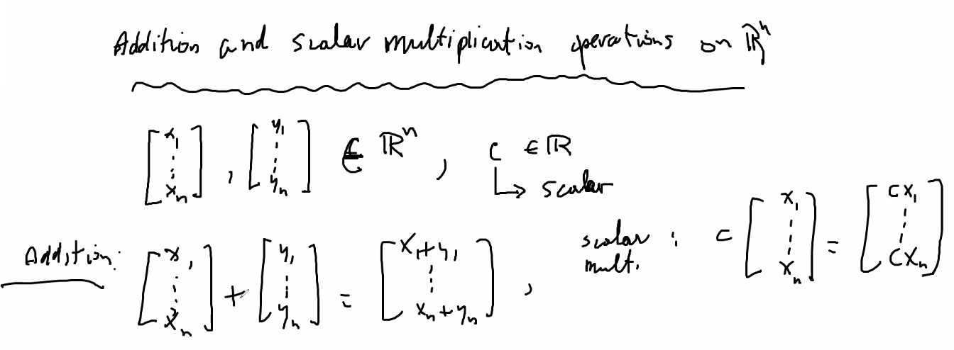
    - Notice above, for addition you do pointwise (corresponding element to corresponding element in each space), and for multiplication you simply multiply the scalar to each element
  + Note for this example: R^n is a closed number vector for addition and multiplication:
  + 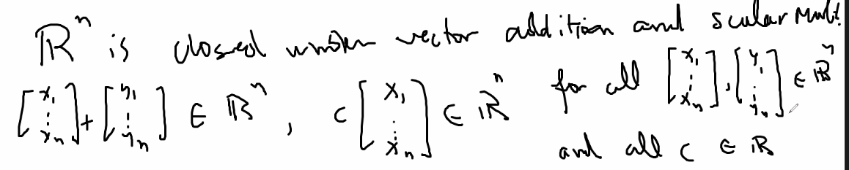
* Graphic representation of vector space (n space)
  + 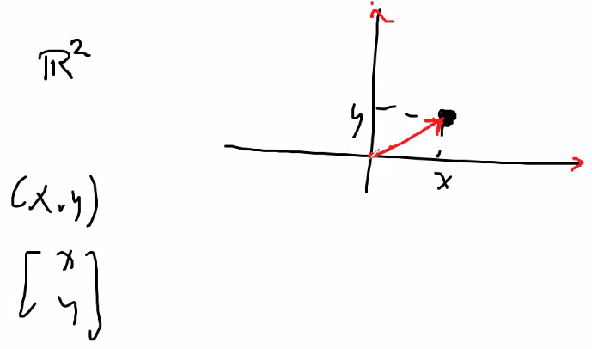
  + Remember we call multiplication by a constant of a vector a scalar because it scales the vector up or down in magnitude but that has a parallel direction (in same direction if scalar is positive, or in direct opposite of the previous direction if scalar is a negative value)
  + 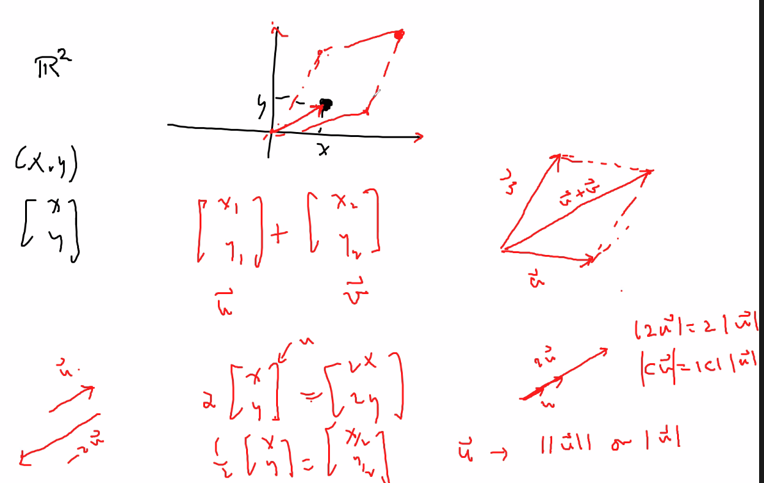
* Algebraic properties of R^n
  + If a set of vector shows all of these properties true, then we can prove and obtain conclusion that we have a vector space
  + 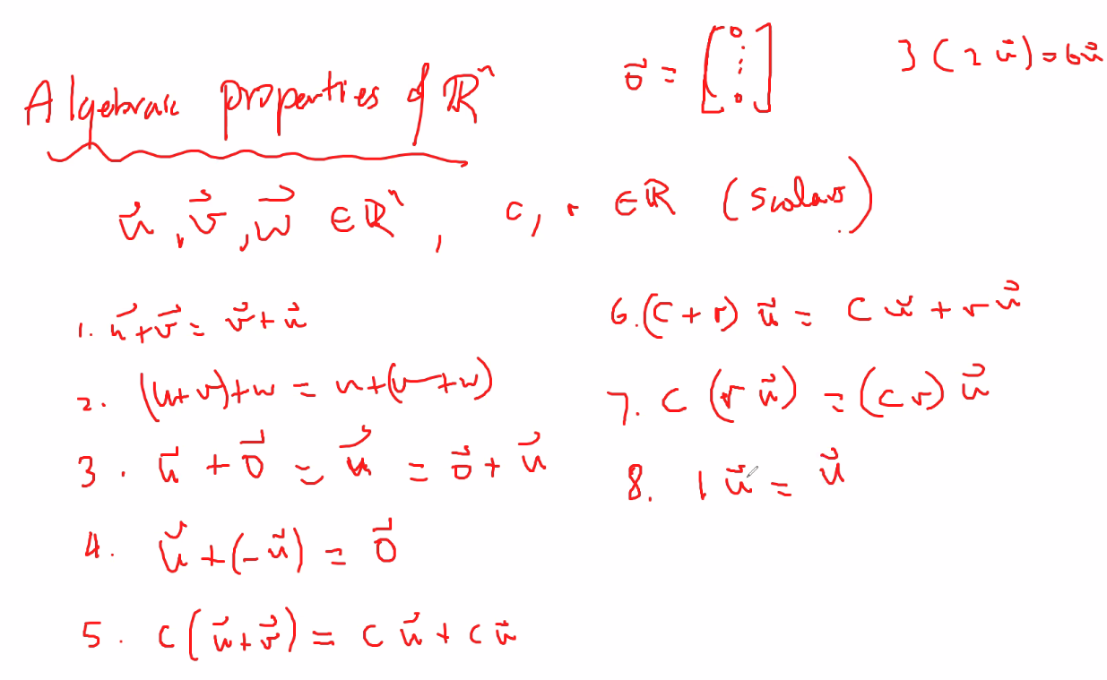
    - Those 8 properties above make R^n a vector space
    - Also note above we are dealing with entires of all Real numbers; some spaces may not be so obvious that those 8 properties will hold
* Linear combinations
  + 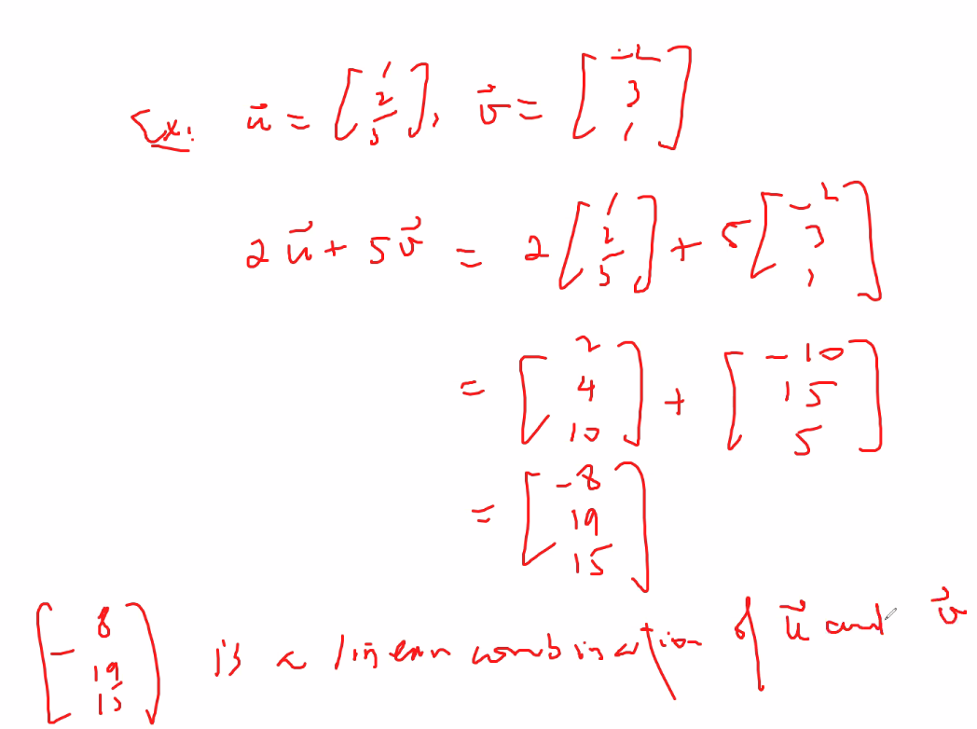
  + Linear combination means you have a resultant vector from the addition of other vectors that are multiplied by some scalar, and each vector can be multiplied by a different scalar
  + 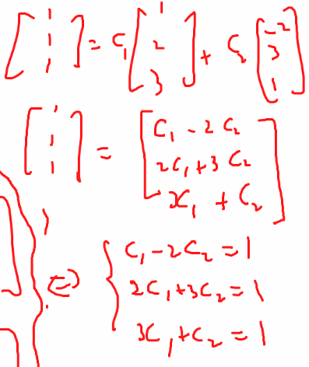
    - Above, if there are no solutions, the [1 1 1] vector is not a linear combination of the two vectors which are multiplied by some scalar c1 and c2 and added together
    - You can also solve to see whether the 1 1 1 vector is a linear combination of the two vectors by using an augmented matrix and then using reduction methods:
    - 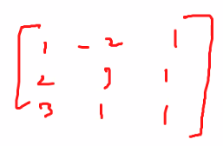
    - 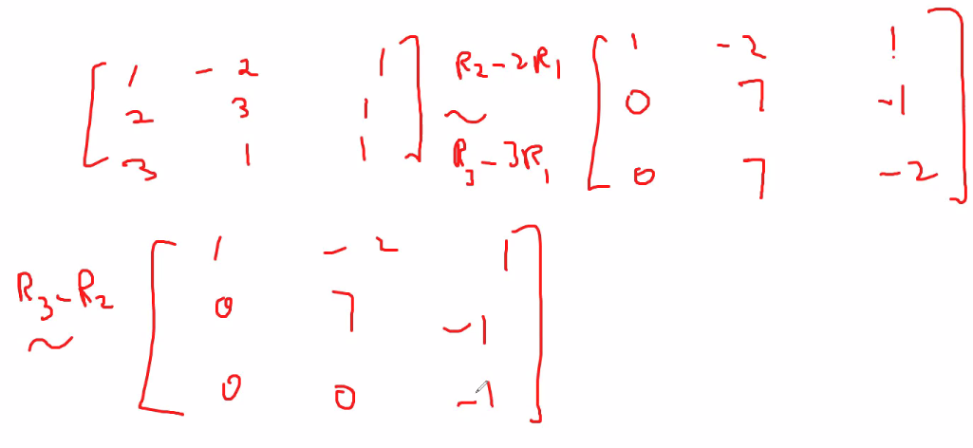
    - So after solving using the reduced echelon form, we see that there is no solution; thus 1 1 1 is not a linear combination of vectors u and v
* Span of a vector
  + 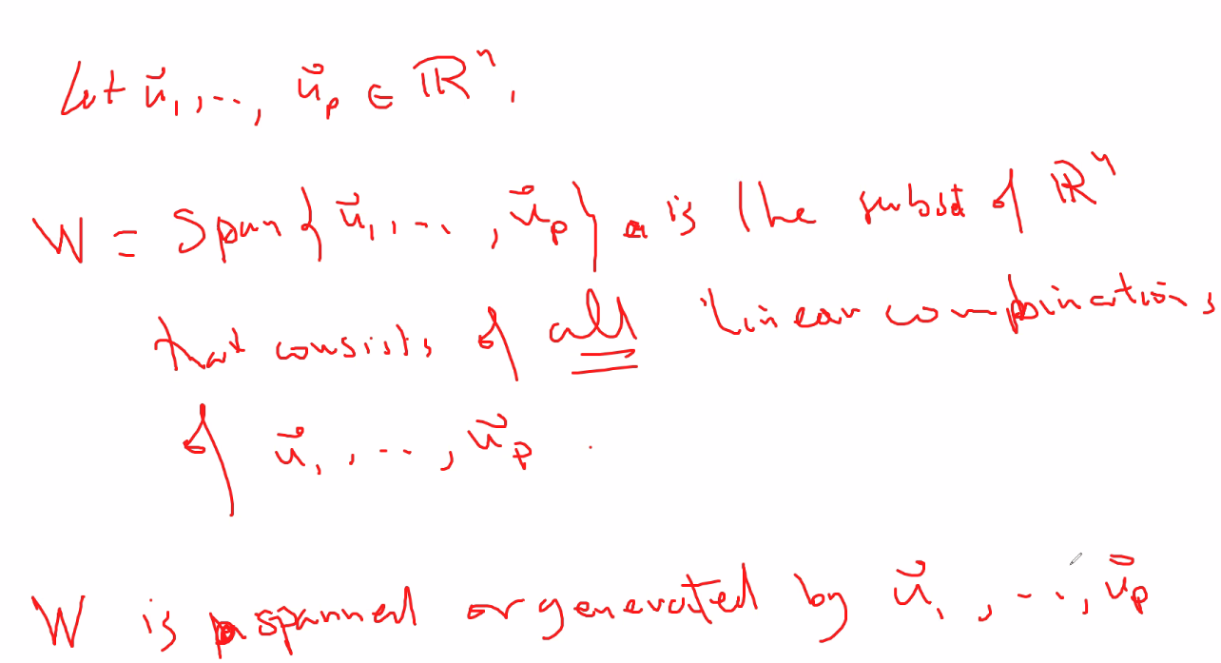
  + The span of a vector is a set that contains all possible linear combinations of the vector u, or of a set vectors
  + You can draw a line or plane (depending on if you find the span for 1 vector or 2 vectors, or more) that defines W (the span), which is the set of all linear combinations
  + The span will be a line or plane through the origin, or the entire space.. depending on if you are working with a space in R1, R2, or R3
  + 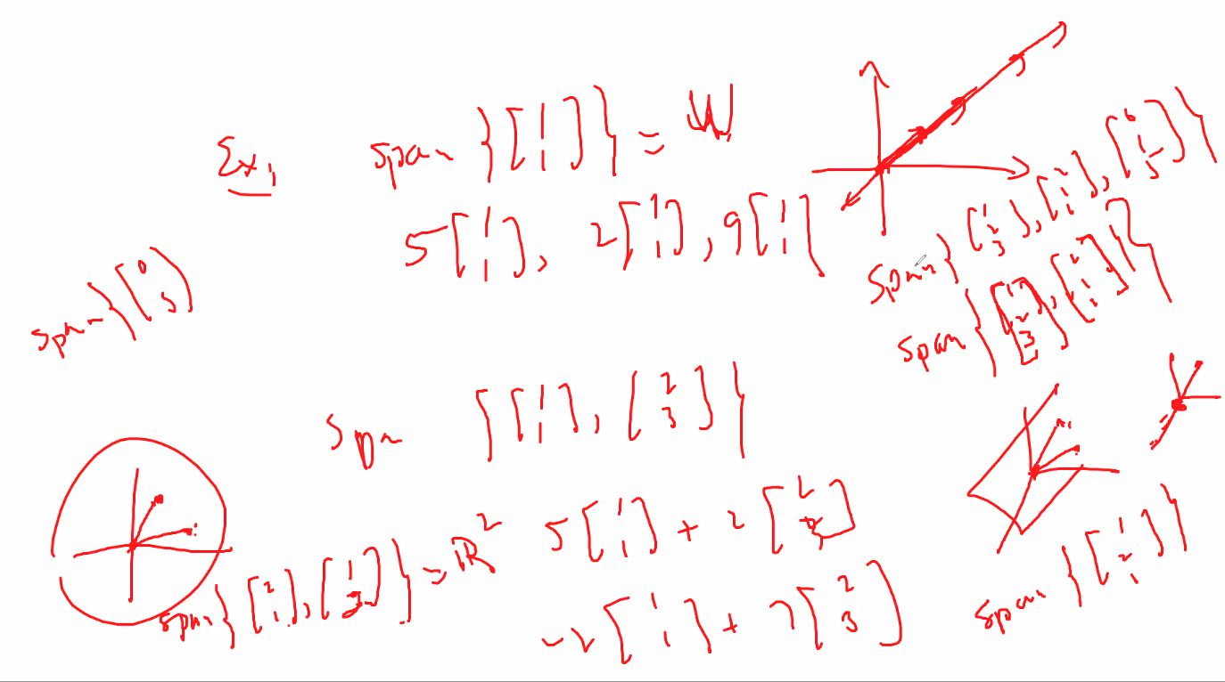
* Section 1.4
* When adding and multiplying two matrices, they must have the correct dimensions
* Remember, all a matrix represents is a system of equations, keep that in mind and the rules for products and other algebra will make sense; its easy!
  + 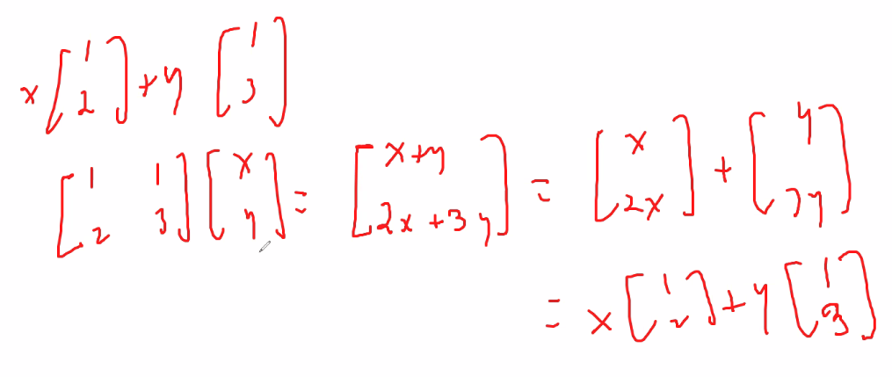
  + 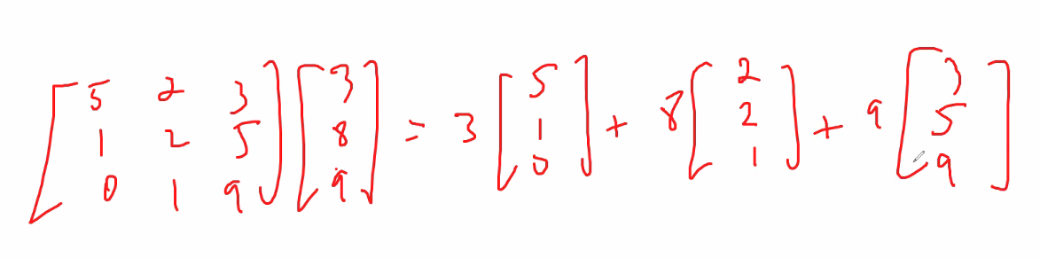
  + 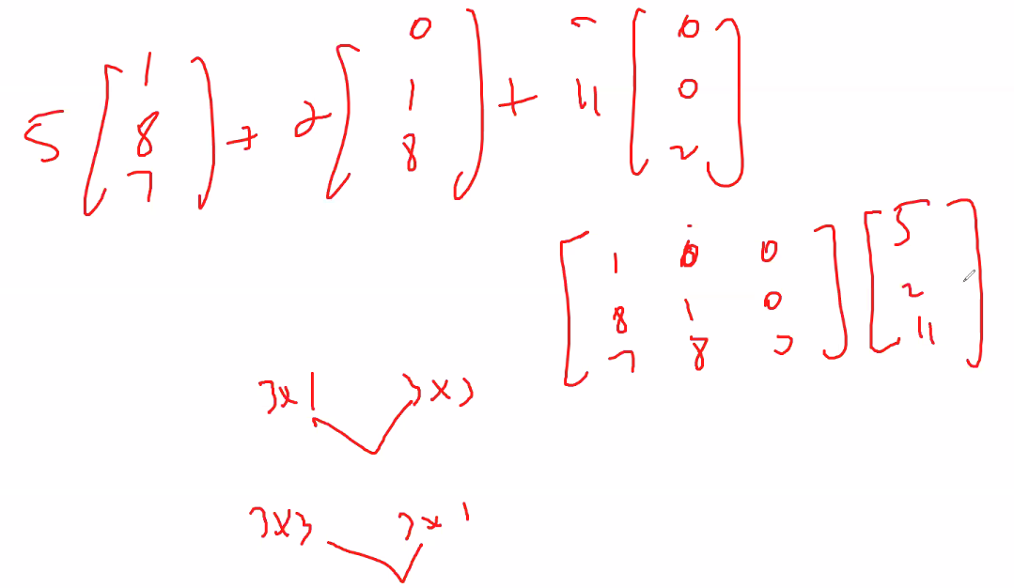
  + Notice multiplier of first matrix must match the multiplicand of the second when multiplying
* An example:
* 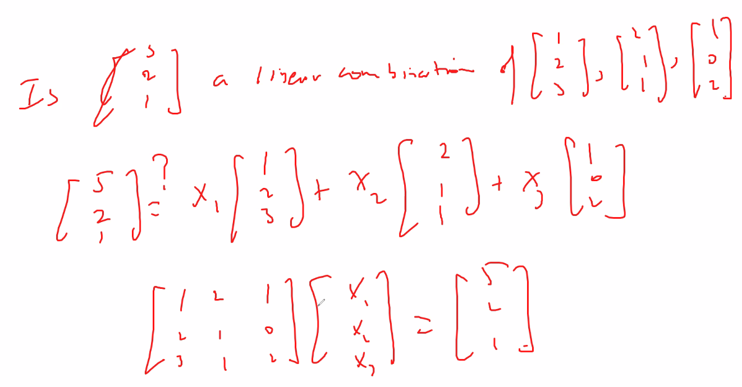
* now here is the system of equations converted into the above matrix multiplication to demonstrate why it works
  + 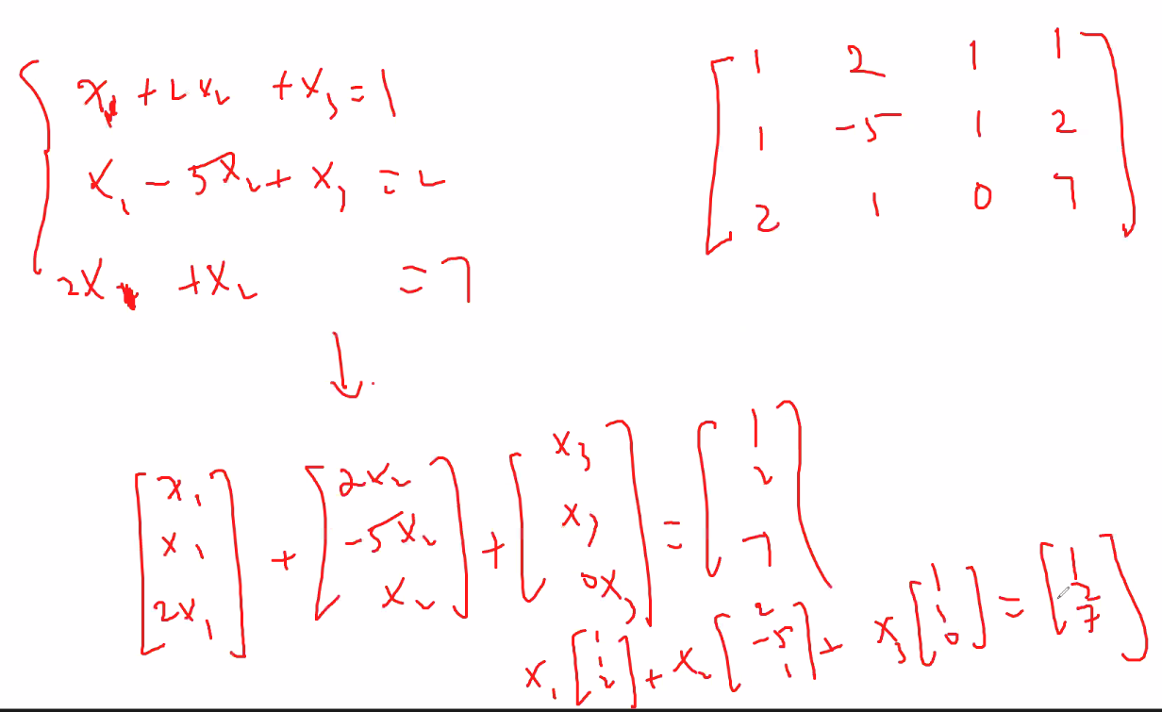
  + Above, now you can see how you can derive representing a system of linear equations as a linear combination represented by matrices
  + 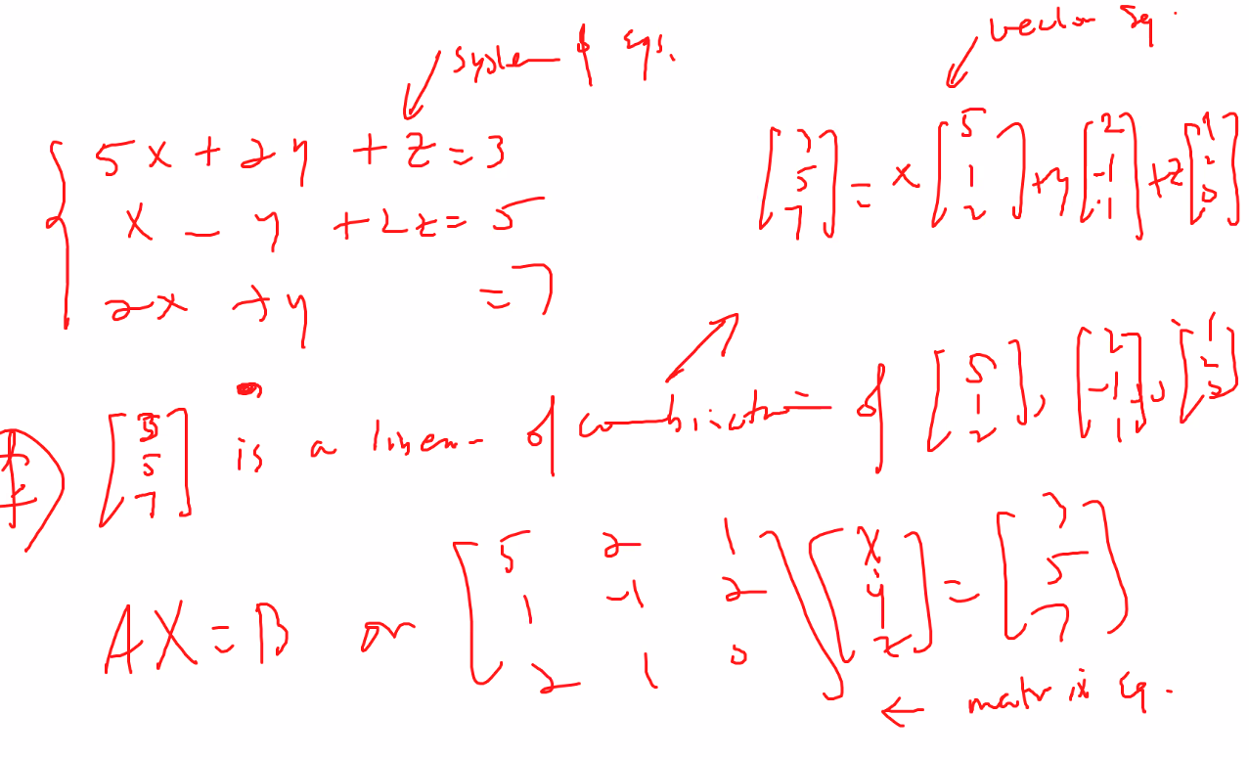
  + Now you see why you do the row-column wise multiplication when multiplying them and adding them, it goes back to the original system of equations
  + Note, you can represent the following question using 3 methods: system of equations, vector equation, and matrix equation:
  + 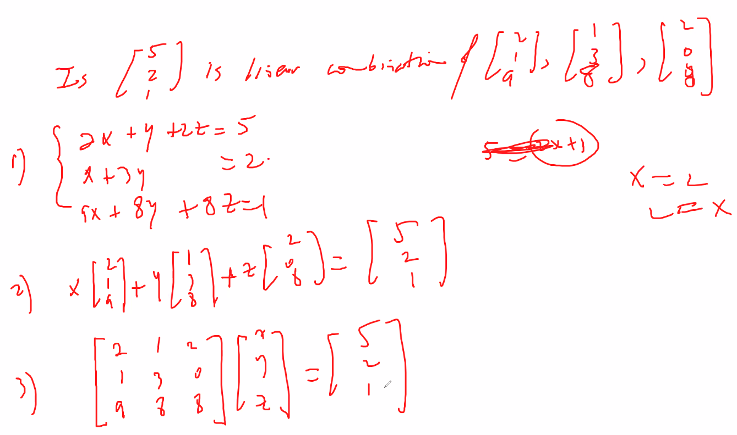
  + Now you can use any of the following to solve the question of if 5 2 1 is a linear combination of the given matrices
* Remember if you are dealing with a matrix m x n, m = row, n = columns, m = number of equations, and n = number of variables
  + m determines the vector space of the solution
* theorem:
* 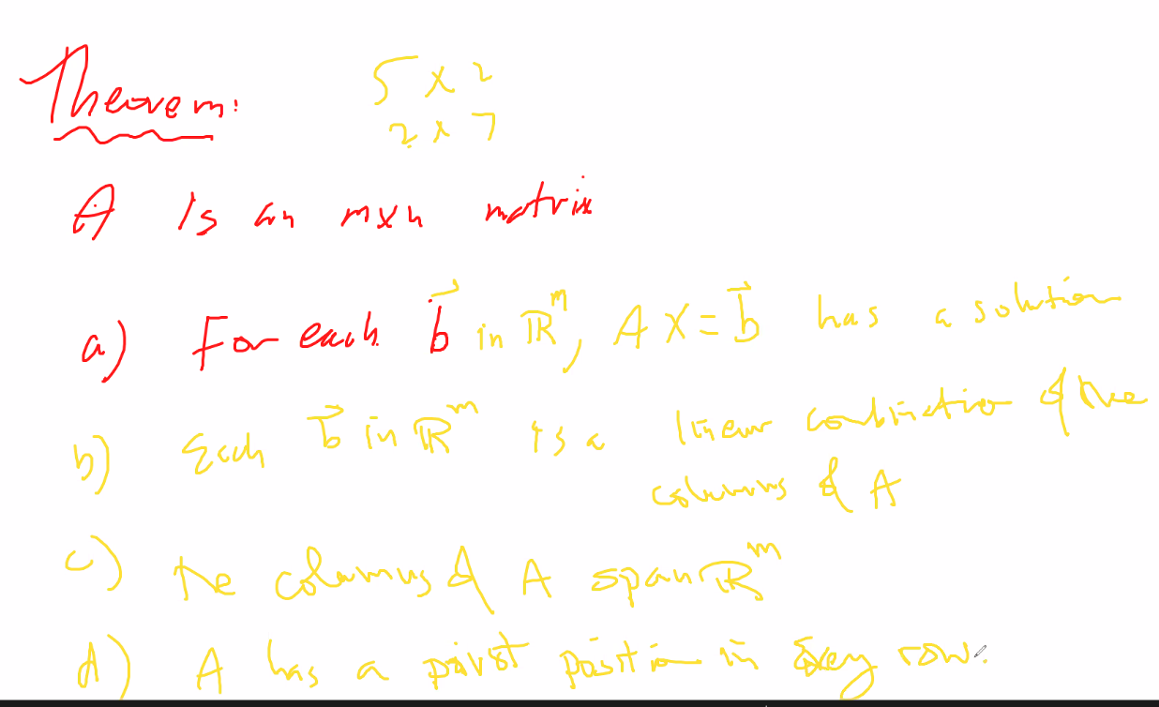

# Lecture 5 – 5/17/21 – linear dependence and independence

* For the HW; “In R3” means:
  + 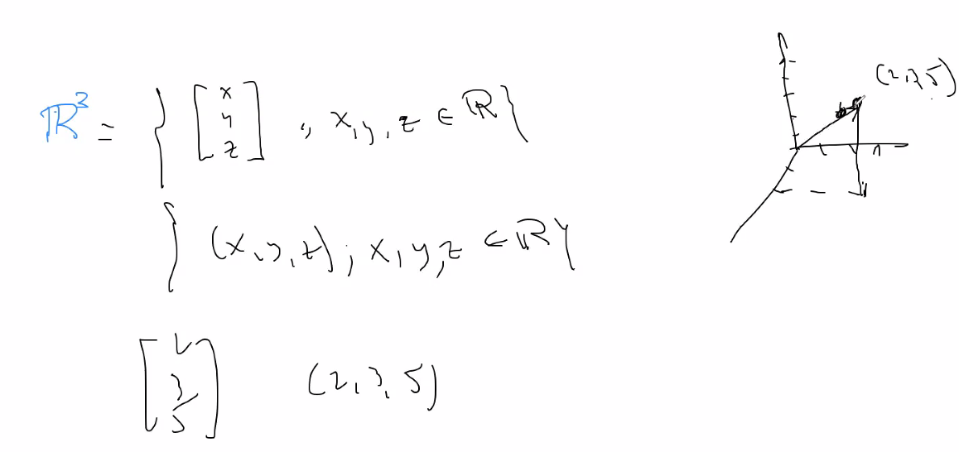
  + Rn refers to a dimensional space (n-space; n-vector space):
    - 
    - Elements higher than 3D space is hard to represent in graphic form; the best way to deal with them is using matrices
* Review on writing a system of equations as linear combinations in vector/matrix form:
  + 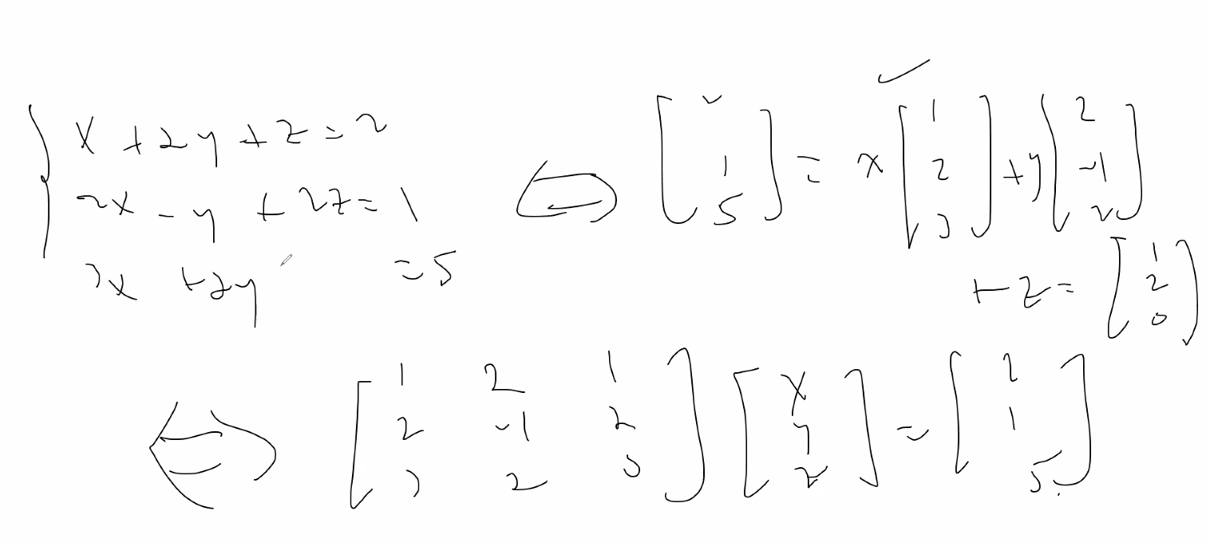
* Theorem review:
  + 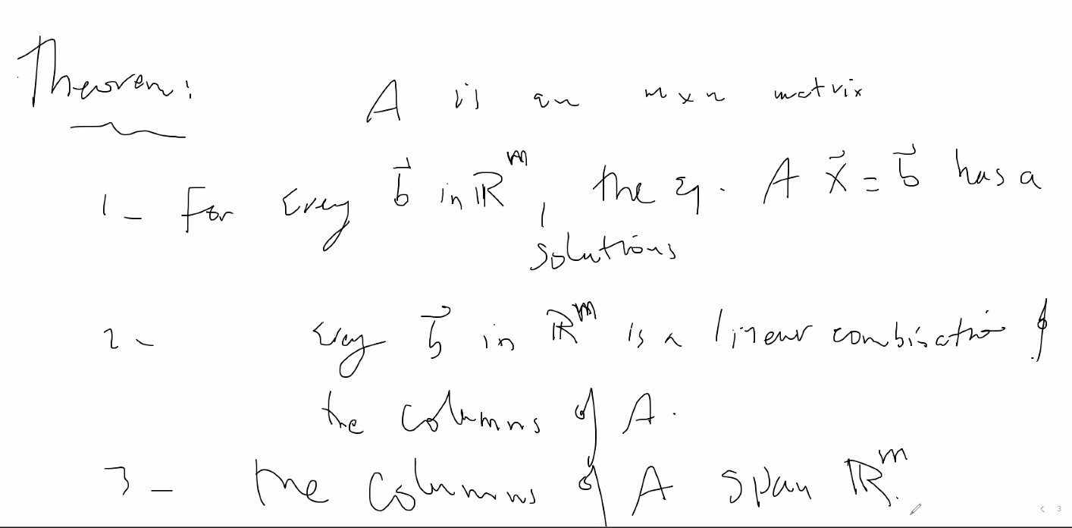
  + 4 – ‘A’ has a pivot position in every row
* Homogeneous system
  + 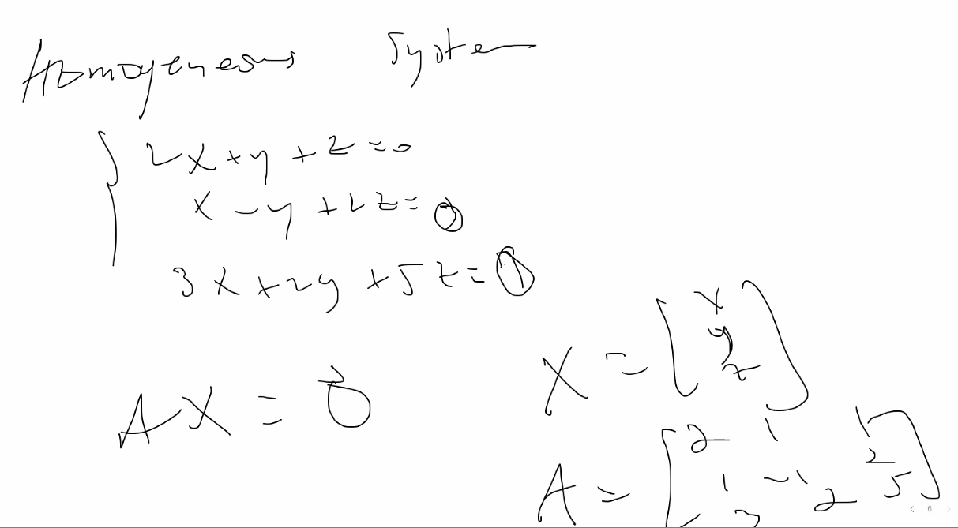
  + Only contain unique or infinitely many solutions
  + All constants in the system of equations = 0
  + 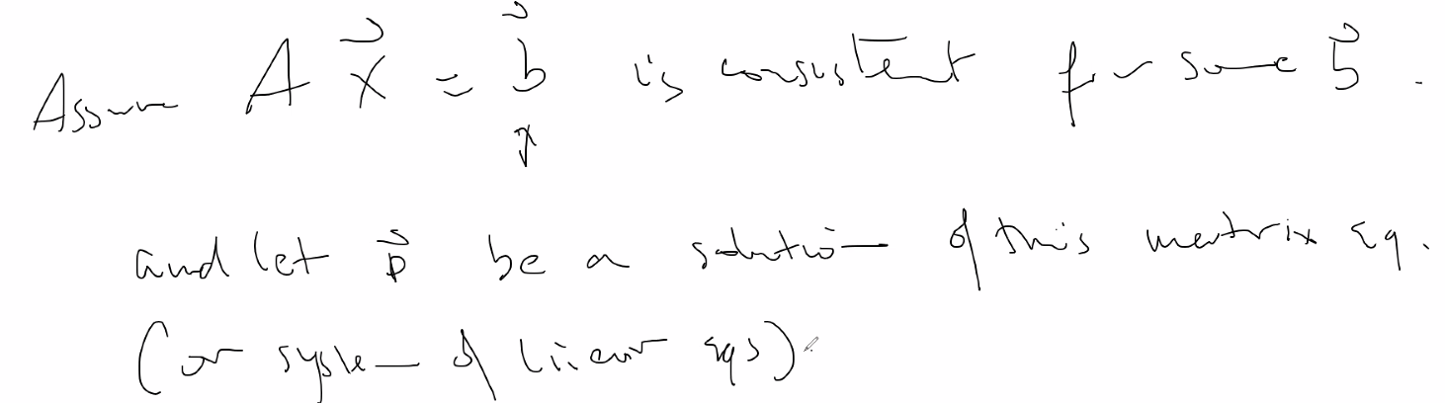
  + 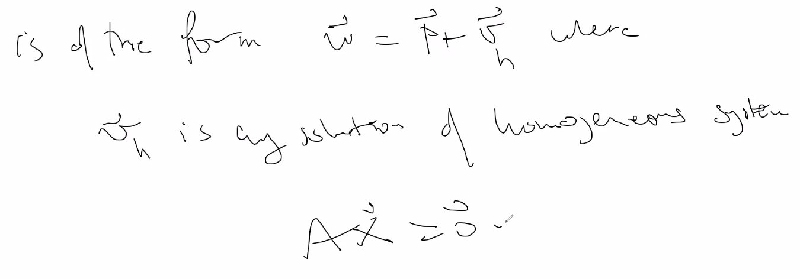
  + Finding solutions to homogeneous systems is much easier to find
  + P is a solution to non homogenous system; + vh is all solutiona to homogenous system
* Linearly independent or dependent
  + If you can find a linear combination where the scalars are not 0; then the vectors are said to be Linearly Dependent
  + If two vectors are not scalars of each other, then we know they are linearly independent
  + 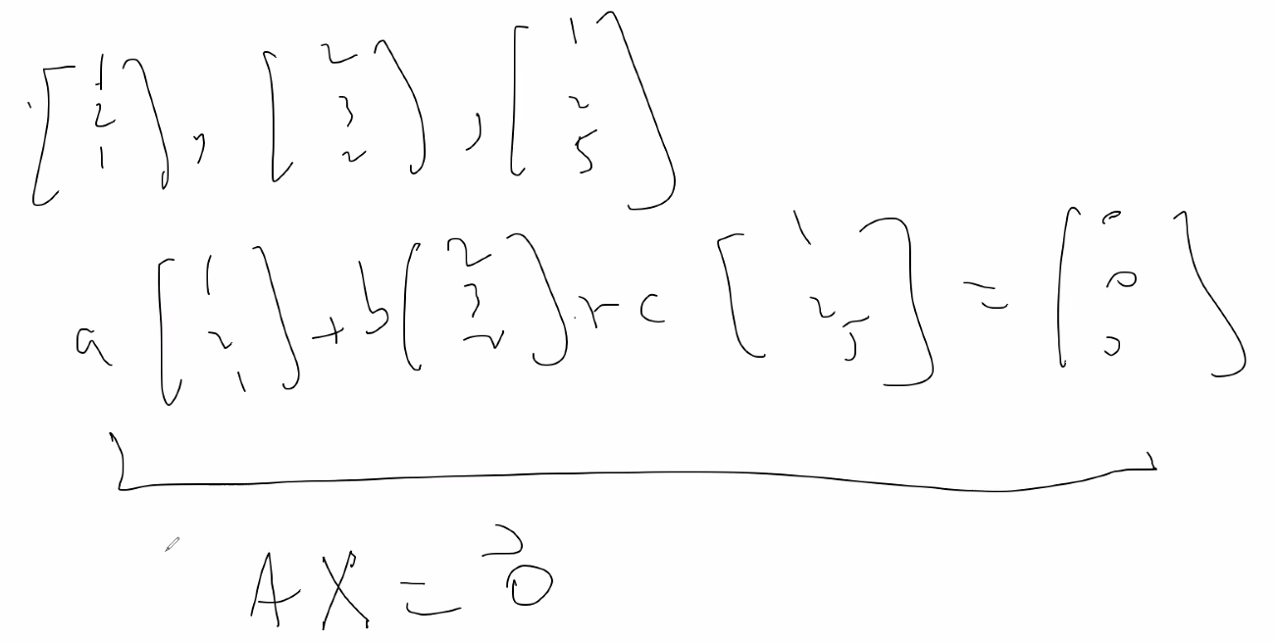
    - We see above 0, 0, 0 is a solution to the system, but if we cannot find any other solutions, we say the 3 equations are **linearly independent**
    - To see for more solution, put system into reduced echelon form and solve the system (place system into an augmented matrix first..then reduce)
    - Remember: A is the matrix of coefficients, X refers to the variables
      * Matrix of coefficients * matrix of variables
    - 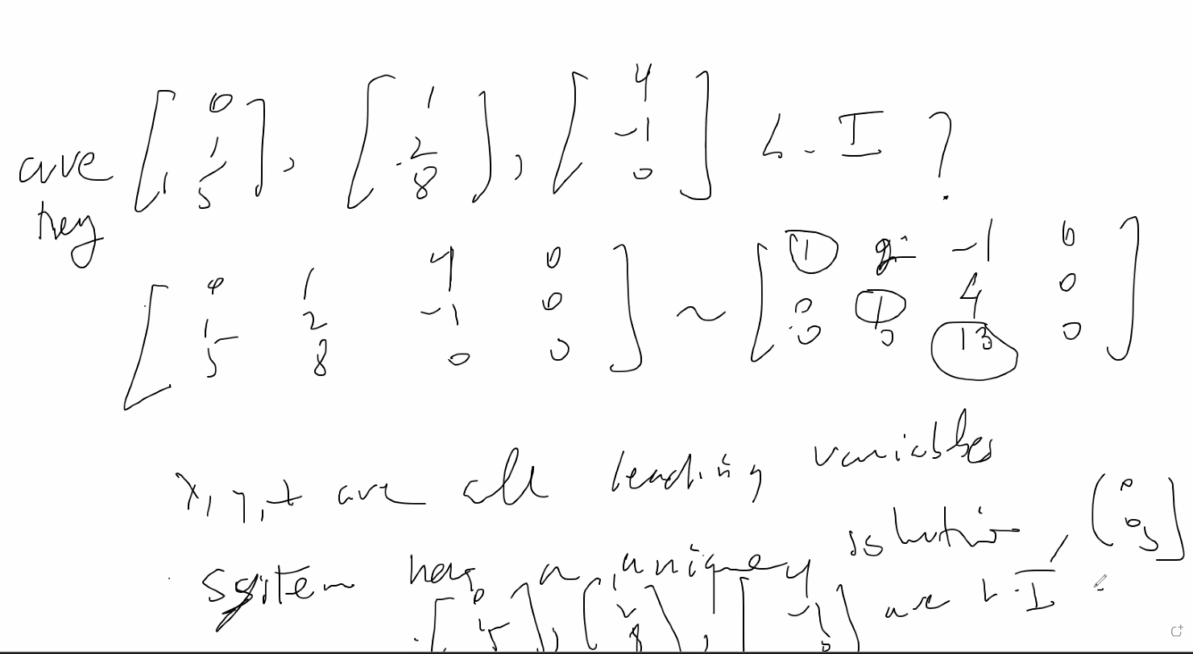
    - So after solving the equation we see there is only 1 unique solution (0, 0, 0); thus, the system is linearly independent
* 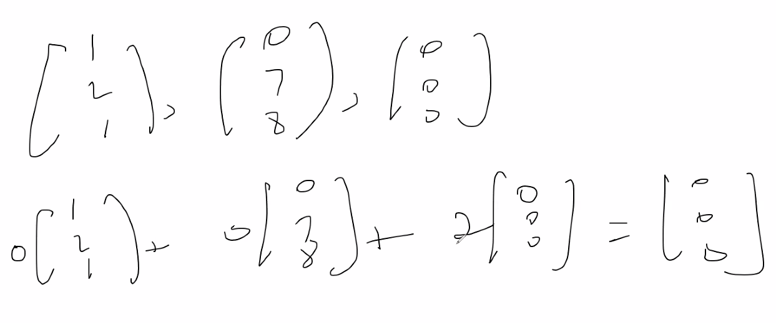
  + Above, the system is Linearly dependent since at least one of the equations are expressed in the linear combination without using the 0 scalar.

# Lecture 6 – 5/18/21

* If vectors are placed in a bracket together, they are considered linearly dependent or indepdent; without brackets the notation is called R-space
  + 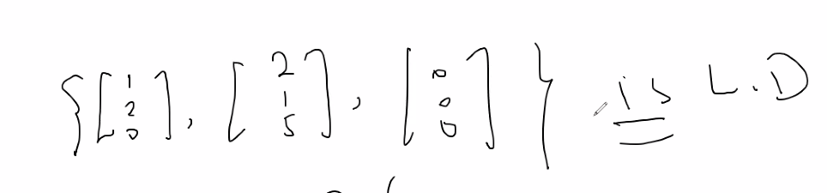
* A single vector is LI if it is a single vector (and not a 0 vector) because you can multiply it only by a 0 vector to get a 0 resultant; a single 0 vector is LD because you can multiply it by any constant other than 0 to get a resultant 0 vector
  + If a 0-vector is involved for a set of vectors it is automatically Linearly Dependent
* If you notice that vectors are not scalars of each other, but that all of the other vectors is a linear combination of one of the other vectors, then we can also say the set of vectors are Linearly Dep.
  + 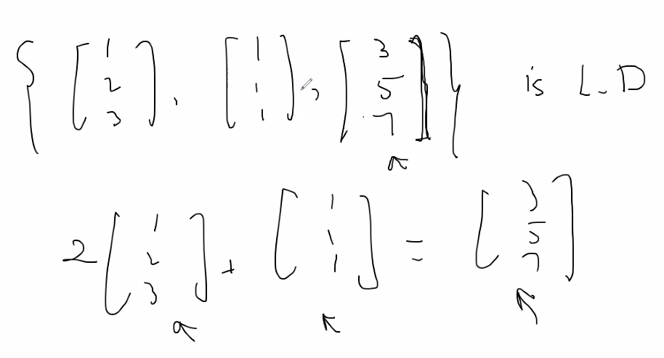
  + And remember the linear combination was found without having to use the constant 0
* Theorem: If you have n number of vectors, as long as 2 of the vectors are scalars of each other that’s not the constant 0, then the entire list of vectors is Linearly Dependent; this is because you can set the vectors in an equation equal to each other by applying the proper non-zero constant, and then you can put all of the other vectors in the equation and simply use the zero-constant to cancel them out; remember as long as we have a linear combination with at least one of the vectors scaled by a nonzero constant, then we say the system is linearly dependent:
  + 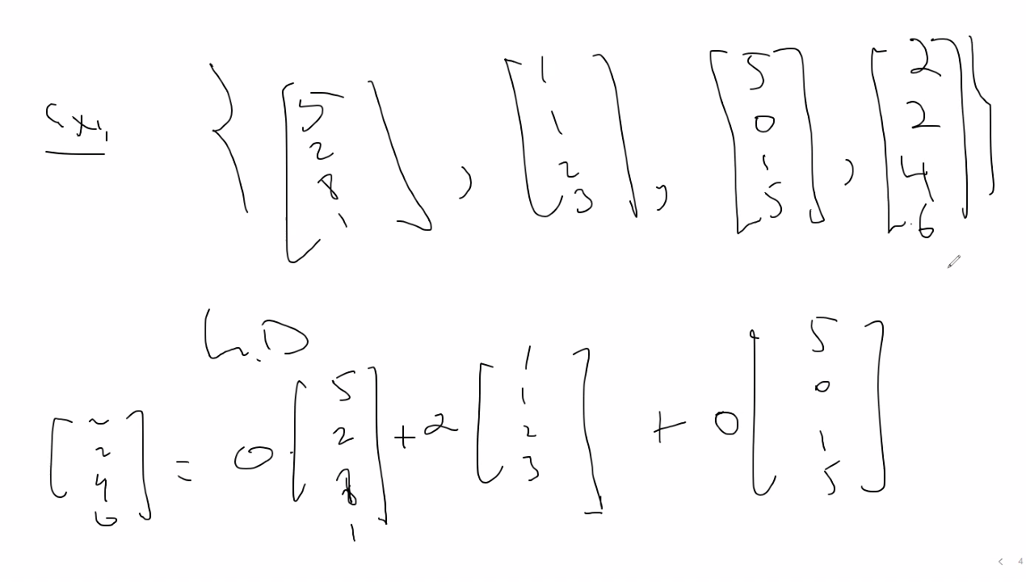
* Number of pivots = number of columns of the augmented matrix
  + Unless last column is full of 0s; then you may have column – x pivot columns; note in order to have a pivot column, remember, you need to have the leading term in a column (first non-zero number) to be nonzero; so a row of all 0s can have no pivot, and similarly, if the last column of a matrix is all 0s, then there cannot be n pivots = columns since at least last row will not be able to have a leading term
    - If last column is all 0s, then no elementary operations can change the values of that last column; it will always be 0s
* Remember, when setting up the system of equations using an augmented matrix system has to be homogeneous so last column added will be a 0 vector:
  + If number of vectors exceeds number of entries of the vectors, then the list of vectors is Linearly Dependent since you will have a free variable
  + 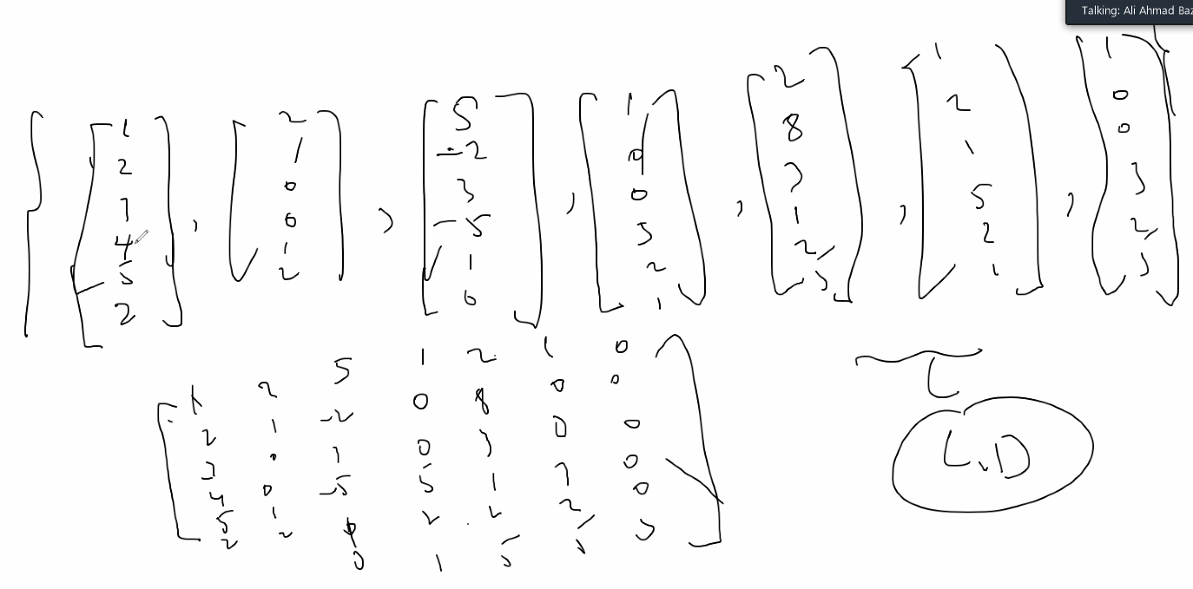
  + Notice above, number of vectors = 7; number of entries in each vector = 6; 7 > 6; so since number of vectors exceeds number of entries, then the list of vectors is LD since there will be a free variable or set of free variables due to the 7th (exceeding) equation which you can now vary in any way essentially using a factor and balance the rest of the equations using the proper factors.
* **Transformations**
* 
* Rn is the domain of T, and Rm is the codomain of T
* The range (or image) of T is:
  + 
  + If T: R2 🡪 R2, so R space 2 goes ot R space 2; thus space has not chan ged, it is called an Operator:
  + 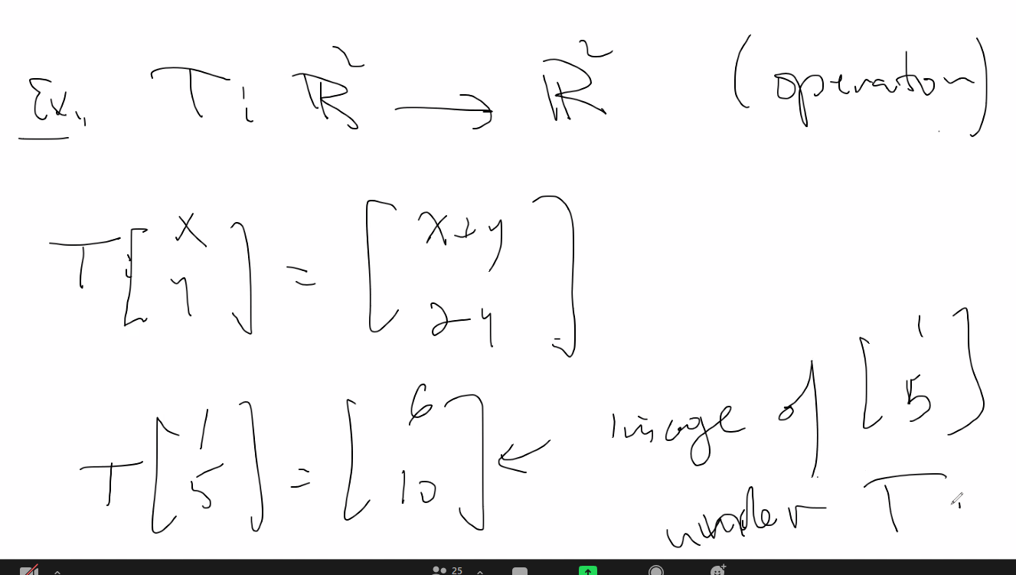
* 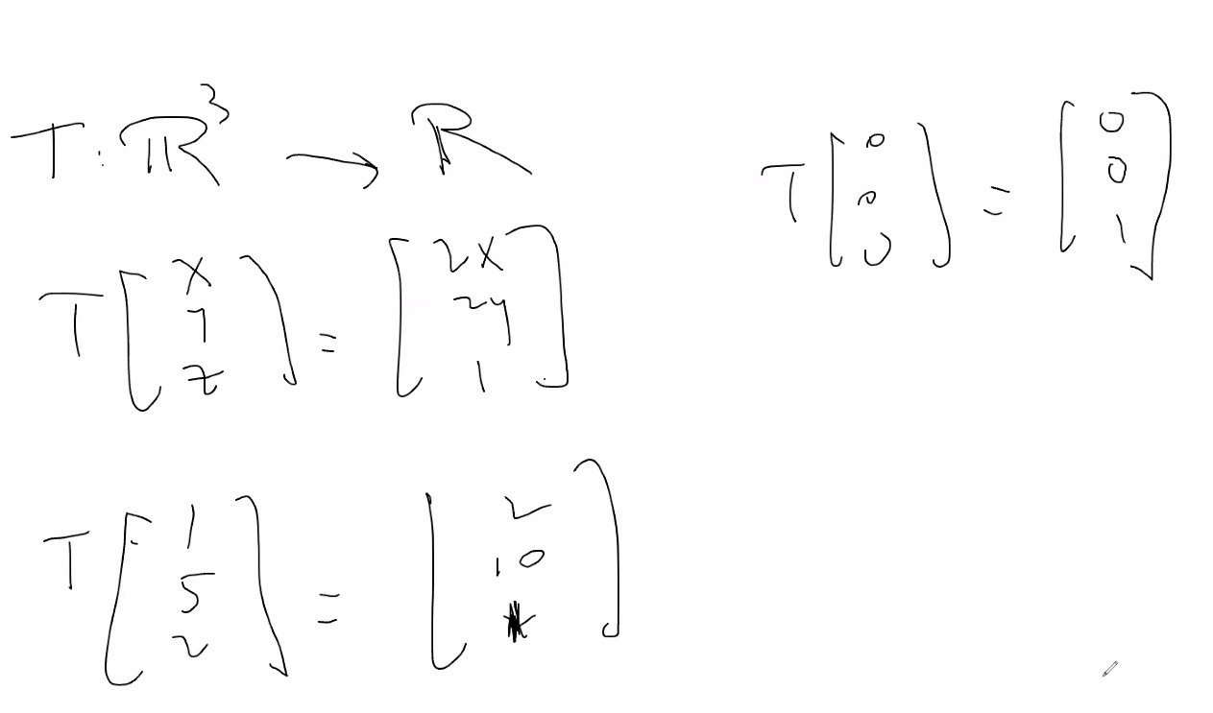
  + Above, we do not like to deal with transformations that are not linear (changing from one space to another)
* 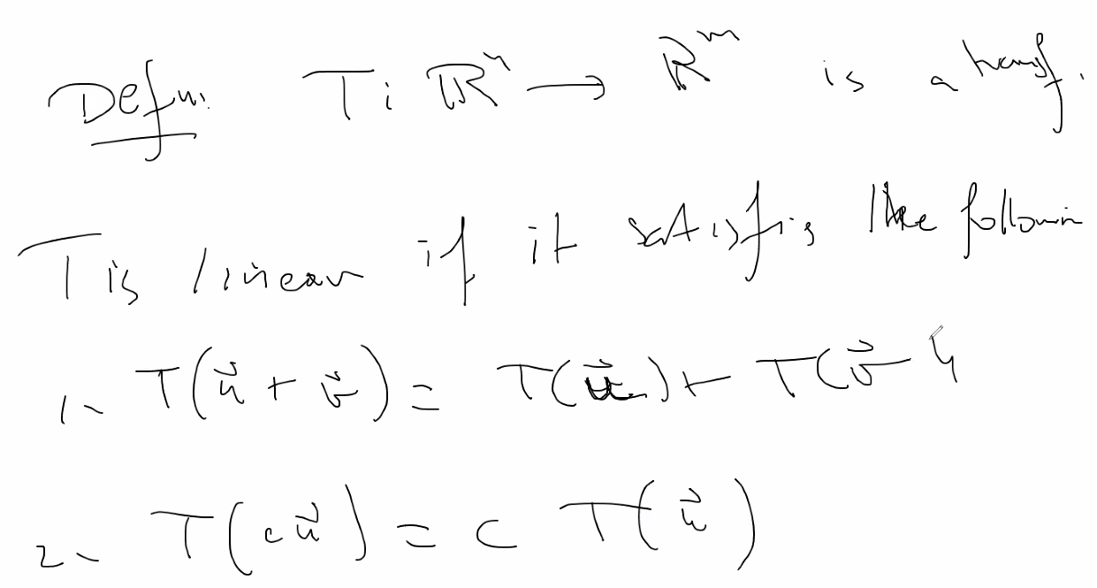
  + Above defines the more flexible transformations if they are ***linear***
  + Are easier and more useful to work with
* 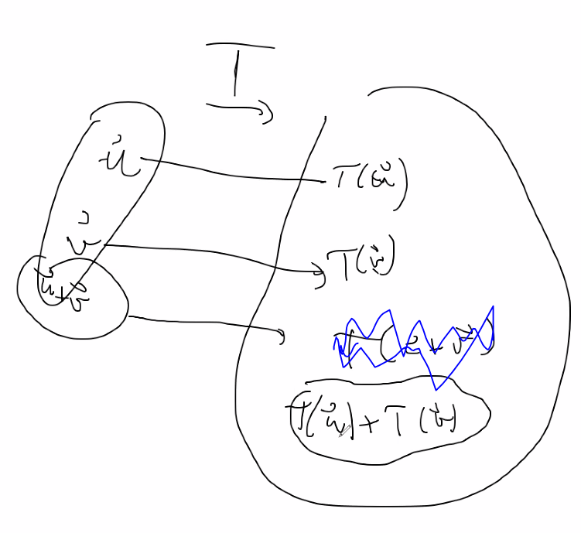
  + The above feature is only true if the transformation is linear
* If addition AND scalar multiplication is not preserved for transformation then the transformation is not a linear transformation
* 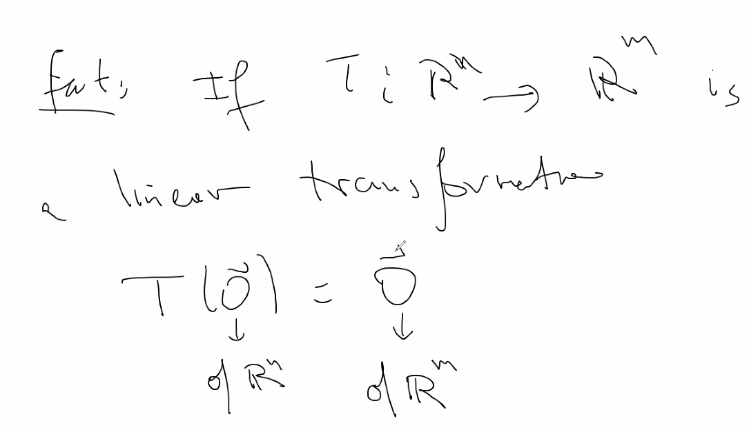
  + Above, 0 vector refers to the 0 in Rn space, and 0 vector on right side refers to 0 vector in Rm space
  + Demonstrates that the 0 of one space is same as 0 in the other space if transformation is linear
  + 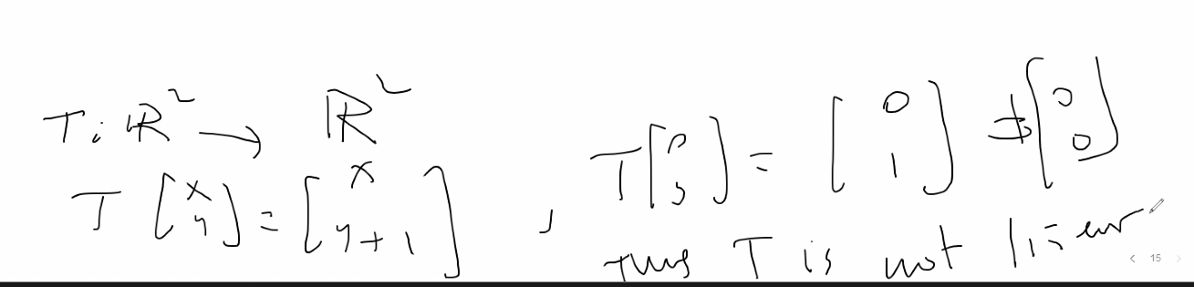
  + The above property can be true for other nonlinear transformations, so you can use it mostly to show that something is definitely not linear if the 0 vector property doesn’t hold, if it does hold then it could be a linear or nonlinear transformation
  + 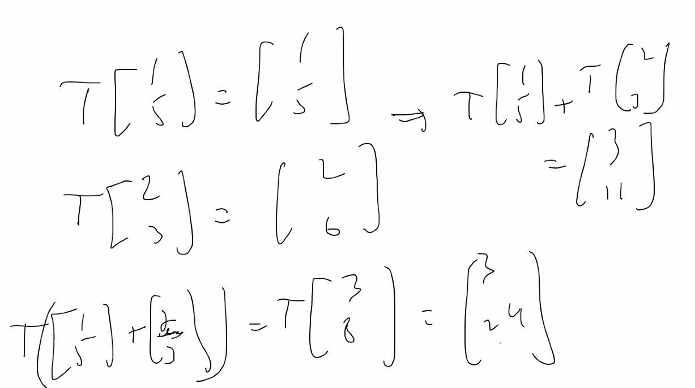
    - Above in the example, addition is not preserved (Image of their sum != sum of their image) so we automatically know the transformation is NOT linear
    - No need to check to see if scalar multiplication Is preserved if one of the properties of a linear transformation does not hold for a transformation; however both properties must be proven TRUE in order to say that a transformation is linear
* 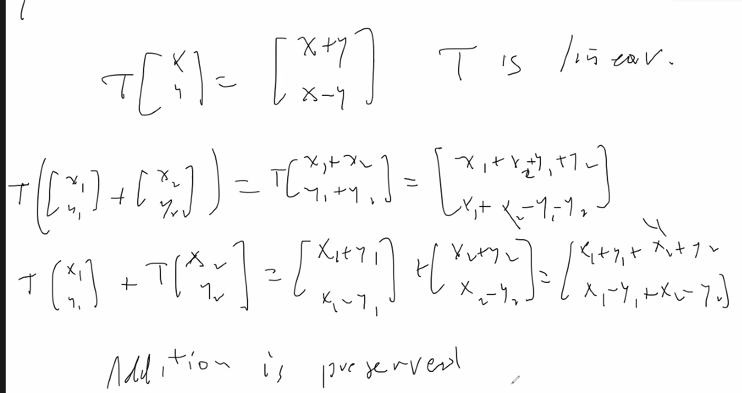
  + Above, showing addition is preserved for any x1 and x2; now we must show that scalar multiplication is preserved for any scalar (r) on any x1 and x2 to prove T is a linear transformation
  + 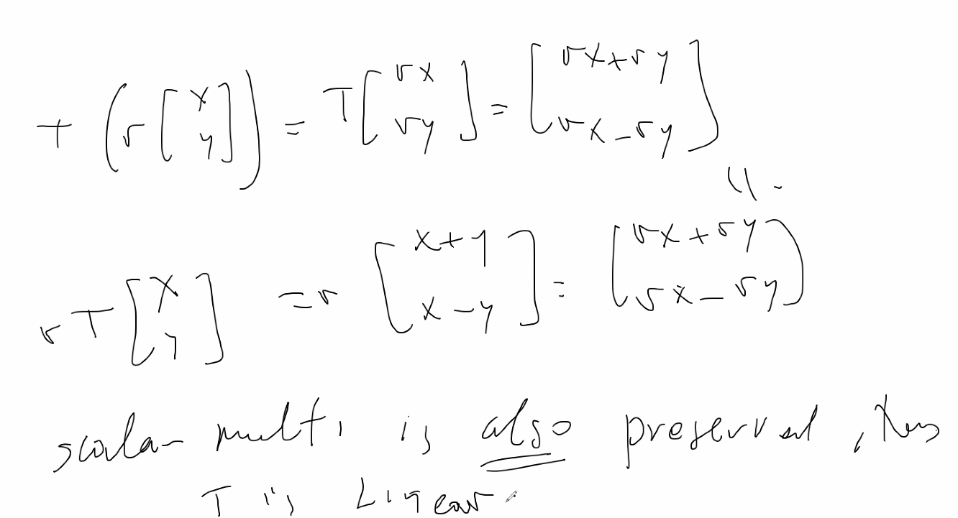
  + So since both hold; the T is a linear transformation
* Remember if there is a pivot position in each row, then system is consistent
  + 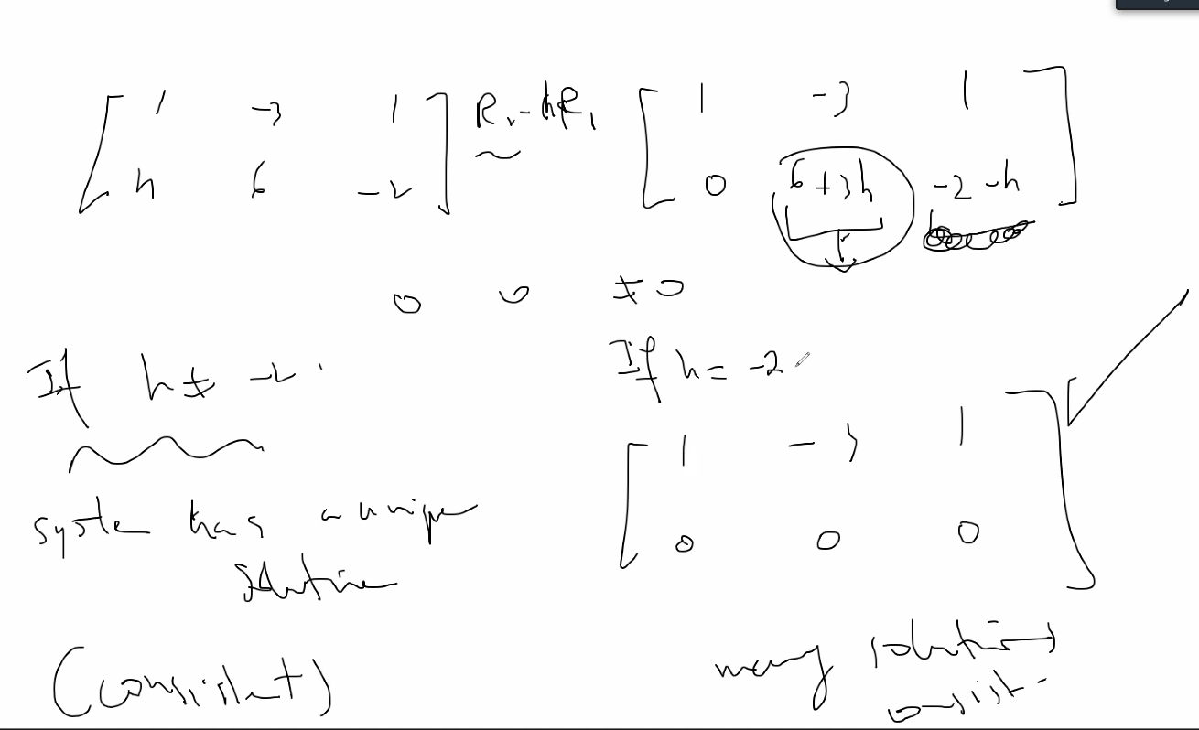
  + Above, it is shown that h can be any value and the augmented matrix will be consistent
  + Now we will show an example where h can be any value != -2 :
    - 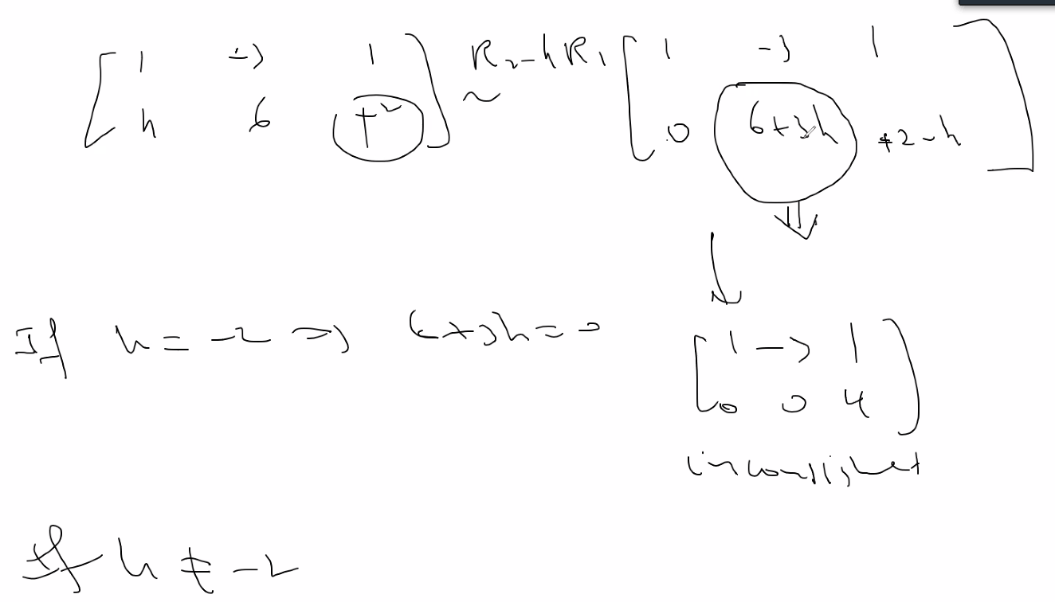
    - If h != 2, system is consistent; it is only inconsistent when h = 0.
* And here, h can be any real number for system to be consistent:
  + 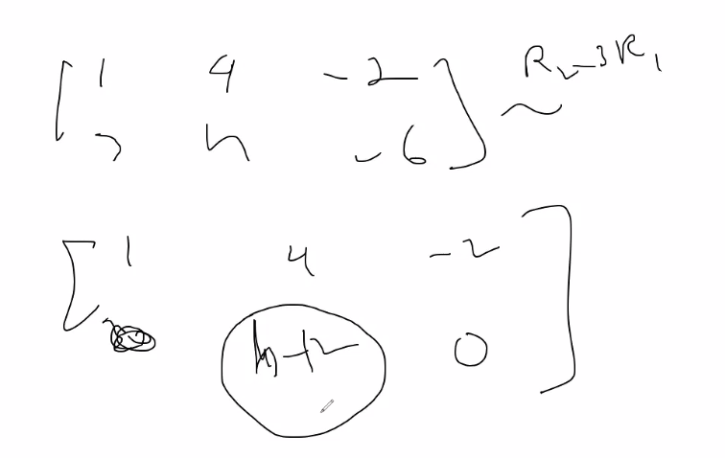

# Lecture 7 – 5/20/21

* Remember the inverse of a function is simply a reflection of the original function
* 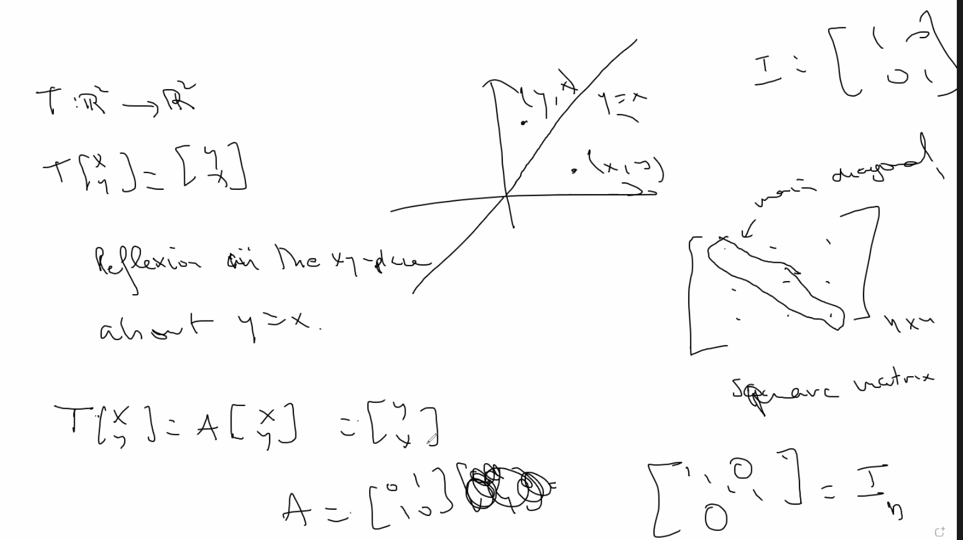
  + Above, I_n is the identity matrix
  + Also a matrix with row=col is called a square matrix
* We can do reflections about the x and y axis, or both, and we can apply these principles of reflections to help transform matrices in order to move a vector by an angle theta:
  + 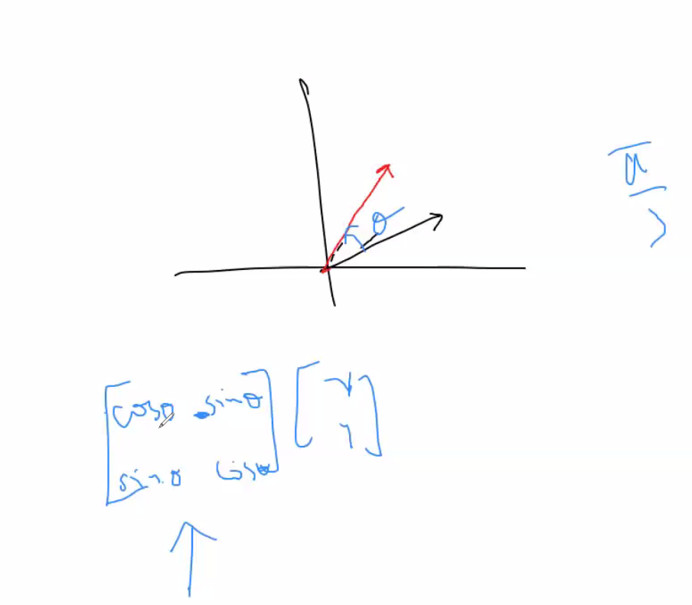
* One to one transformations:
  + 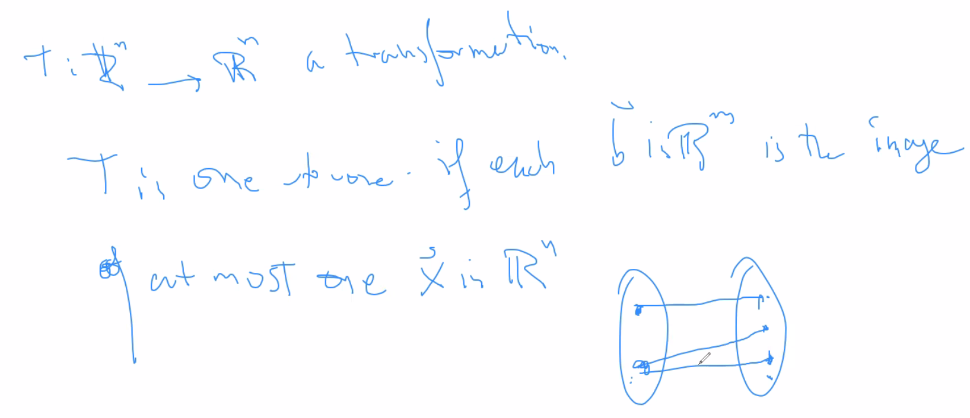
  + It is no different than when we learned about functions being 1 to 1 in basic algebra
    - In order to be one to one, each value in the domain should be mapped to only one value
    - Above shows a domain where the same domain value is mapped to different solutions, thus it is not one to one
* 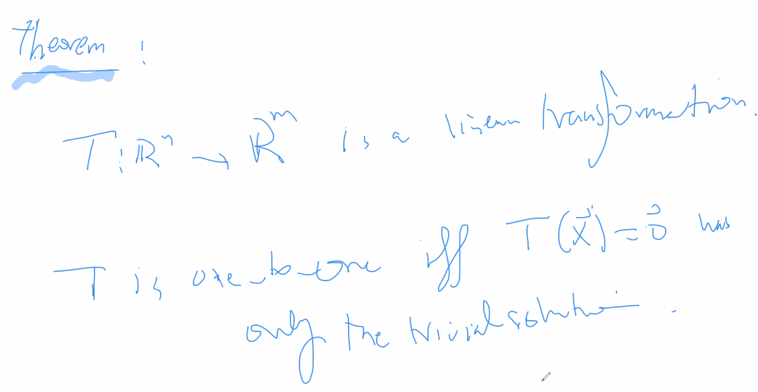
* Example:
  + 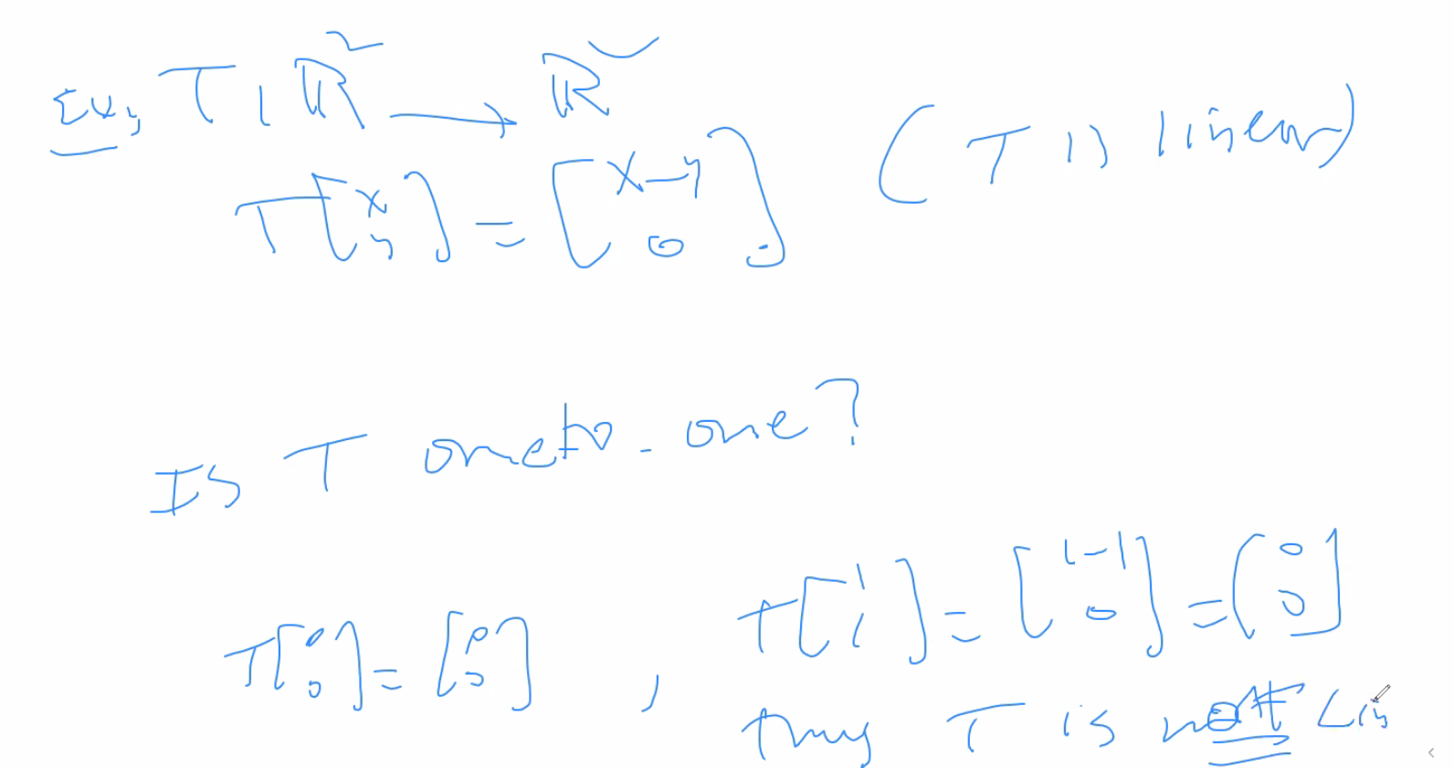
  + Above, the example is one where the transformation is not 1 to 1 since there are nontrivial solutions; which essentially means that there are multiple solutions for a single domain value
* Theorem for a linear transformation where T is ONTO Rn (and thus span Rm; remember Rm can be written as a linear combination of Rn)
* 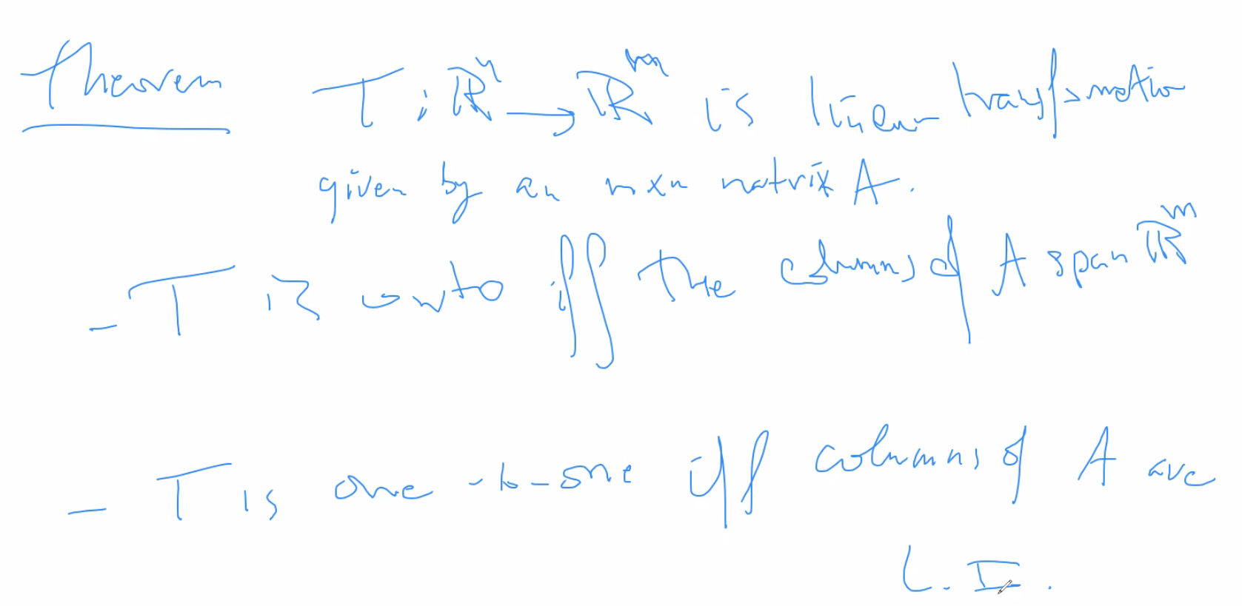
* 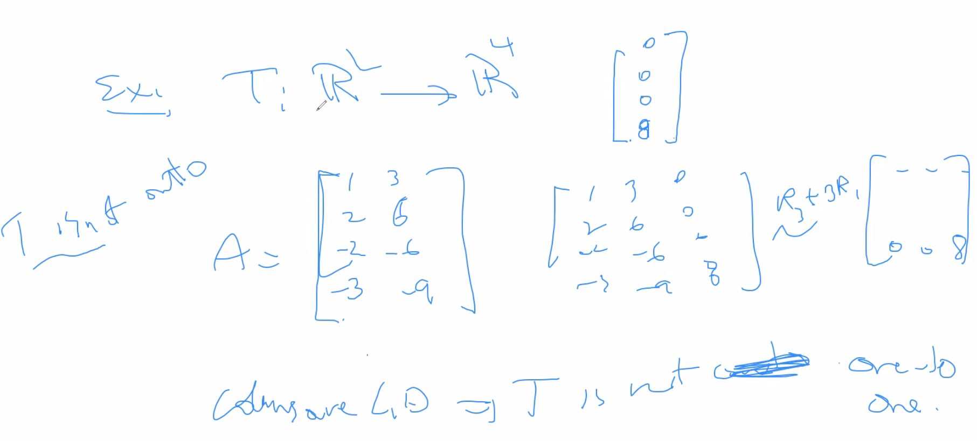
  + Above, 0008 is not an image of R2;
* Some addition and multiplication properties of matrices
  + 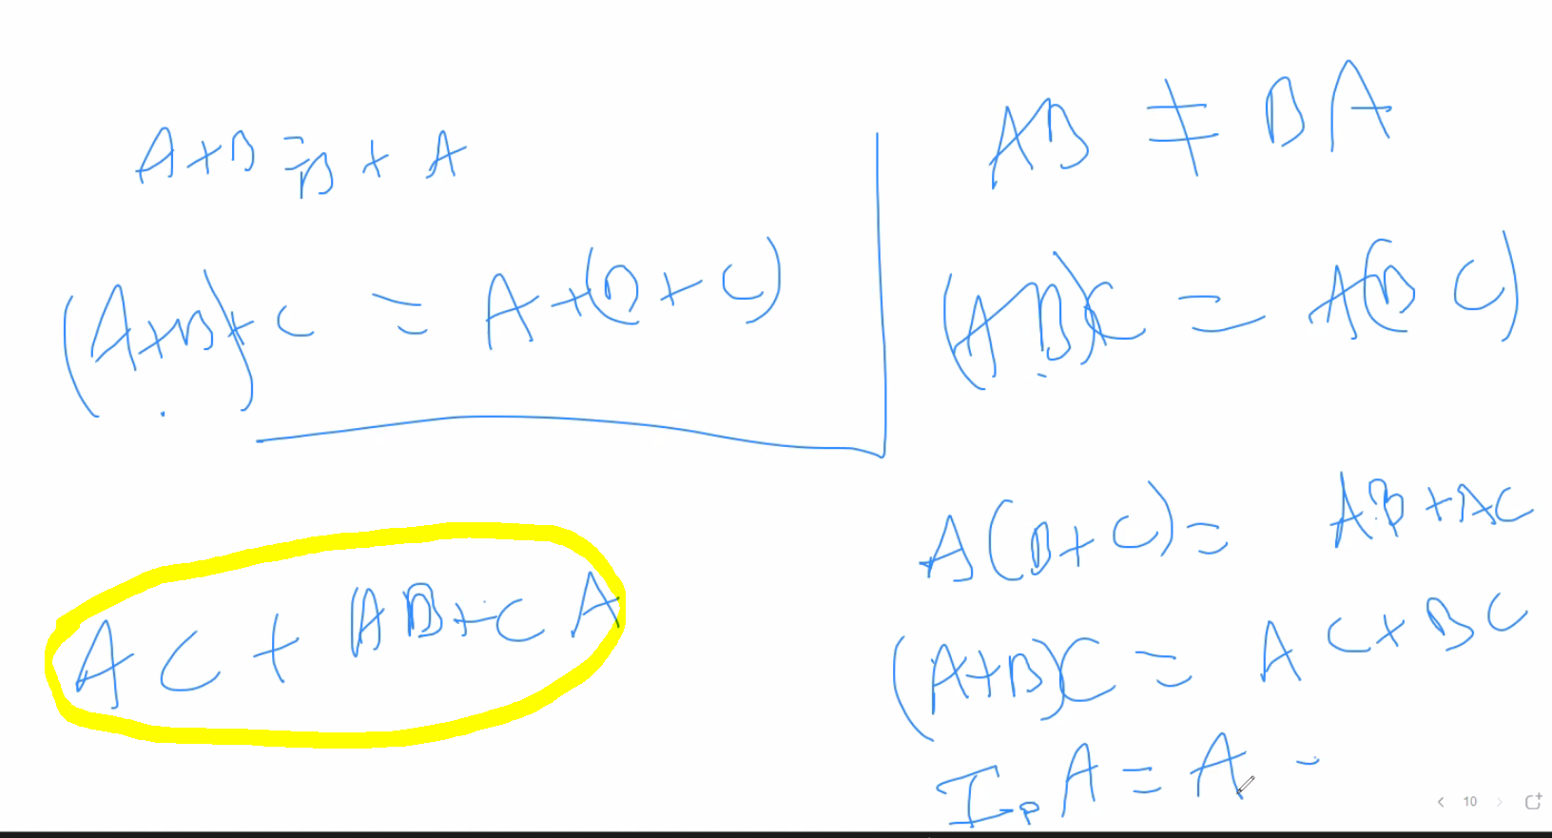
  + Above, notice what is highlighted, AC cannot be simply added to CA; because CA is not necessarily = CA for matrices
  + Also Ip * A = A, refers to the identity matrix
* Number 17 for section 1.2 in the hw
  + 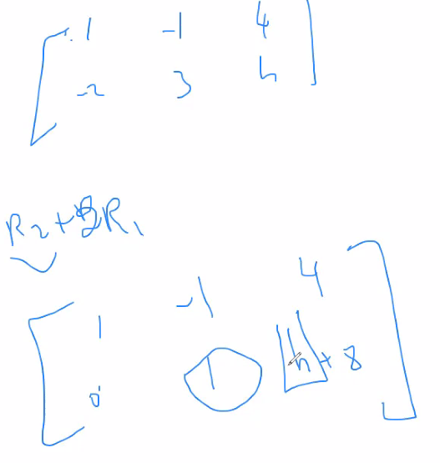

# Lecture 8 – 5/24/21

* I_n, the square identity matrix is the replacement of scalar one for matrices
* For matrices, for AB = 0, does not necessarily mean A or B must be a 0 matrix
* To transpose a matrix, switch rows and columns ( rows become columns, columns become rows)
* 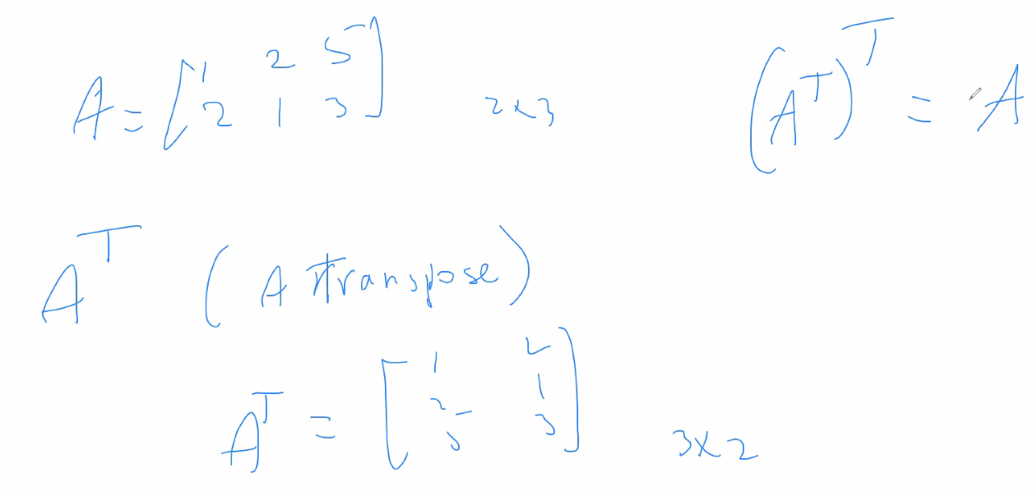
* Transpose properties:
  + 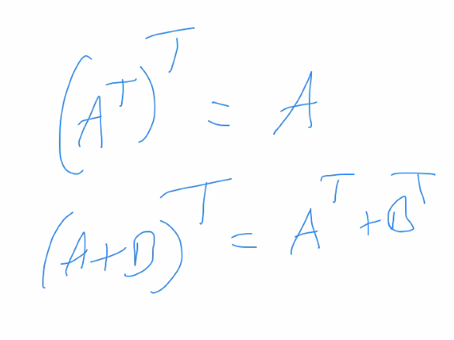
  + 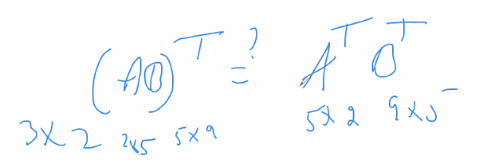
  + Cannot apply distribution of transpose of a product unless you reverse the order:
  + 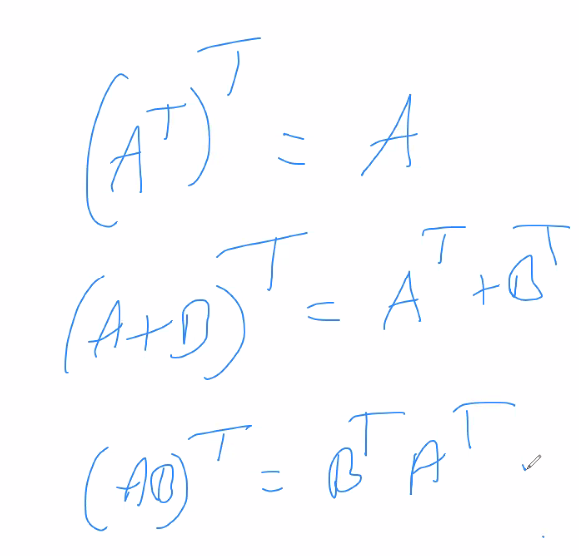
* You can only take powers of a matrix if it is a square matrix otherwise the product of itself (raised to a power > 1) will not be defined
* Be careful when expanding and simplifying matrix expressions because multiplication property is not commutative (but associative) for matrices; so do the full expansions before combining like terms
  + Example
  + 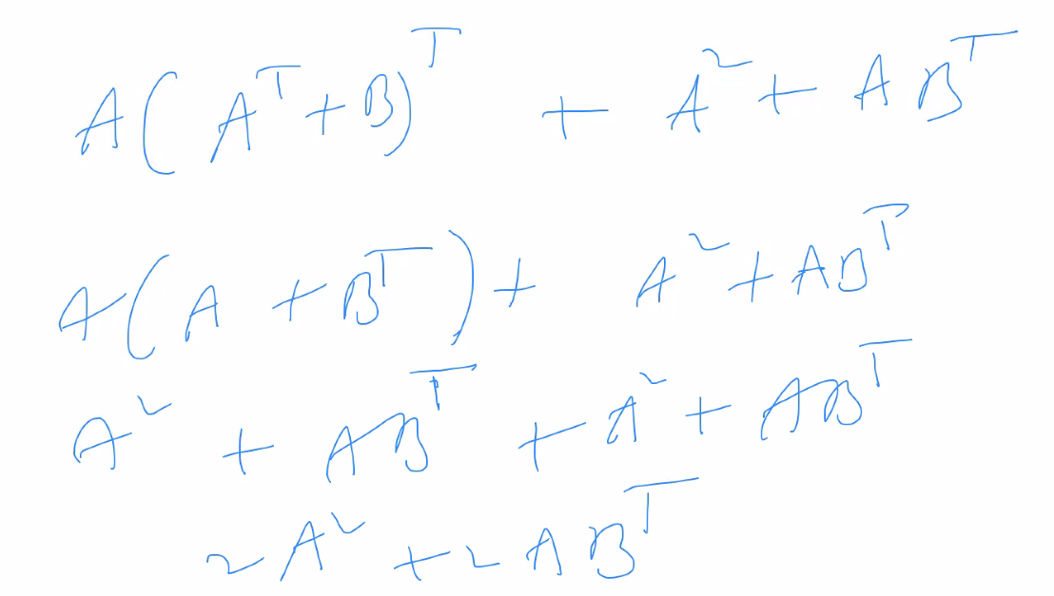
* Inverse of a square matrix (inverse can only be done on square matrices)
* 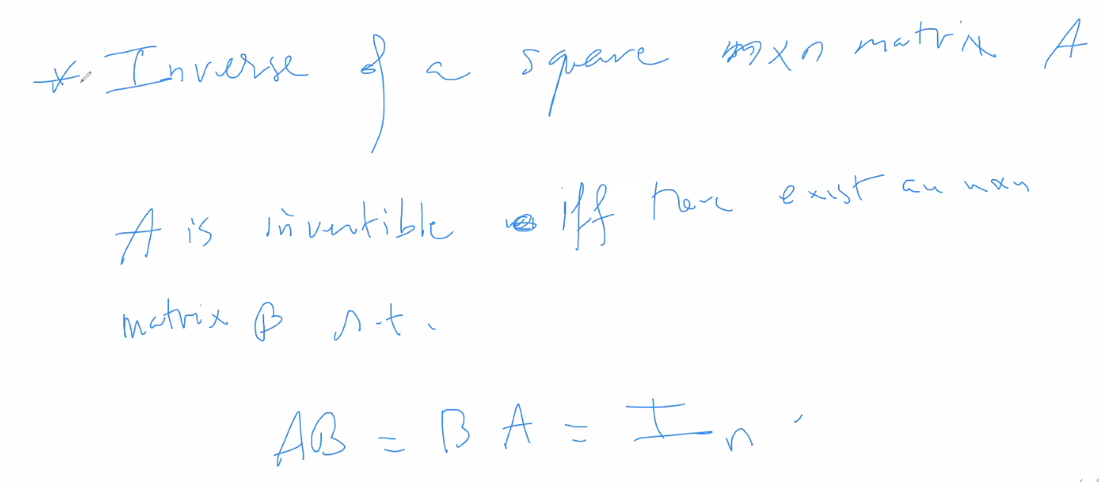
* 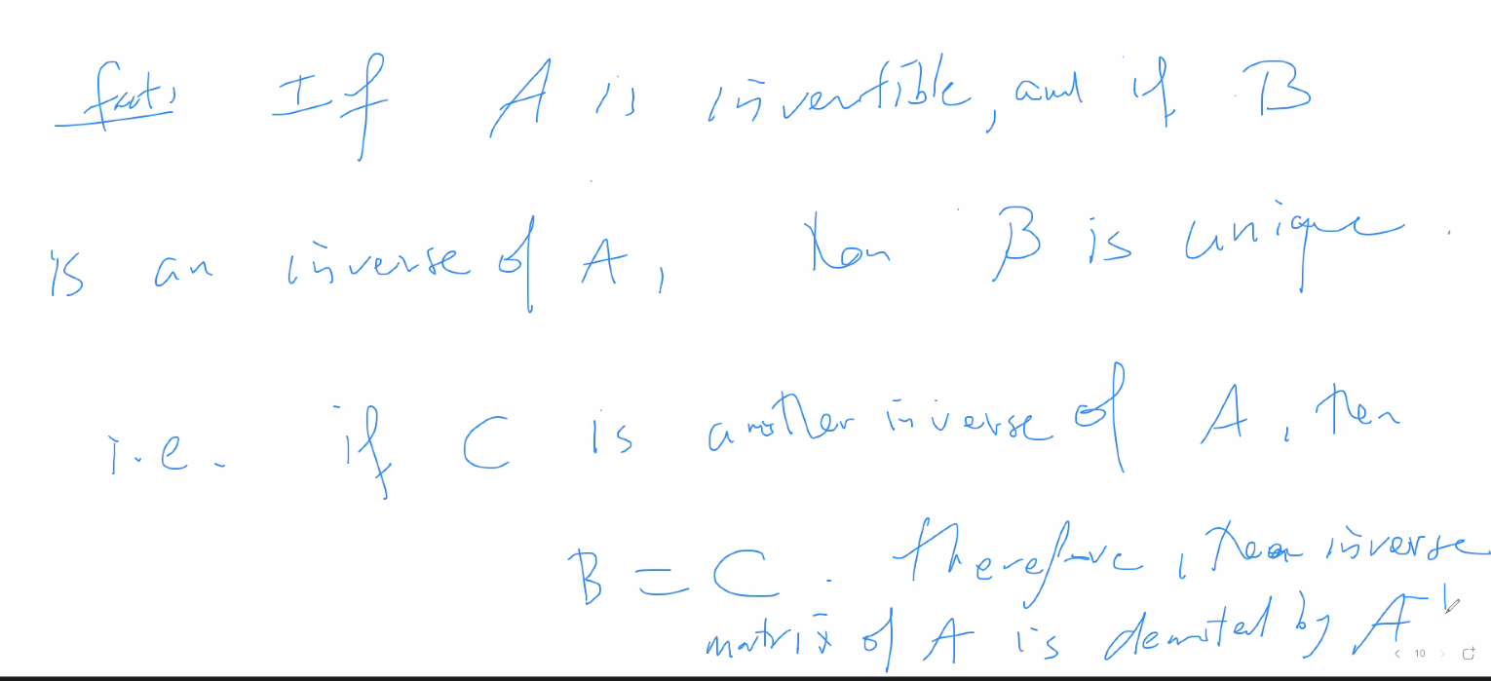
* If a matrix is invertible, it is non-singular
* If a matrix is not invertible, it is singular (alone)
* Algorithm for determining if a square matrix is convertible
* 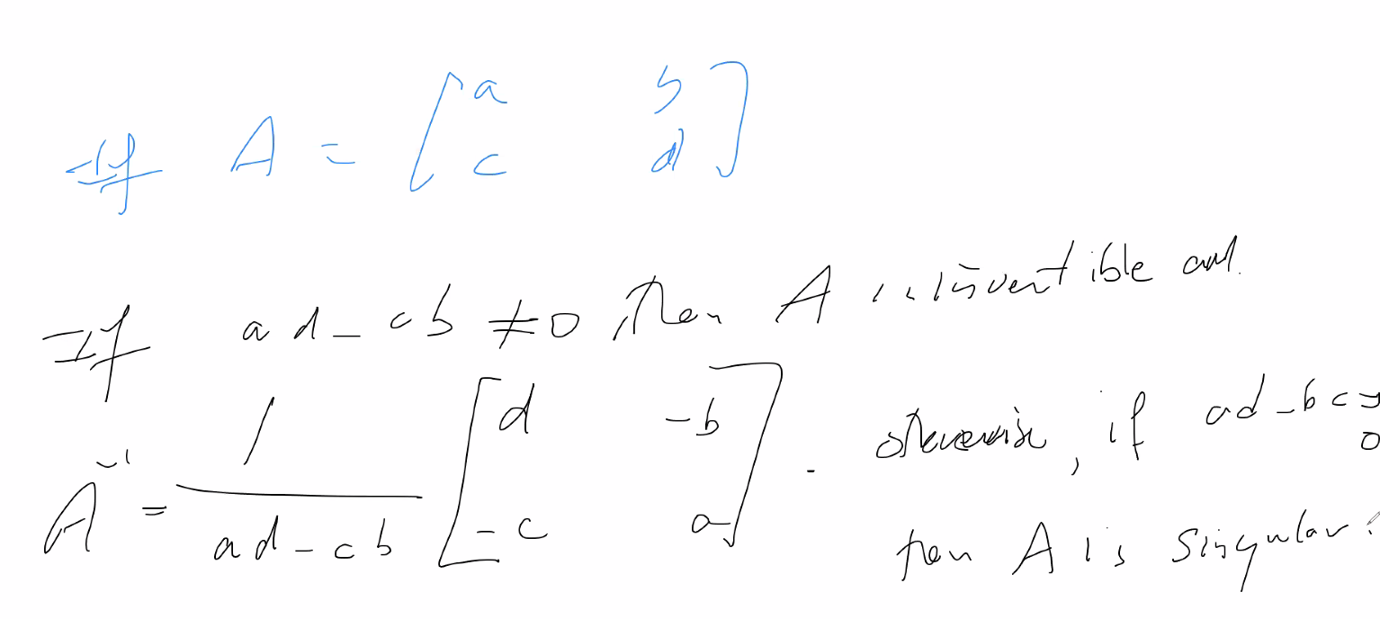
* Inverse properties
  + 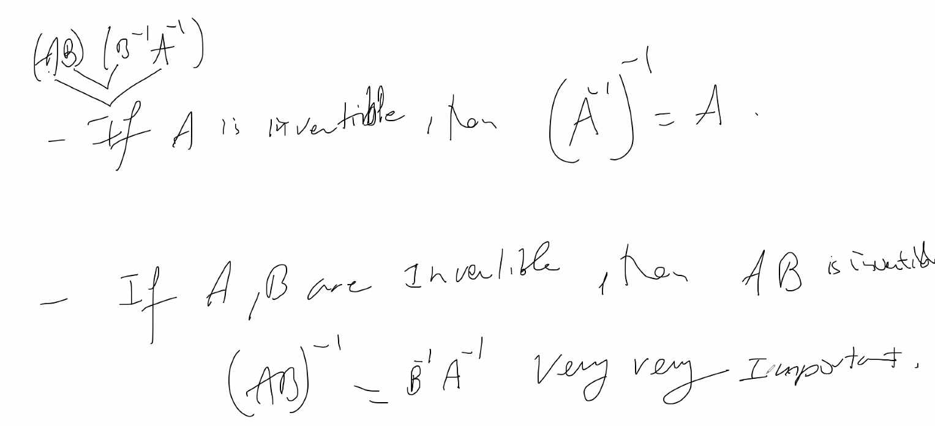
* Algorithm for testing for invertibility
  + 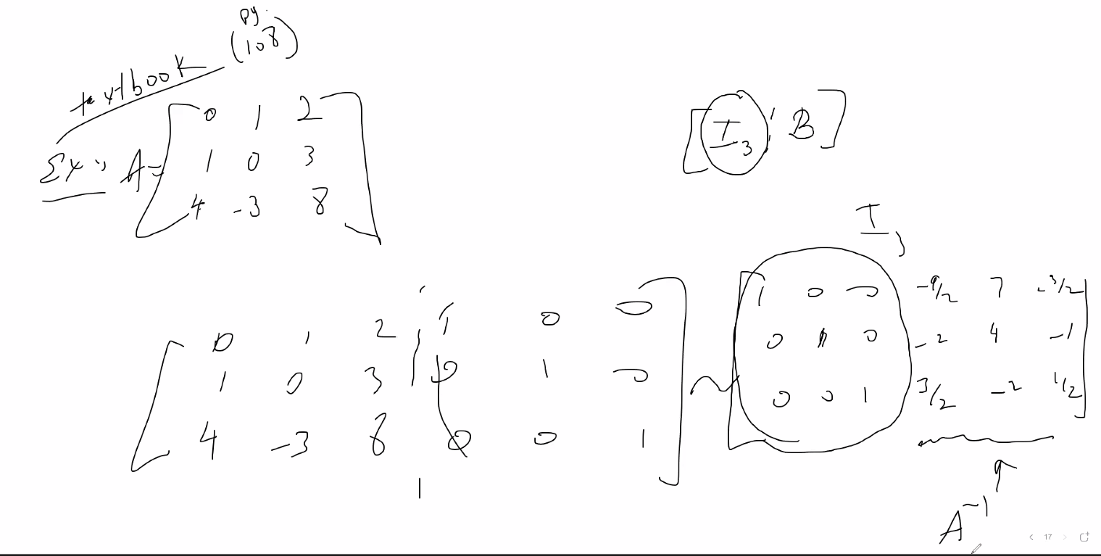
  + Add identity matrix to end of the current square matrix, put it into reduce row echelon form, and if the result has the Identity matrix, then the rest of the matrix is the solution to the invertible matrix
* 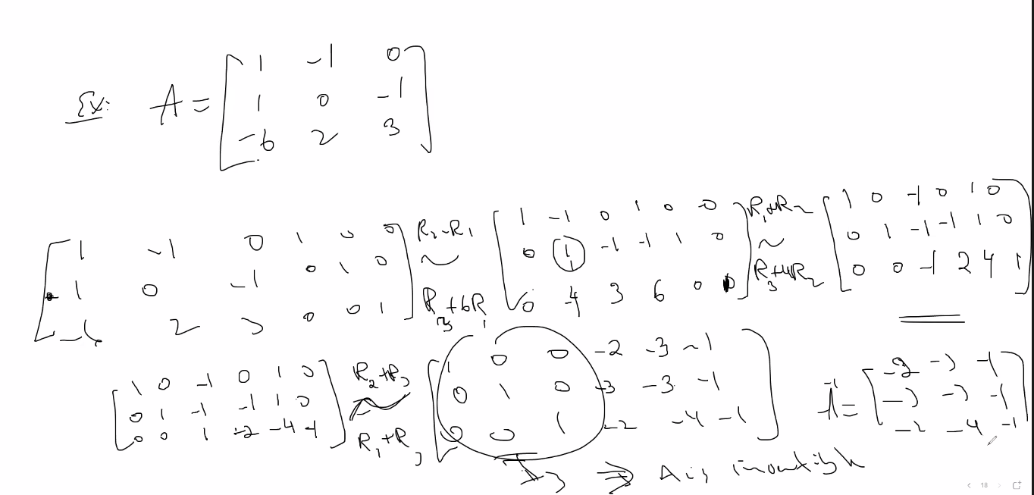

# Lecture 9 – 5/25/21 – section 2.3

* Theorem from 2.3 – If one is true, all are true; so choose easiest one to prove or disprove:
  + 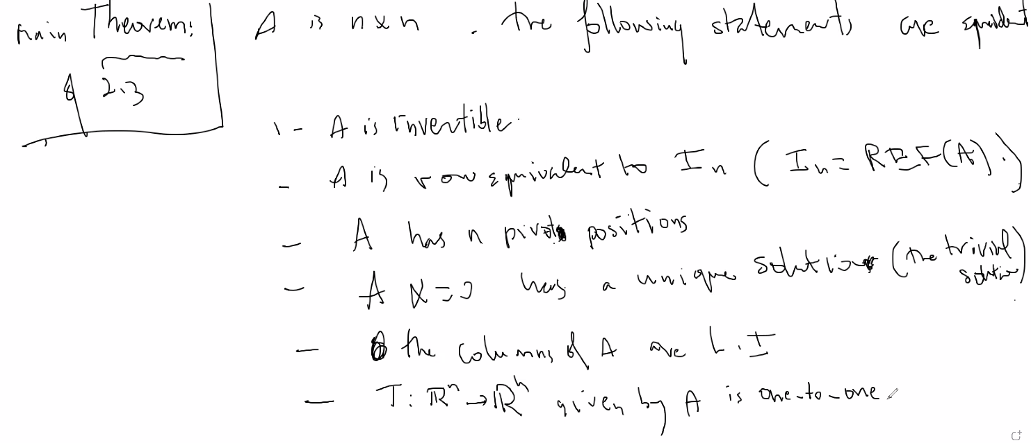
  + Notice above, it is the trivial solution because if it has a non-trivial solution then there would be infinitely many solutions to the homogenous system which would make A non-invertible
  + If one of the statements are not true, then none of them are true; and equally, if one of them is true, then they are all true
* Very useful:
  + 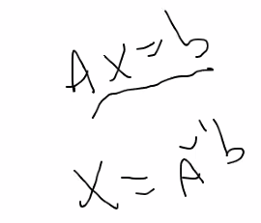
* 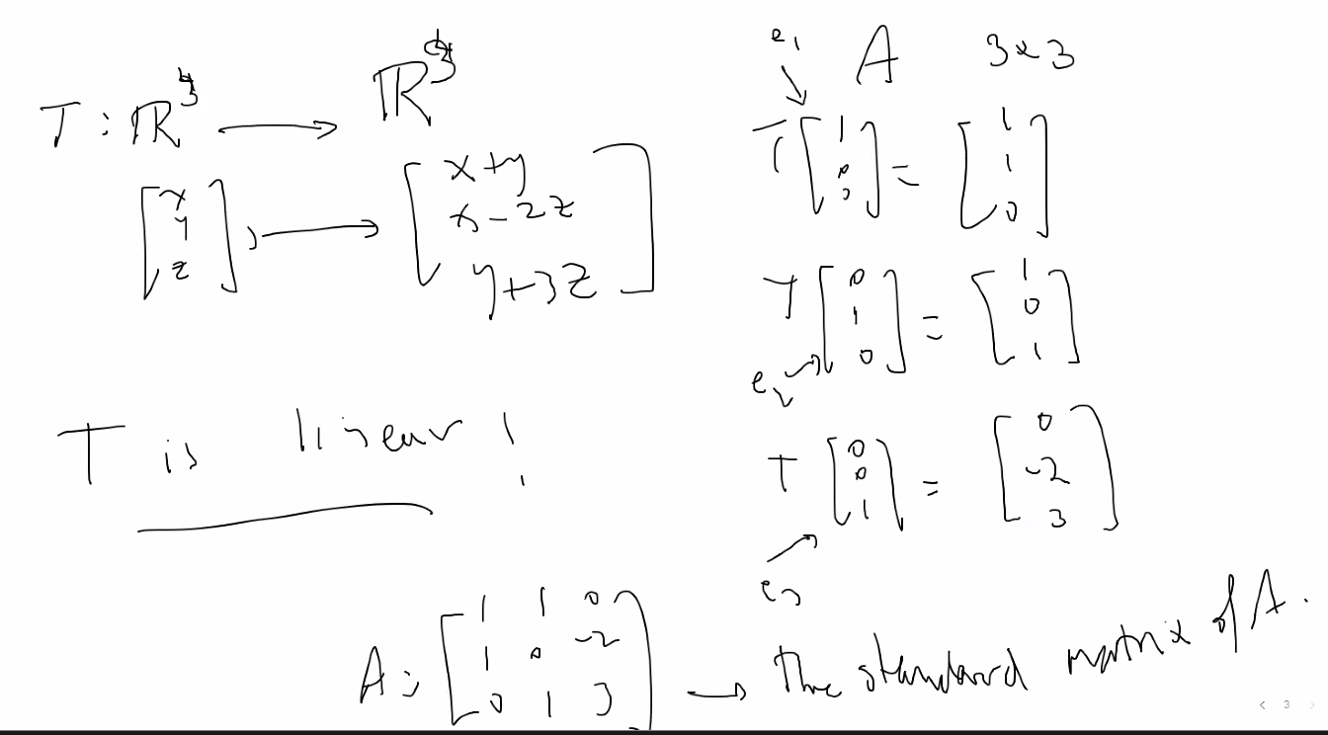
  + Above, we see e1, e2, and e3 define the vectors for each position of R3 separately; notice then transforming each of those into the respective transformation which is give and filling in the respective positions; this is the standard matrix of A (the transformation from Rm to Rn)
  + Resulting standard matrix will always be n x m
* Theorem:
  + 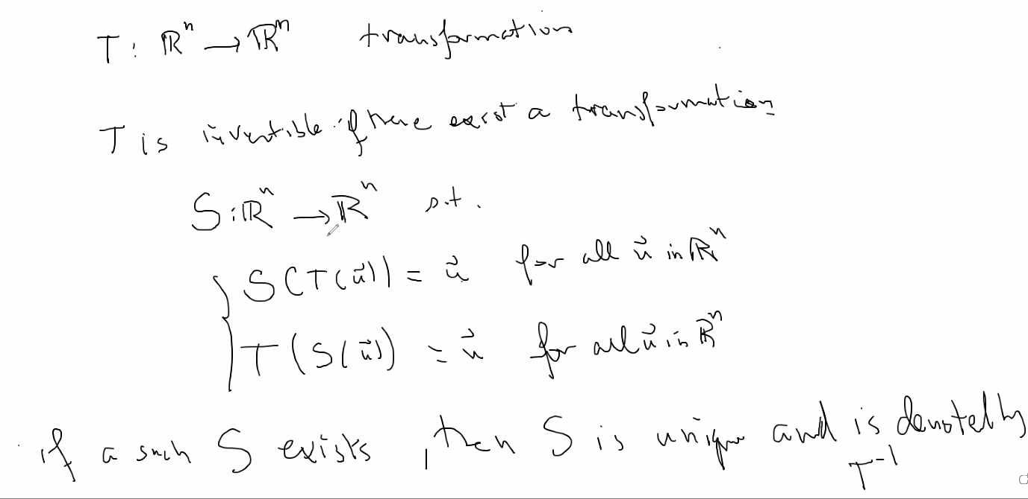
  + S undoes what T does; it is the inverse transformation
  + 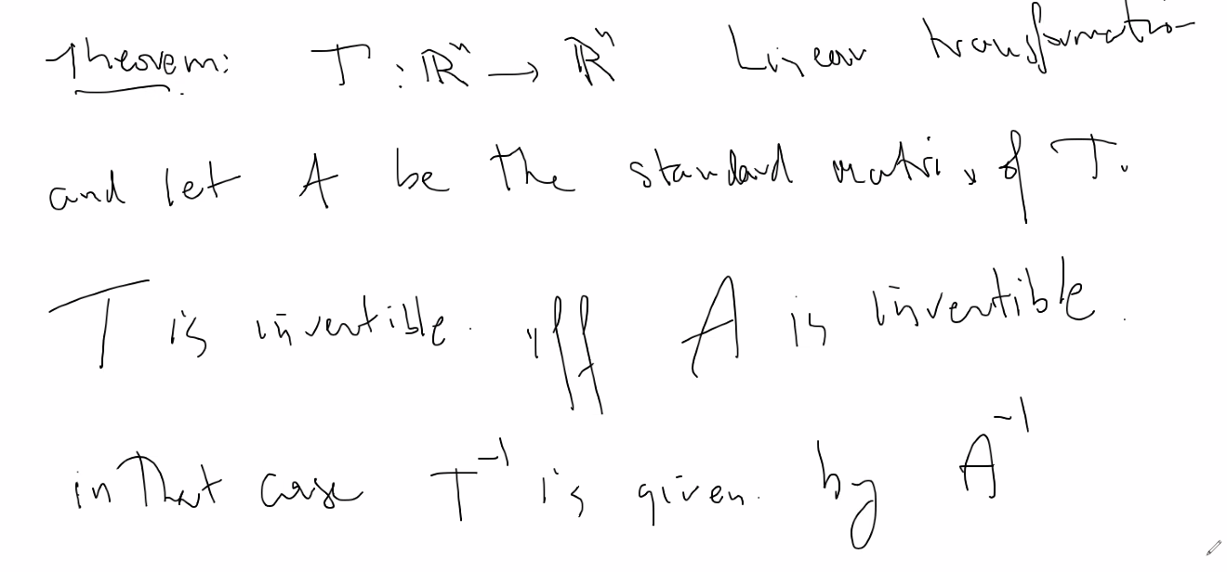
* 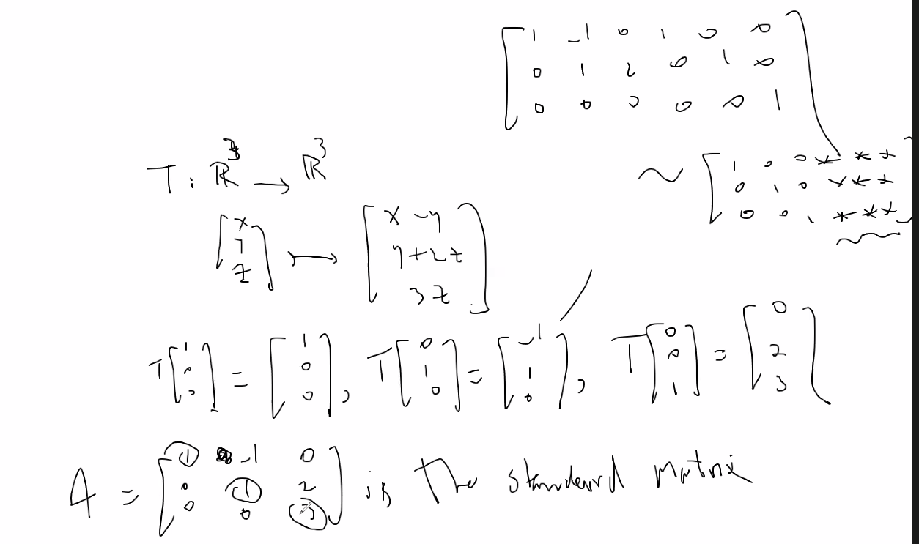
  + So after finding A, put a pivot position of every column of A (if it is possible); if you are able to, then you know you can find the inverse of A using the technique; that inverse will be the inverse of T (the transformation); (above, the stars after putting the above matrix in Reduced Echelon Form, represent the answer to the inverse of A, which is again, also the inverse transformation of T)

# Lecture 10 – 6/01/21 – section 3.1

* Determinants of n x n matrices
* Denoted |A|
* 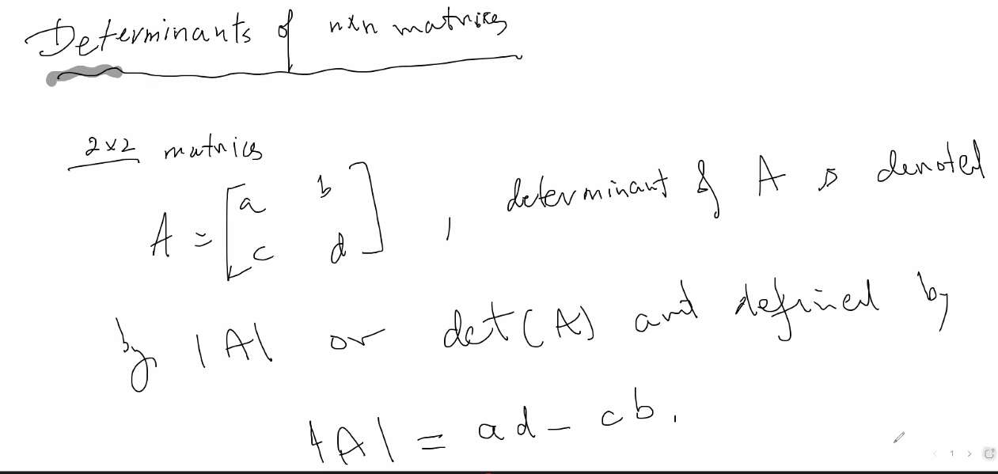
* 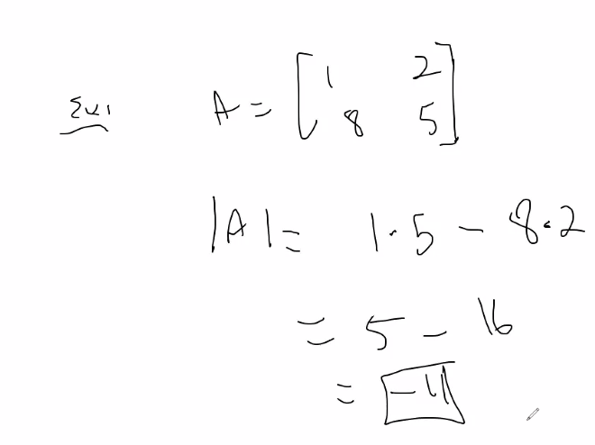
* Minor of row, column (M_ij):
  + 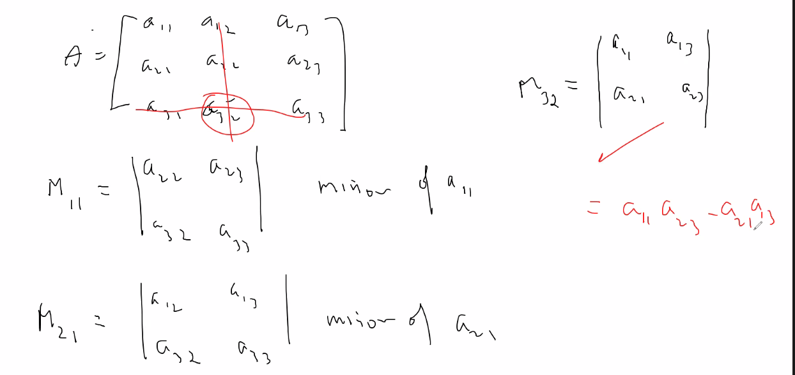
  + Delete the associated row and column including the element a_ij to produce M_ij, the remaining elements is the determinate of a_ij = (M_ij, the minor, or determinant of a_ij)
  + 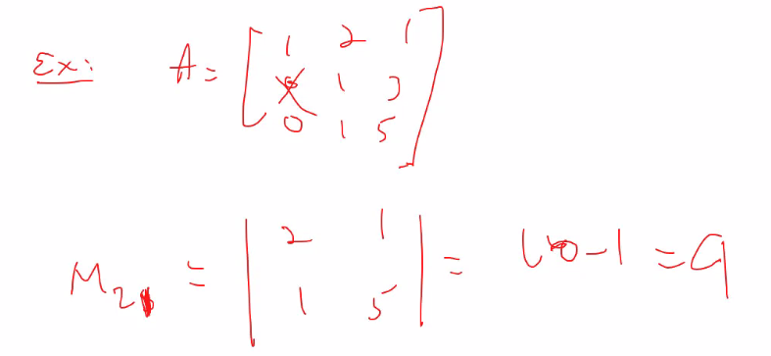
* Cofactors of A
* 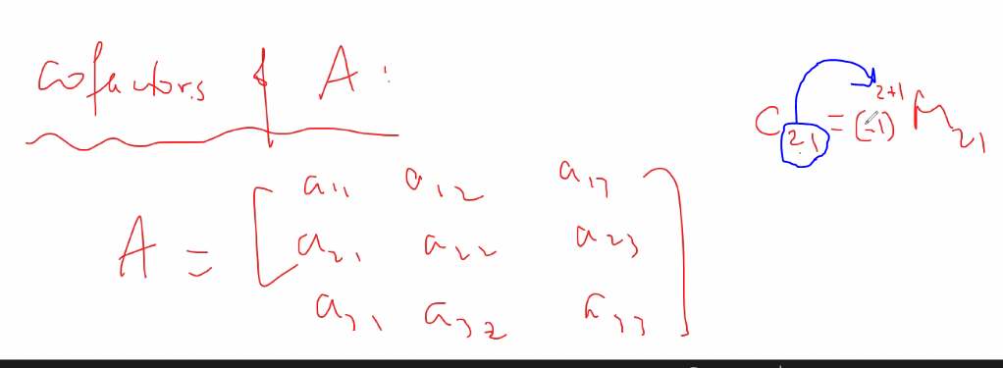
  + The power of -1 is determined by the element to which we take cofactor (ij)
  + Find Minor if the a_ij, multiply it by (-1)^(i+j) 🡪 notice -1 to a power give an alternating + and – sign for a value; of course if i+j is even, then signwill be positive, which means cofactor of a given ij will be the same as the determinant (Minor) of an element ij
* Determinant of an n x n matrix for matrix A = (a_ij)
  + 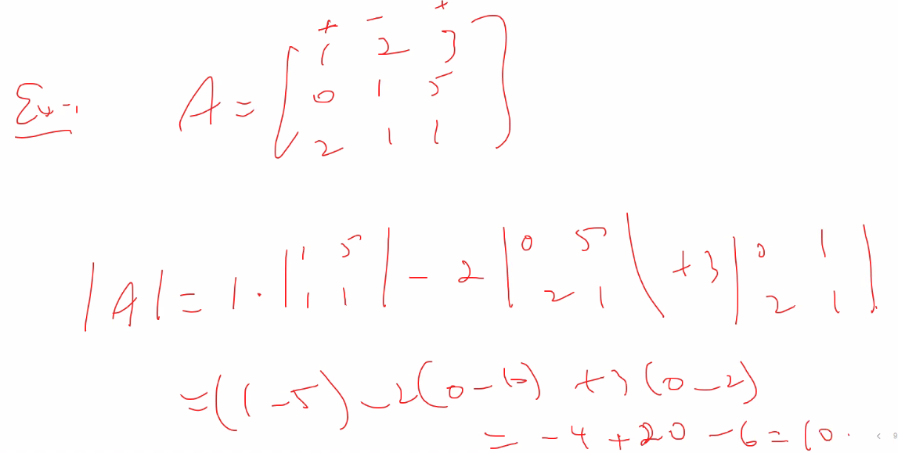
  + Determinant is the cofactor expansion of row 1 of A
  + Simply take the a_ij element and multiply that element value by its Minor, and of course the sign is determined for a cofactor by (-1)^(i+j), so the expansion will always be an alternating + and -.
  + **It turns out, if you do any cofactor expansion through any column or any row, you will get the same value: the determinant**
  + 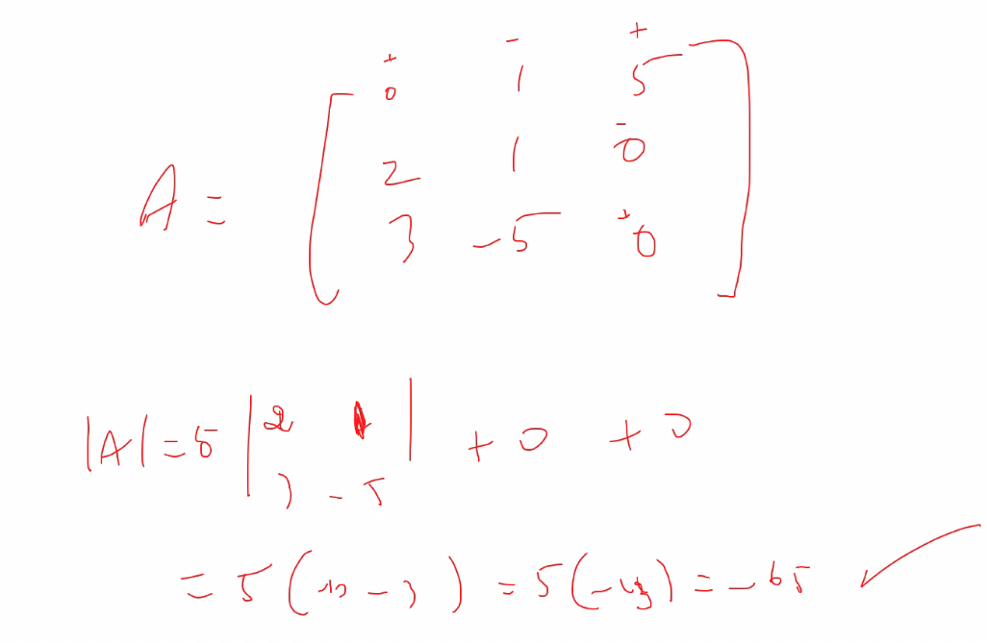
  + Strategy: If you want to get determinant by doing cofactor expansion, choose the row or column with the most 0s so that there is more cancelations (multiplication by 0) so it will make it easier to do the expansion and find determinant
* To find determinant of 4x4, you have to break it down to 3x3 matrices and find the determinants of those
* 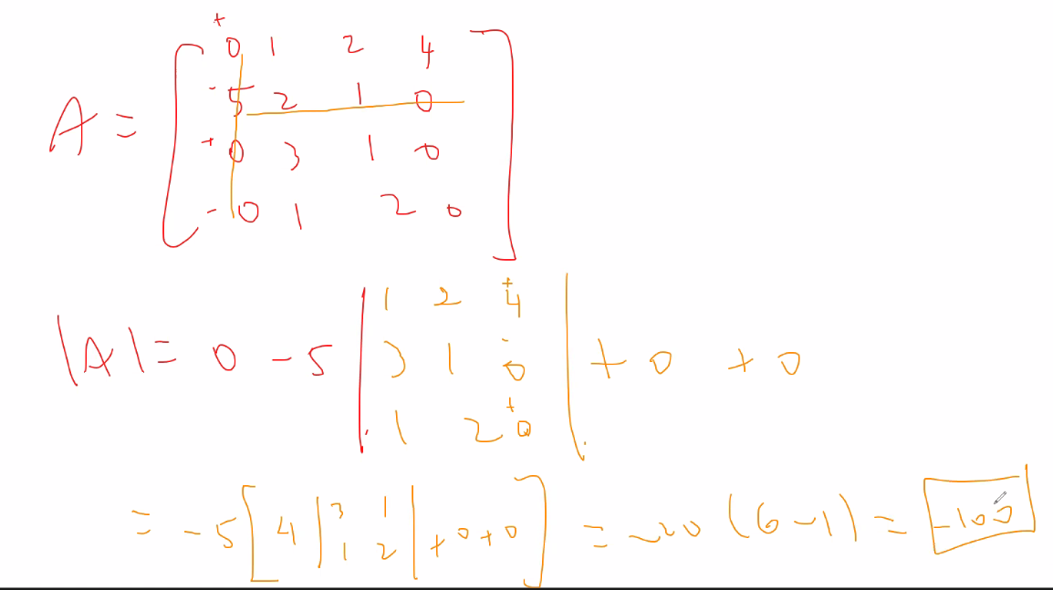
* Upper triangular matrix
  + 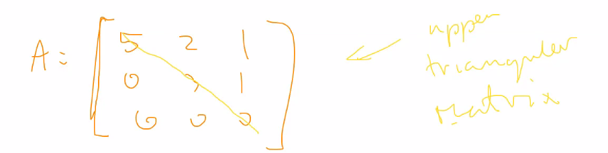
  + Notice A is in echelon form (not reduced echelon though)
* Lower triangular matrix
* 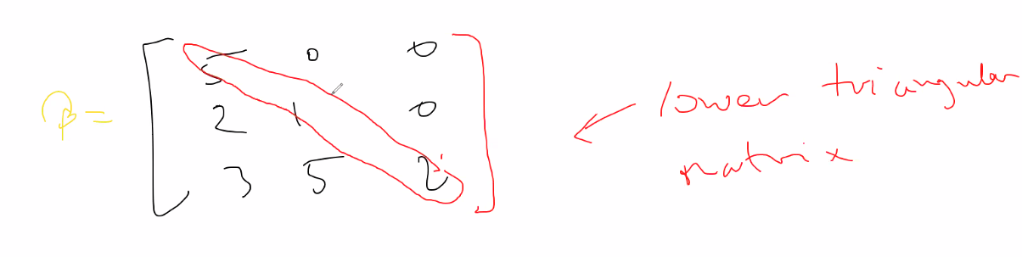
* Diagonal matrix
  + 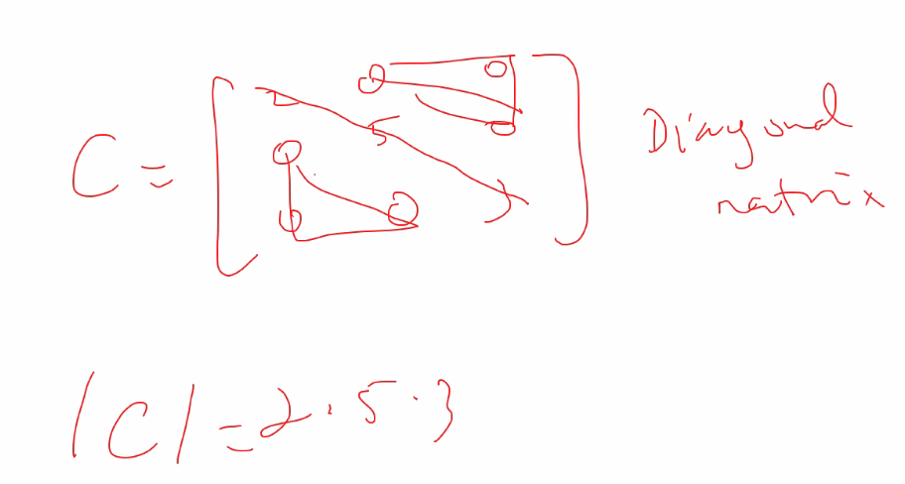
* Notice that for a lower or upper triangular or a diagonal matrix, the determinant is simply the product of the main diagonal
* 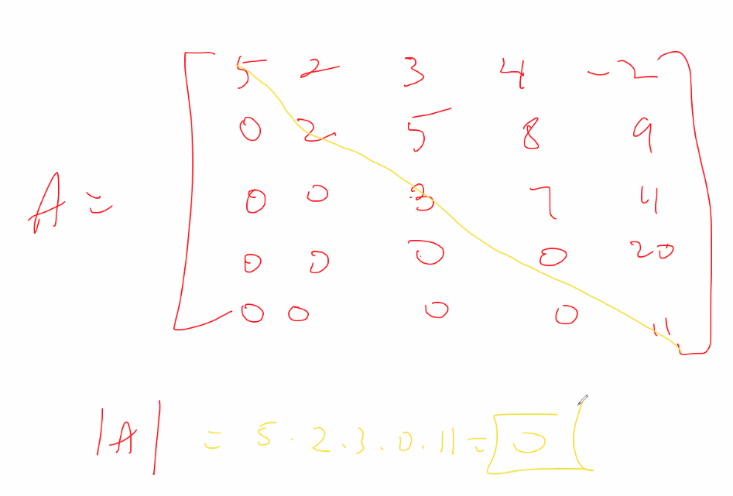
  + There are no limits for the diagonal, as long as it is a diagonal nxn matrix, or a upper or lower triangle matrix nxn matrix, you simply take product of the diagonal to find the determinant
* Interchanging rows or columns of n x n matrix A
  + 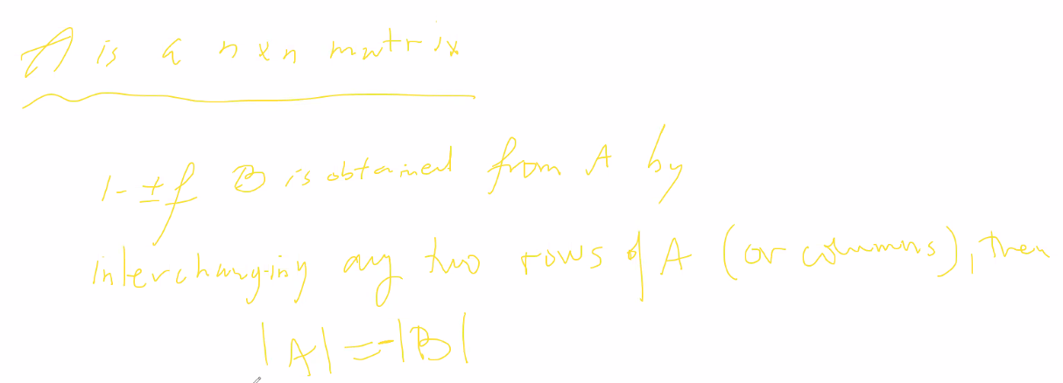
* 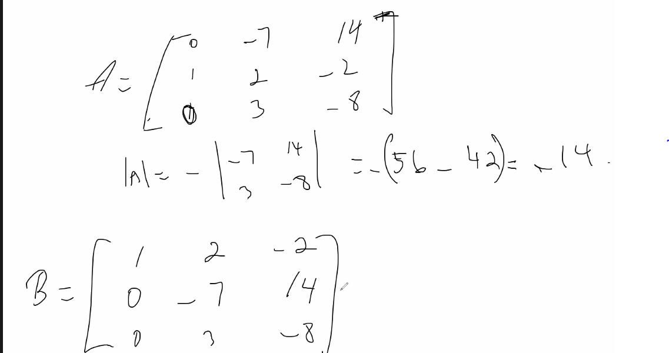
  + Notice above, B is formed by interchanging row 1 and row 2 from A, then the |B| = -|A|.
  + It is simply because then i+j when you take cofactor expansion at same position In B will become one more or one less depending on the interchange, thus (-1)^(i+j) will cause the sign of the determinant to be inverted
* Strategy: reduce rows to form as many 0s as possible before finding determinant; of course the more 0s involved the easier and faster it will be to do the cofactor expansion to find determinant:
  + 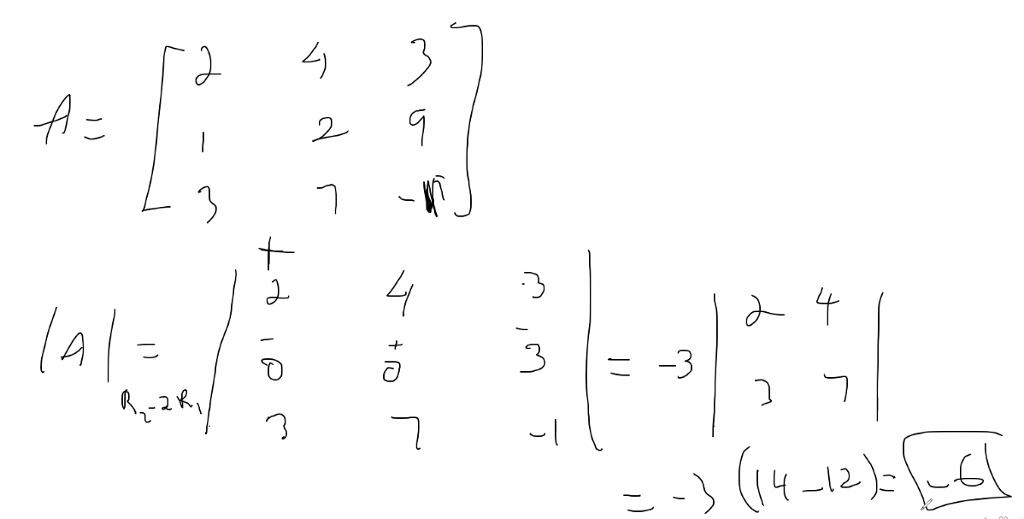
  + Notice above, reducing doesn’t give as much of an advantage, but with larger matrices it is smart to make as many 0s as possible
* Properties of determinants
  + 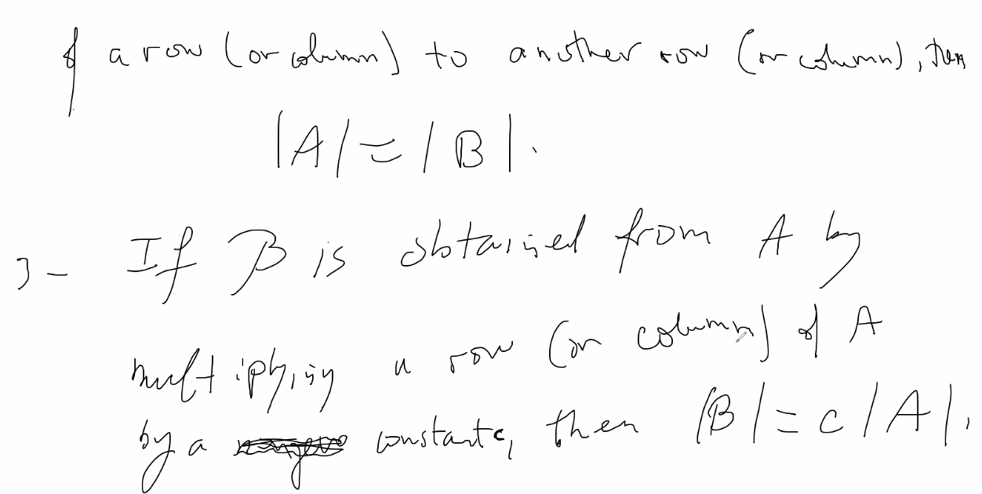
  + 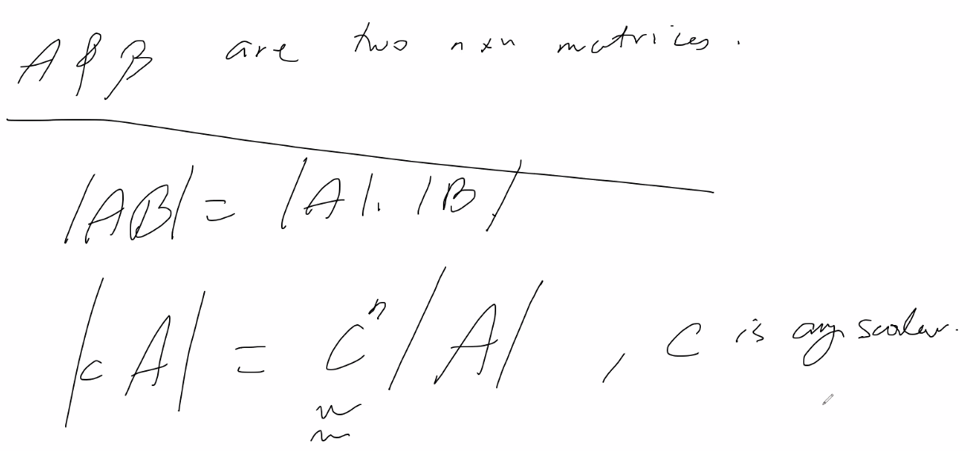
  + Example
  + 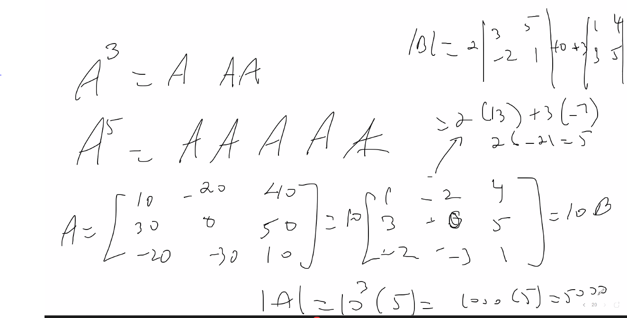
  + Notice above, factor out scalar 10, then when you find determinant, you have to include that factor but by c^n, so 10^3 (n x n matrix, with n =3) and multiply it by determinant found after factoring; so solution is 10^n * 5 = 10^3 * 5 = 5000
* 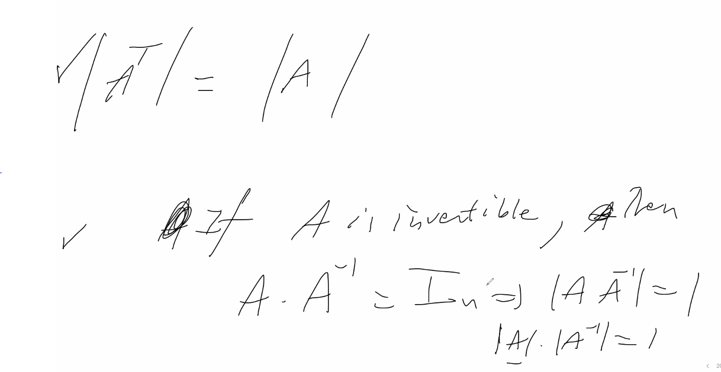
  + Above, shows that if A is invertible, then its determinant is never 0
    - Thus: A is invertible if and only if the determinant of A is not 0
    - But we still have to prove the other direction (we will do this later, but it can be proven it is bi-directional)
  + 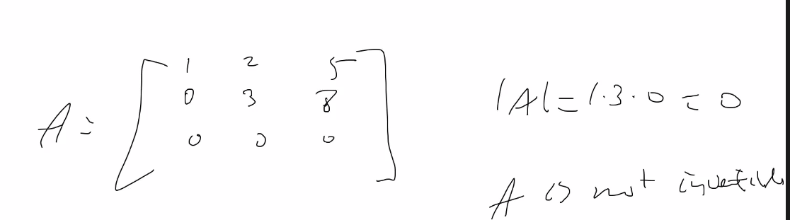

# Lecture 11 – 6/03/21 – chapter 4 (covers also concept from 2.8) – vector spaces

* Vector spaces
* 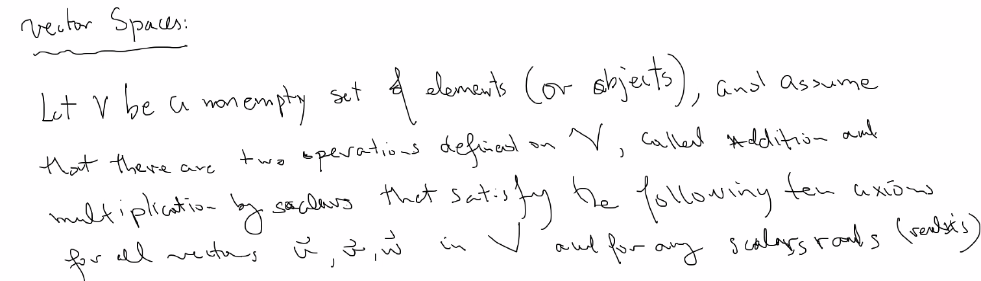
  + Ten axioms:
  + 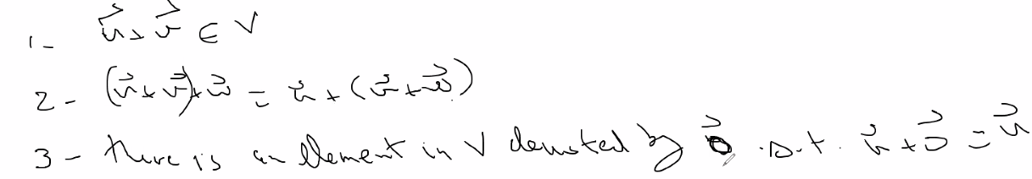
  + 4- u+v = v+u
  + 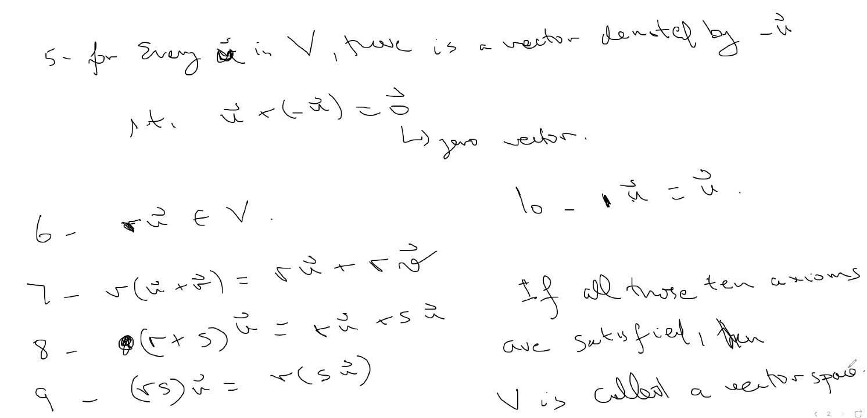
  + Example of a vector that is not a vector space:
  + 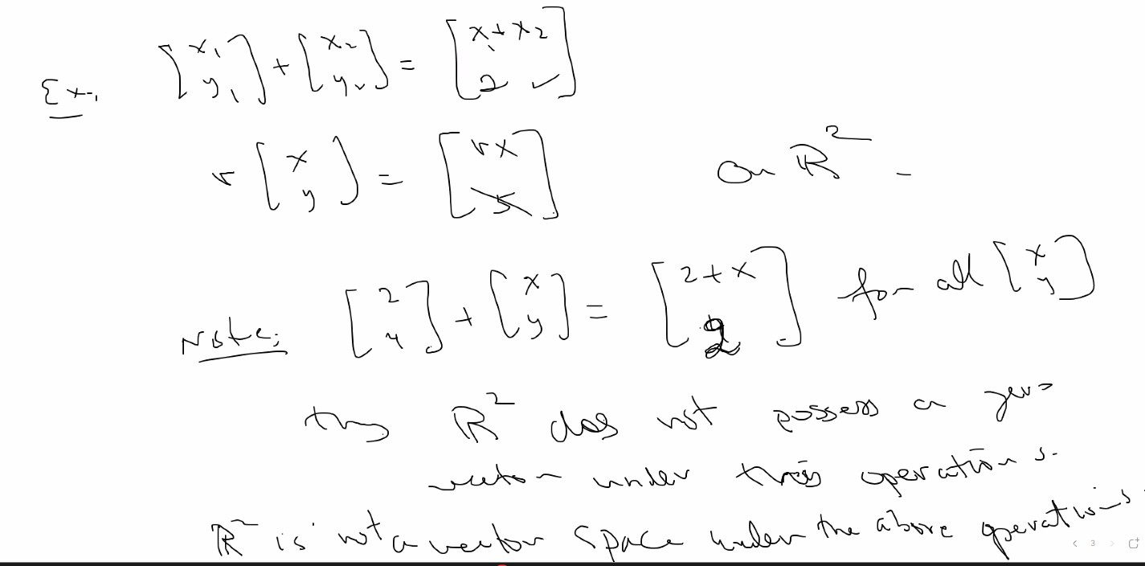
* 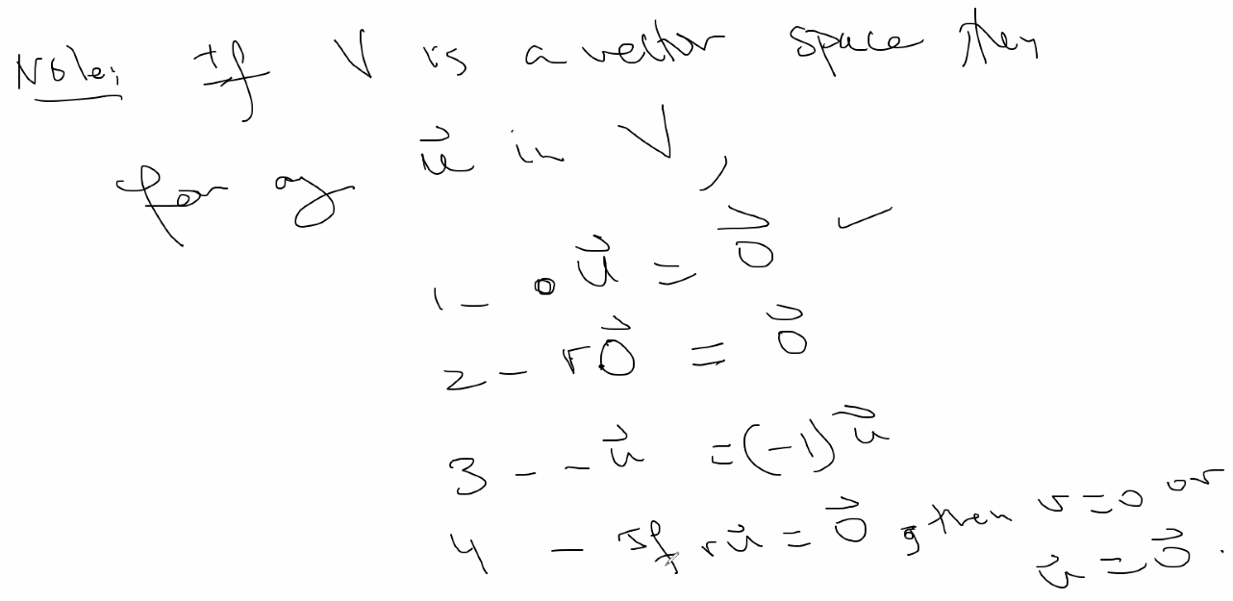
  + Above, those properties are not as obvious for vector/matrix multiplication depending on the type of elements in the vector
* Pn
* 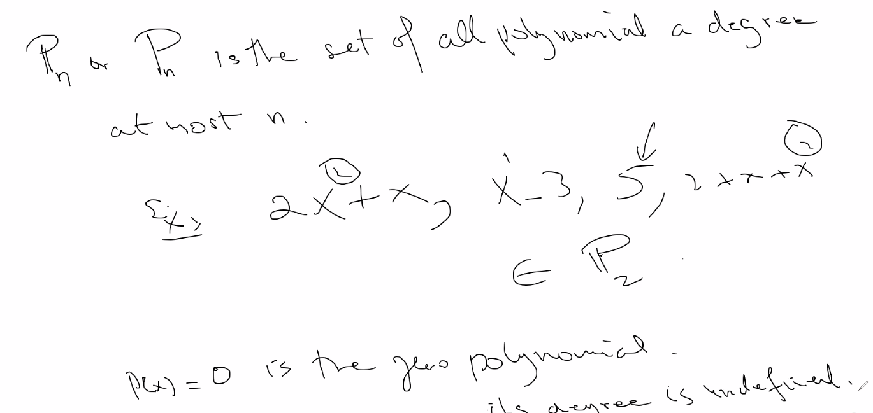
* Properties of Pn that make it a vector space
* 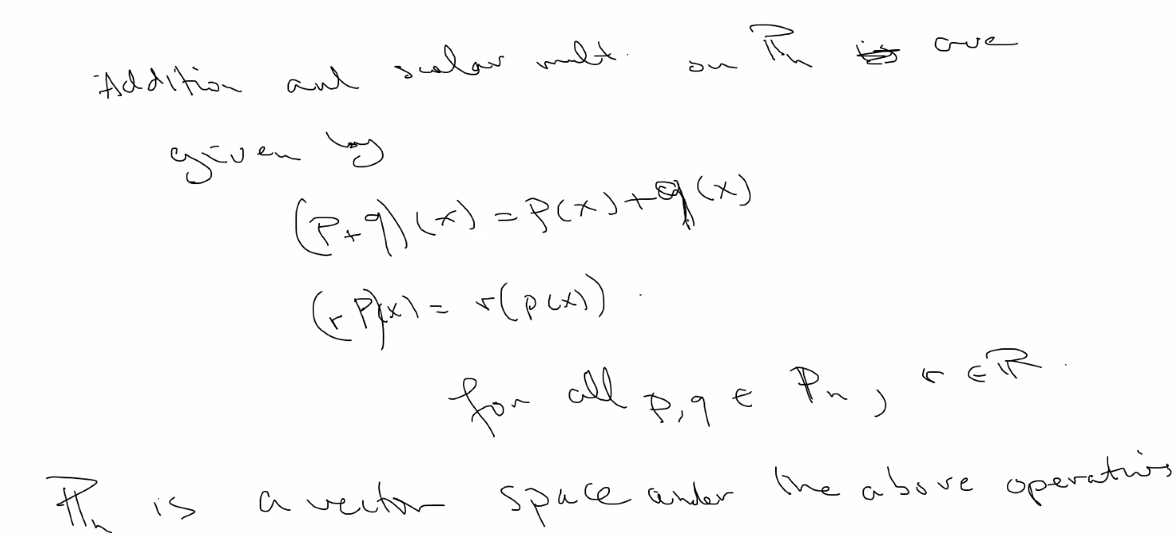
* Webwork notations and notes for hw; examples of vector spaces:
* 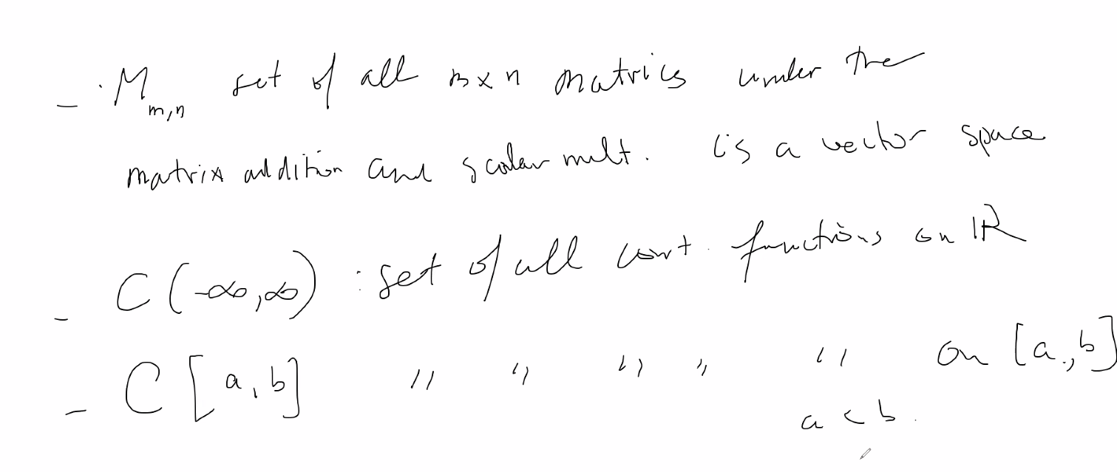
* 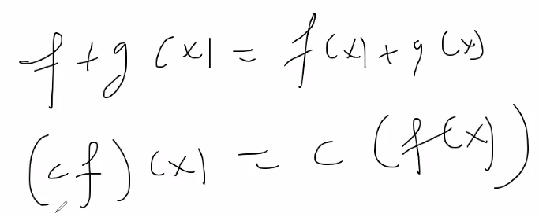 here is addition and mult. Properties applied to functions of the form f(x)
* Subspaces:
* 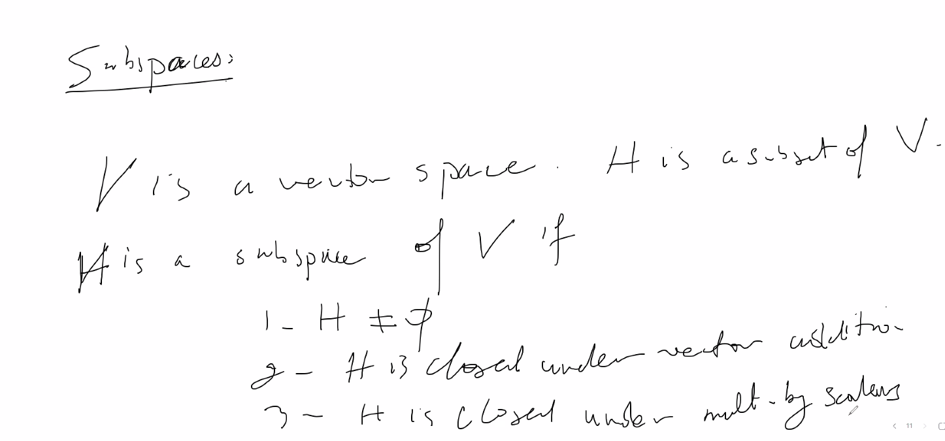
  + The other 8 axioms after 2 and 3 are inherited as long as we prove those (2 and 3) for H as a subset of V; but also prove that 0 vector is in H so that you know H is not empty
* Example:
  + 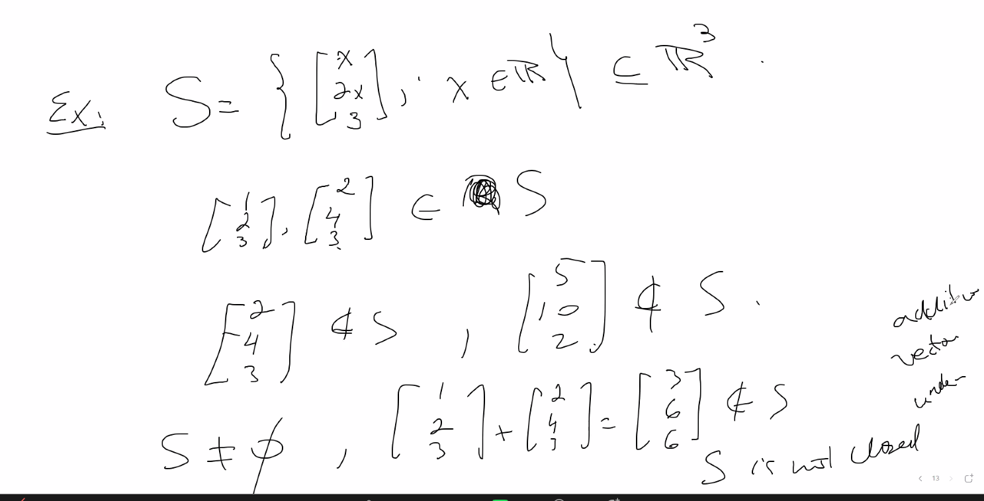
  + Above, the vector is a **subset** of vector space R3
  + Notice S is not a **subspace** of R3 because the vector addition property does not hold; thus S is not a vector space and thus cannot be a subspace of any vector space
* Another example:
  + 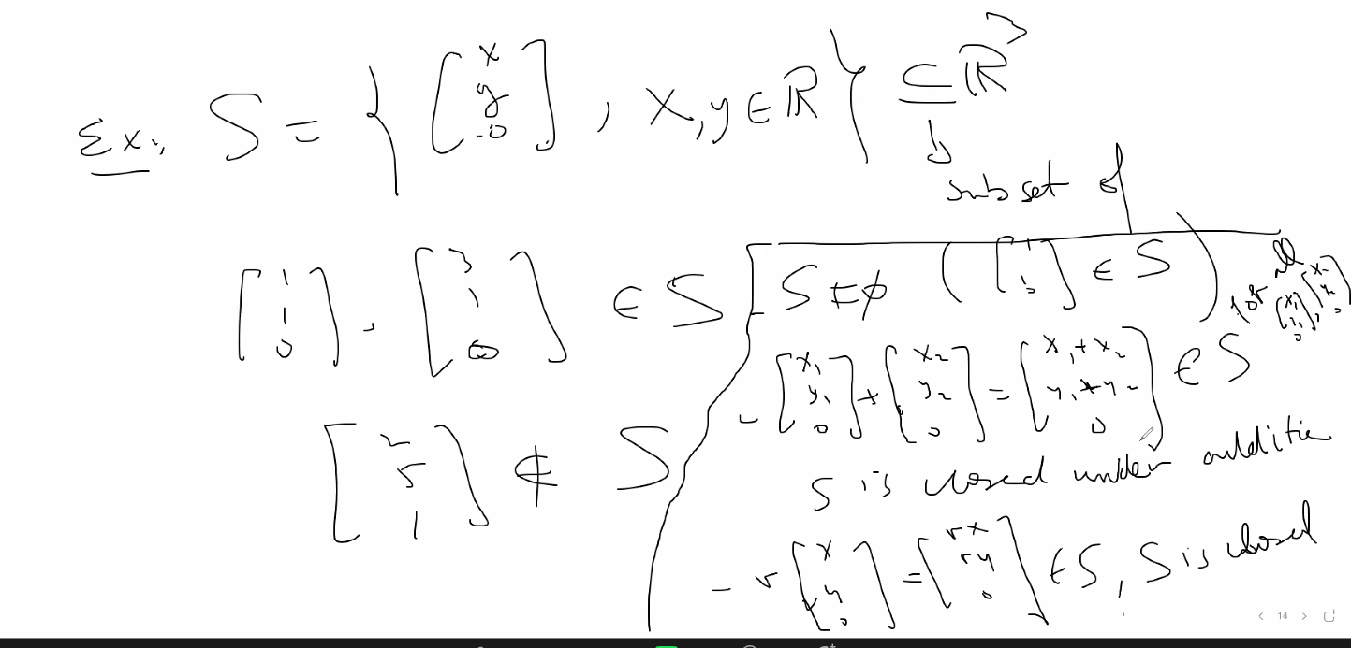
  + 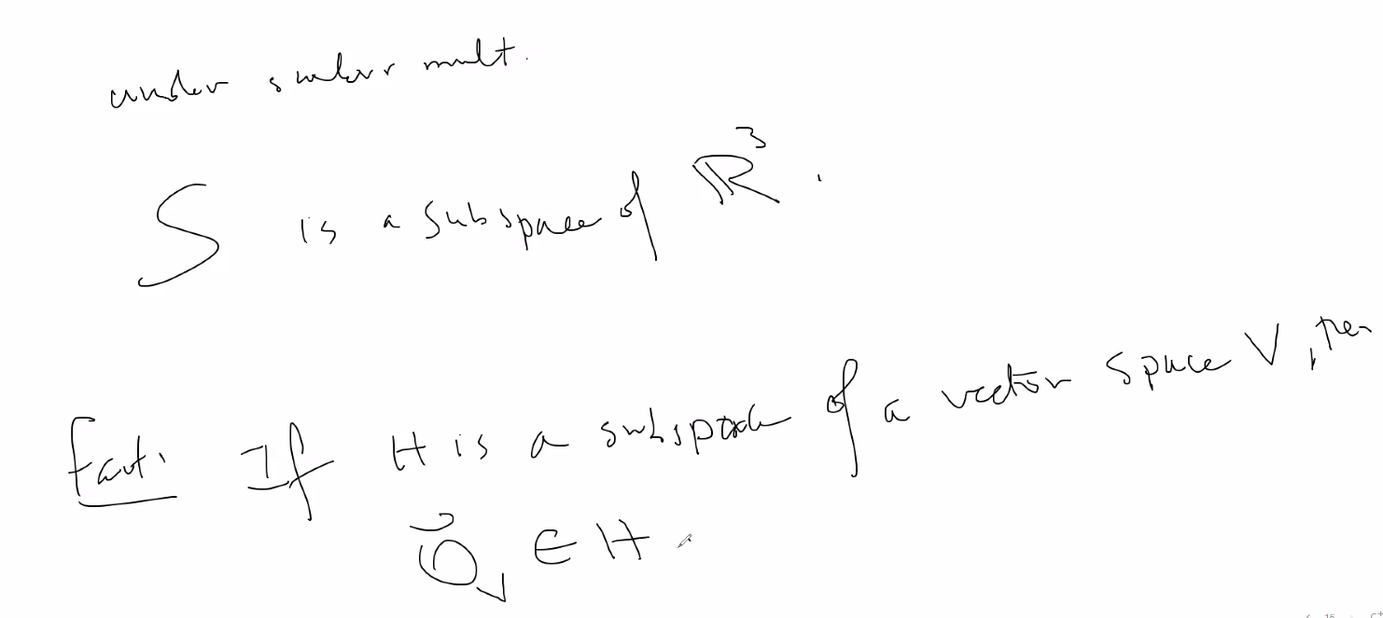
  + Above, S is a **subspace** of R3 since vector addition and scalar multiplication properties hold for elements in S, and S is not the empty set; also since H is a subspace of V, then the 0 vector of V is in H (because since scalar mult holds, we can use the 0 scalar)
  + An example of a subset that appears to be a subspace of R3 is this:
  + 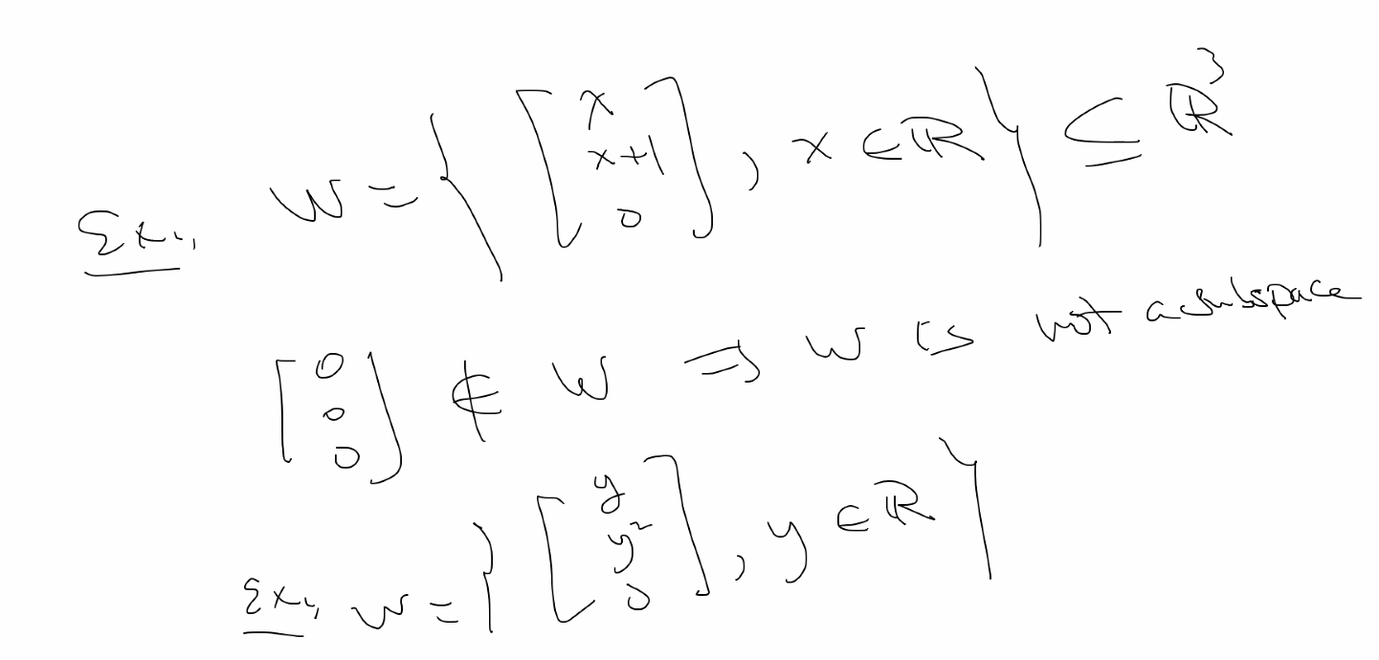
  + Mult and addition holds, but 0 vector is not in W, thus W is not a subspace of R3 since one of the 10 axioms for a valid vector space says 0*u = 0; but in the case above 0*u will result in a non-zero vector
  + Also in the other w example, it is still not a subspace of R3  even though it does contain the zero vector ((0*u) = 0 vector), but it does not hold for other properties (the 3 main ones to prove, or any of the 10 axioms of vector spaces)\
* Linear combinations and spans
  + The span of any vector is always a subspace
  + 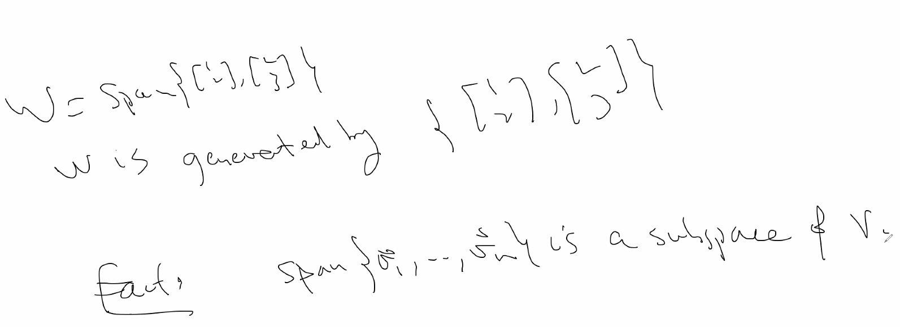
  + Clever way to show a S is a subspace:
  + 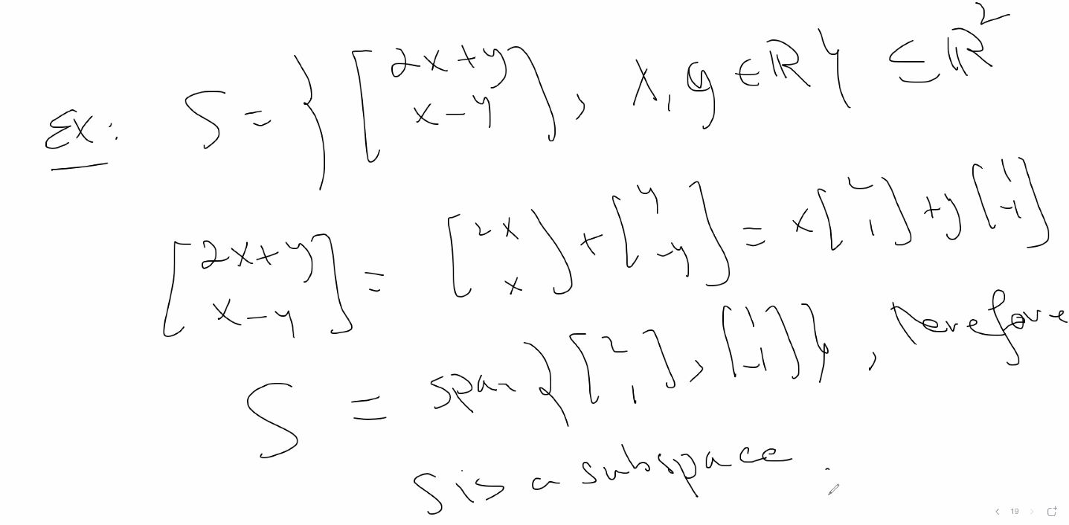

# Lecture 12 – 6/07/21 – chapter 4 (covers also concept from 2.8) – vector spaces (page 200 in textbook)

* 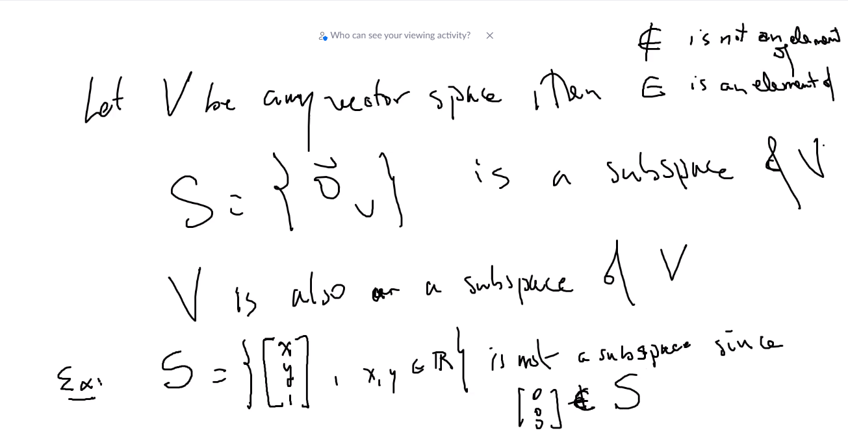
  + Notice above in ex 1, S is not a subspace since it does not contain the 0 vector
* 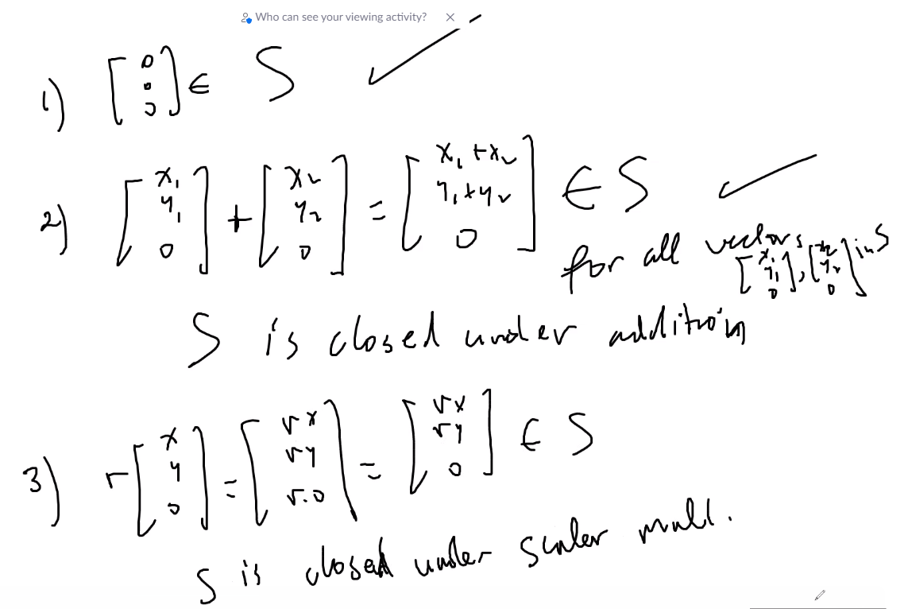
  + Above, for example 2, S = (x, y, 0) and we use the 3 rules to determine if S is a subspace, which it is since the 3 properties are shown true
* Linear combination refresher:
  + 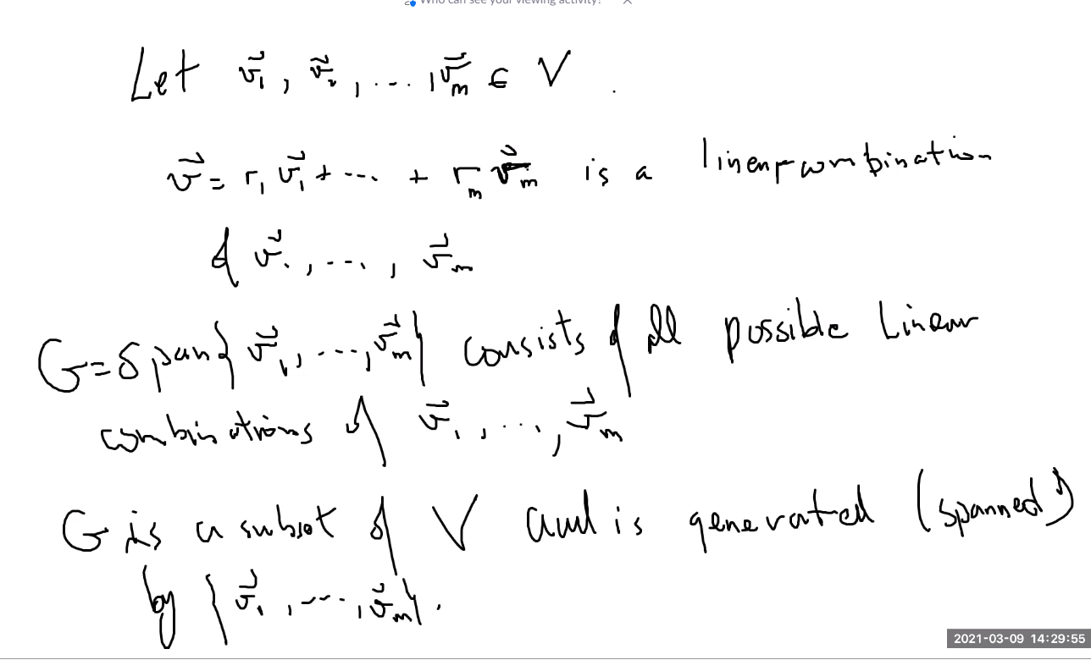
  + 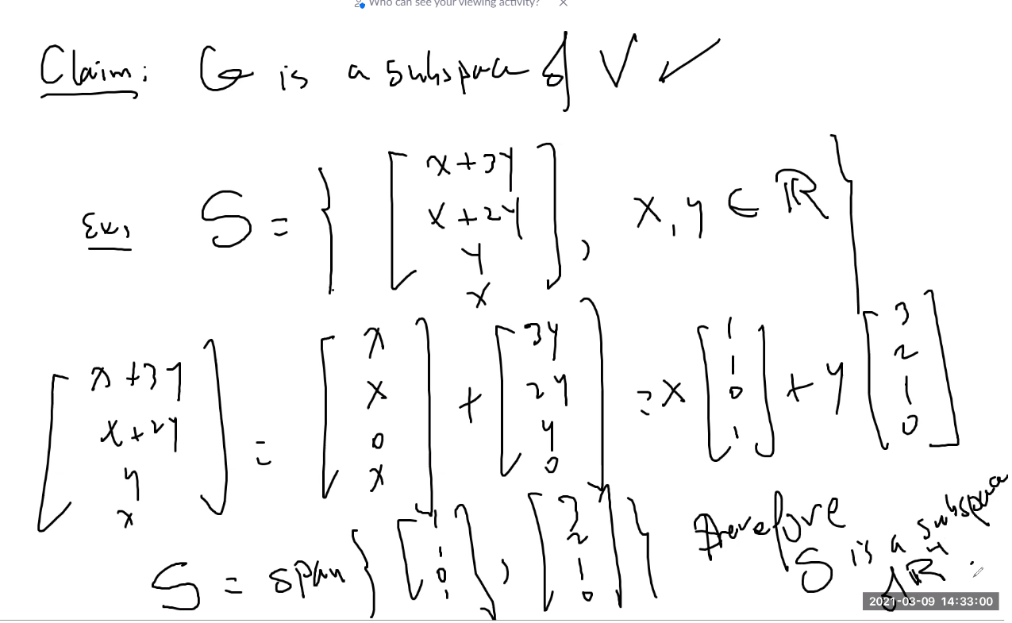
    - Above, states that a linear combination from the span of a subspace V is itself a subspace of V, so instead of using the 3 rules, if you see that all elements are a linear combination of the elements of V, then we know that it is a subspace
* Null Space of a matrix
  + 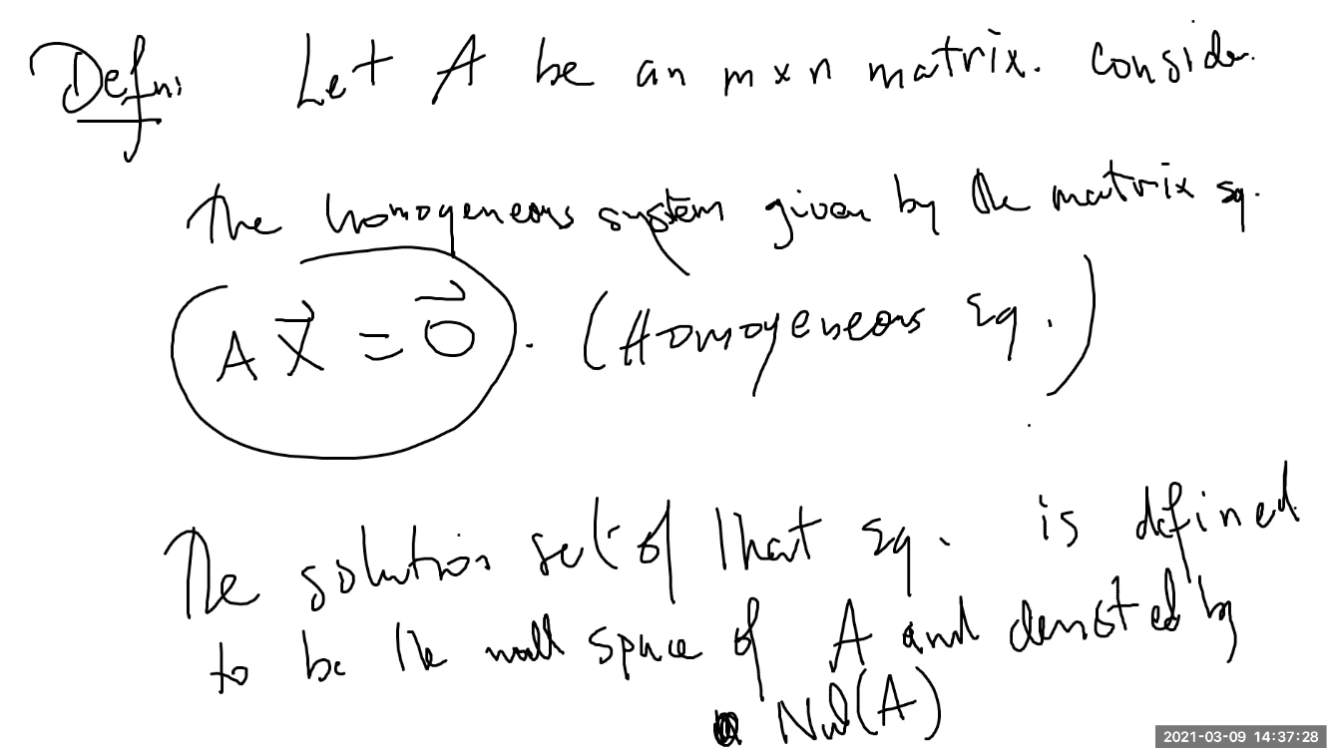
  + 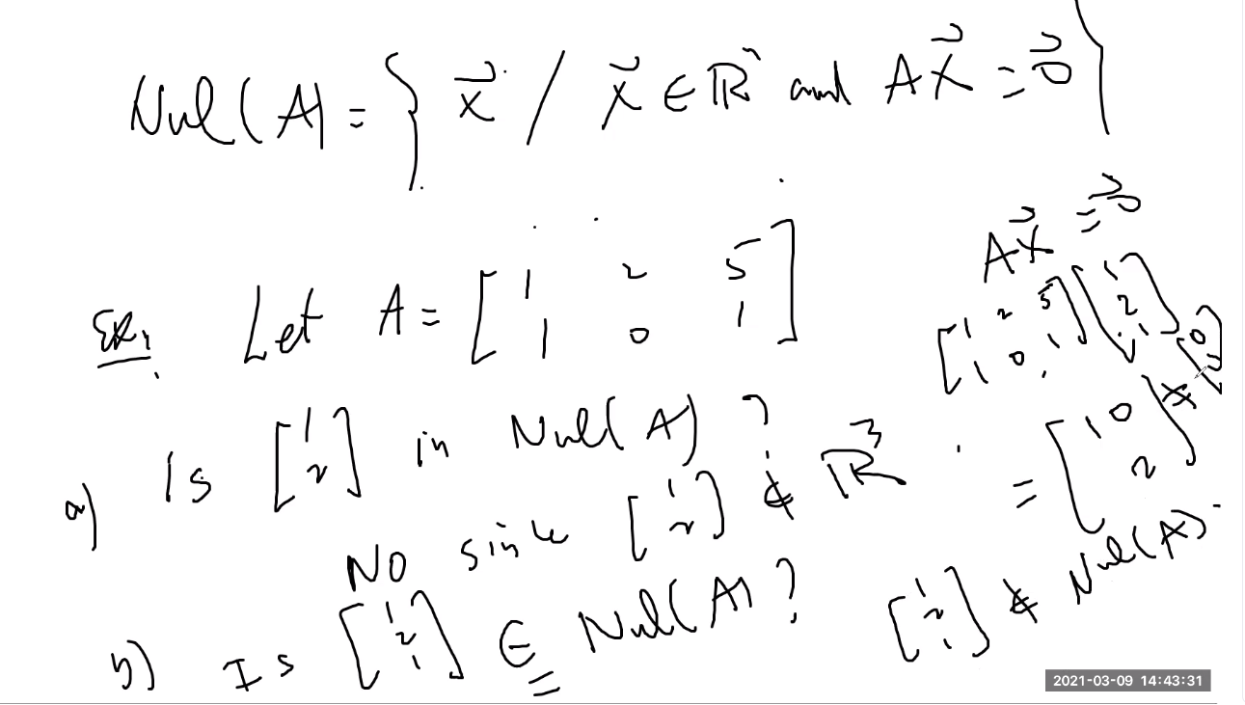
  + Null space is all about: is a vector the solution to Ax=0 that is = the 0 vector; it is simply determining if a given vector is a solution to the homogeneous system (system = 0)
  + 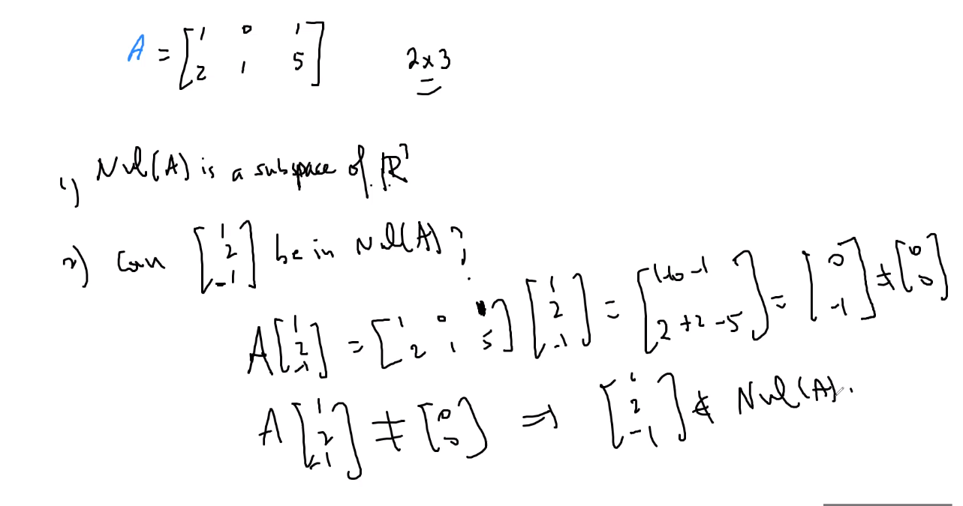
* 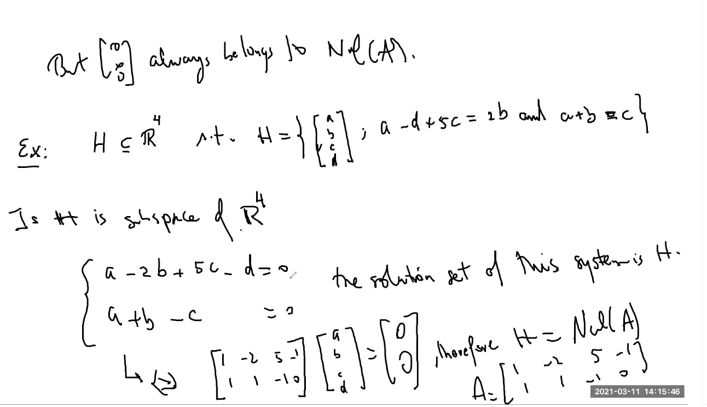
  + Above, the solution set of the system is H because those things must be satisfied for H
  + Thus, H is a subspace of R4 since we are able to find a null space of H
  + Thus also, if you have a matrix mxn A, if you can find a vector where Ax = 0 , a null space, then you know the vector x is a subspace of Rn
  + There may be multiple vectors x where Ax = 0, thus you know you have a span of null space of A:
  + 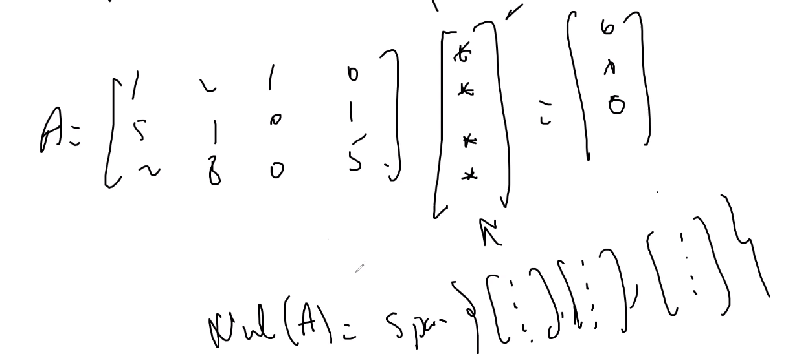
  + Put a matrix Ax = 0 into an augmented matrix, and find all solutions for vector x, thus, you can find the span of the null space of A 🡪 Nul(A)
  + You can note that if the solution set has any free variables, then the Nul space span of A will be infinite (there will be several vectors and linear combinations of those vectors to give you the 0 vector); see example:
  + 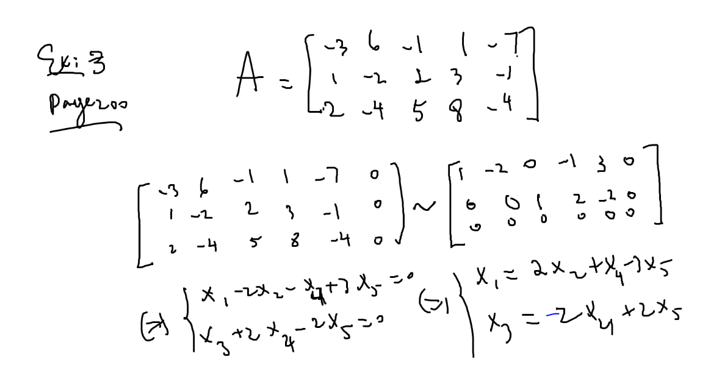
  + 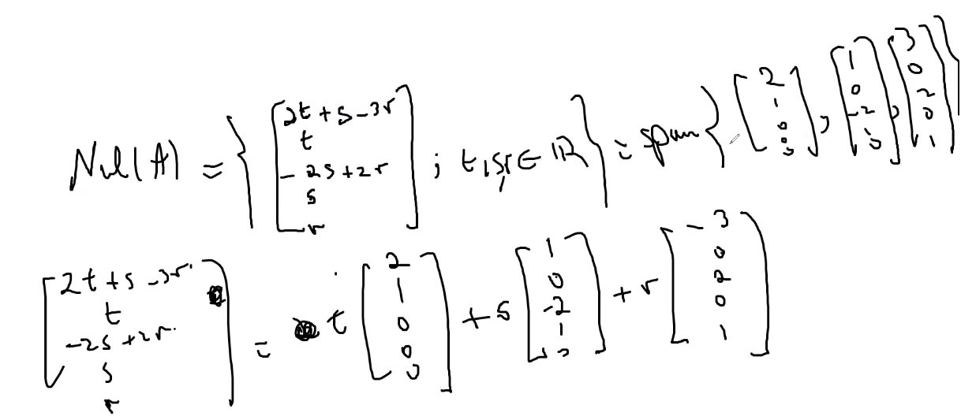
  + The solution is linearly independent (homogeneous)
  + So linear combinations of those vectors, or one of those vectors singularly (setting the scalar on the other 2 vectors to 0) is a null space of R5
  + Notice number of base vectors is equal to the number of free variables
* Column Space of A 🡪 Col(A)
  + 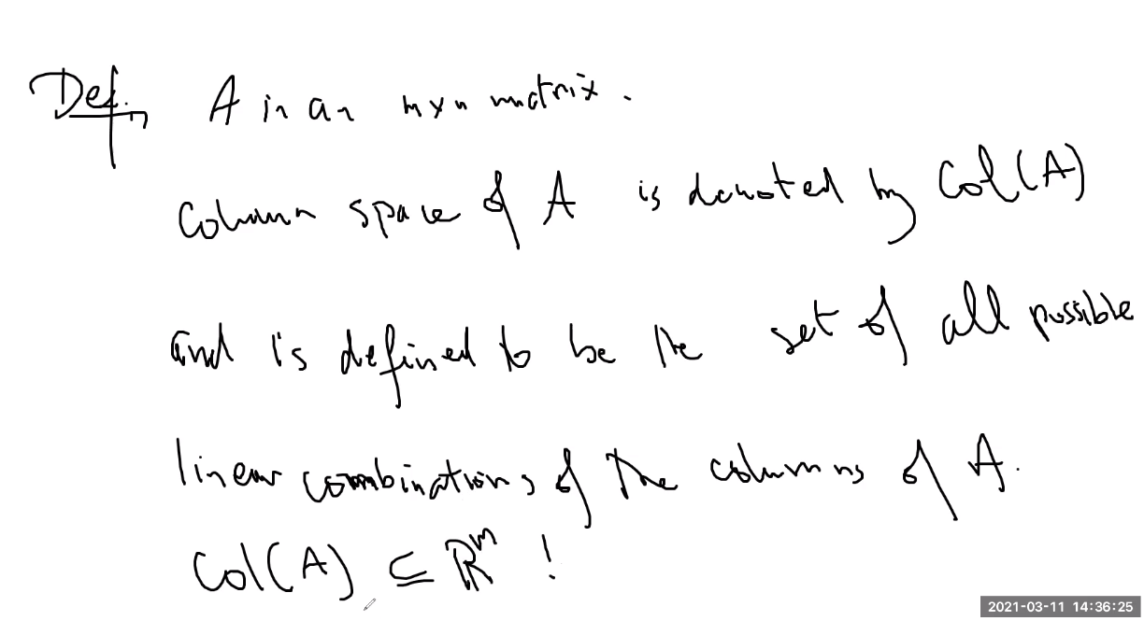
  + 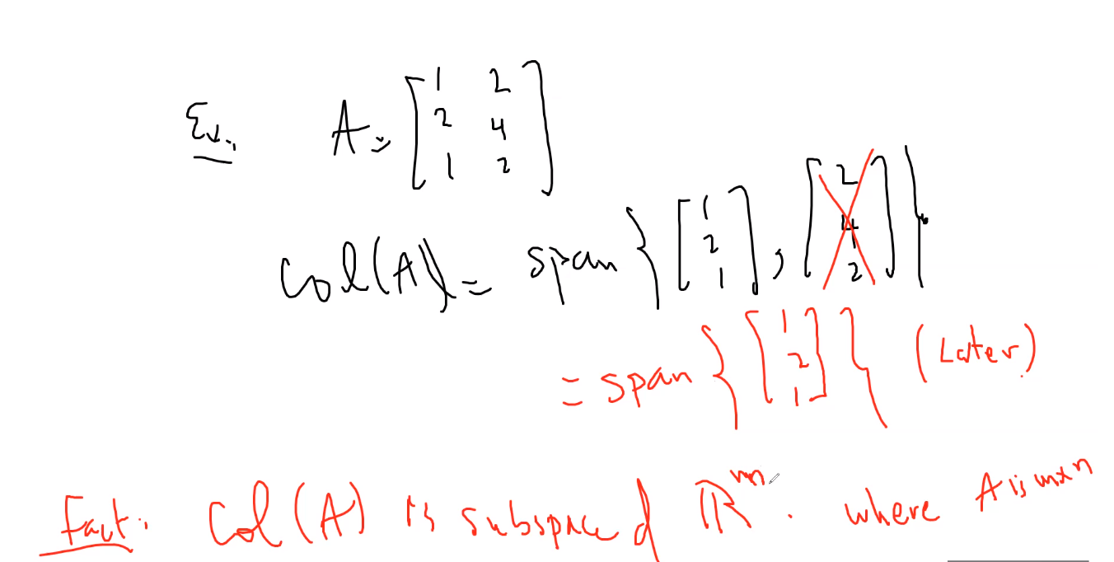
  + Above, you eliminate 2,4,2 because it is simply a multiple (and thus also a linear combination of) 1,2,1; so span is only 1,2,1
  + Remember any spanning set is a subspace of some vector space
  + 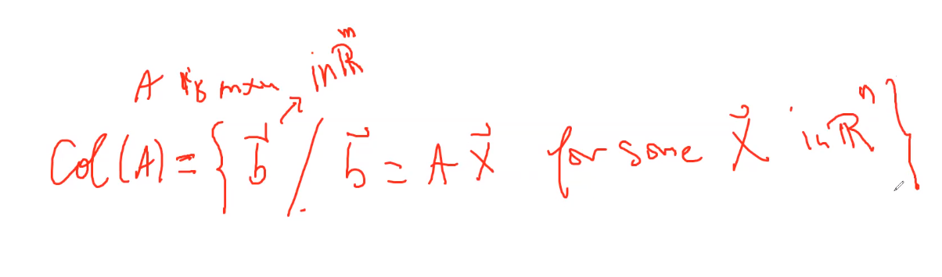
  + 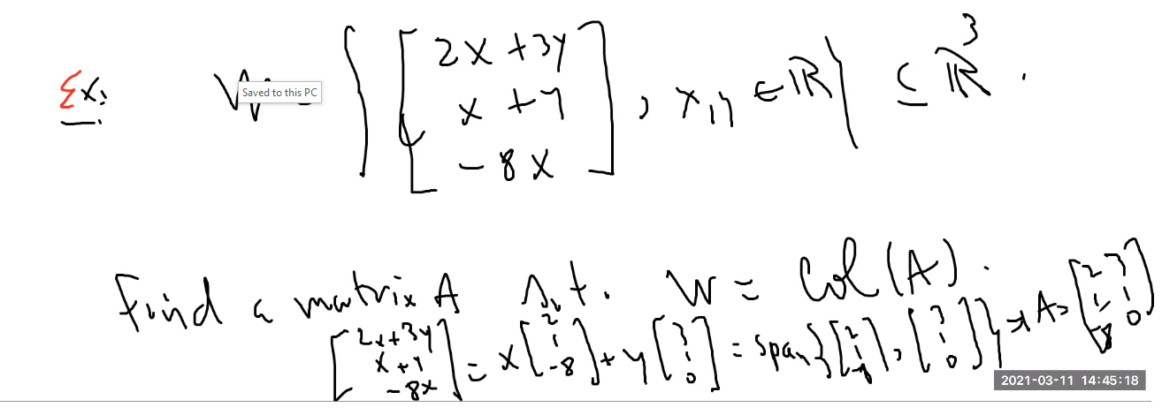
* Special case:
  + 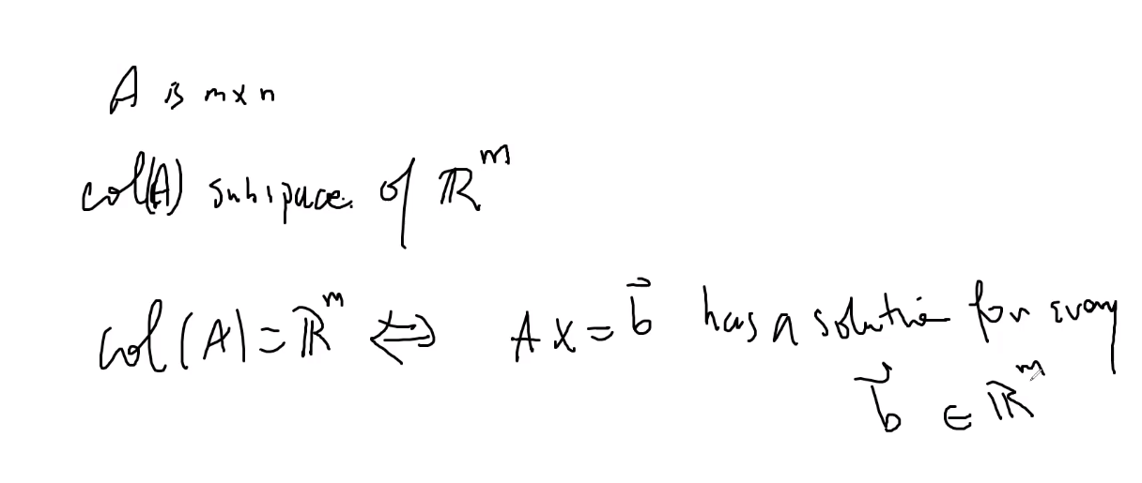
  + 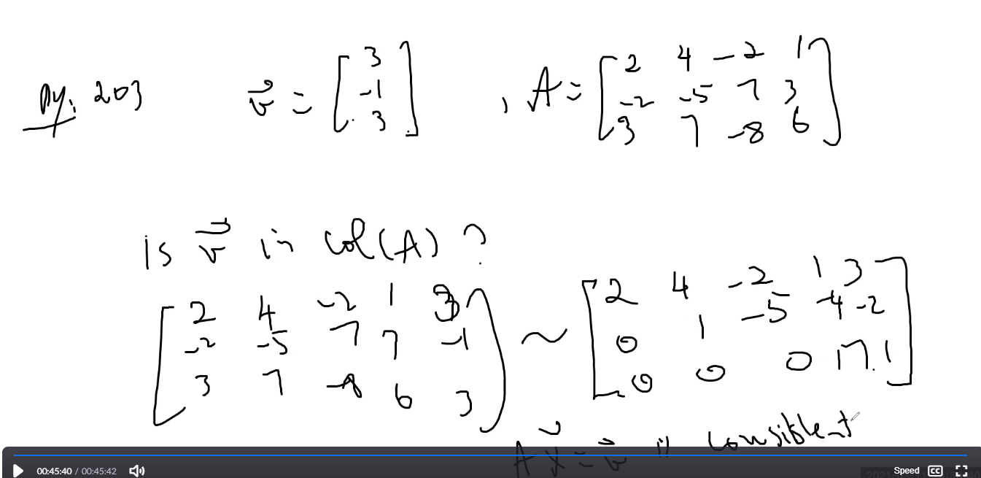
* Remember: row spaces, column spaces and null spaces are subspaces of some vector space, and they all contain the same number of vectors in their span, this is what is called Rank
* Remember the difference between Linear dependent and Linearly independent: LD = multiple vectors that can give you the solution of the 0 vector in the homogeneous system (Ax=0) because all columns of A is a linear combination of the other columns and thus has many solutions; LI 🡪: Ax = 0 has only the trivial solution (only 1 solution for x that gives you the 0 vector)
* Basis
  + 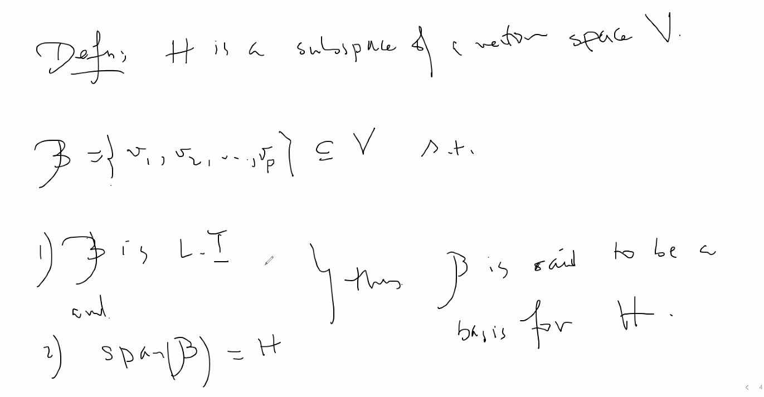
  + 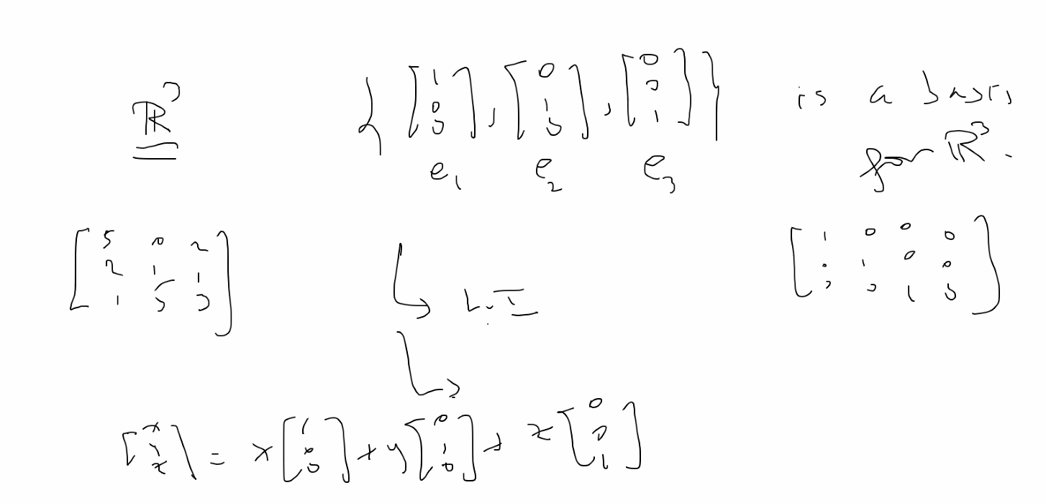

# Lecture 13 – 6/08/21 – chapter 4 – vector spaces (page 200 in textbook)

* Standard basis of a matrix A (in R3 for example)
  + Can be expressed as a linear combination of each column of the matrix:
  + 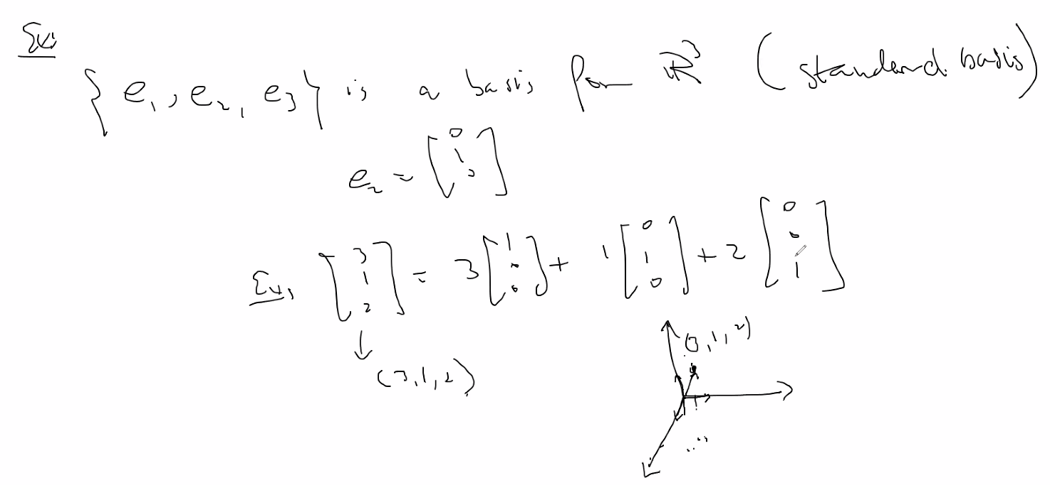
  + Another example, the set of all polynomials P2 (2nd degree) has a basis of {1,x,x2}:
  + 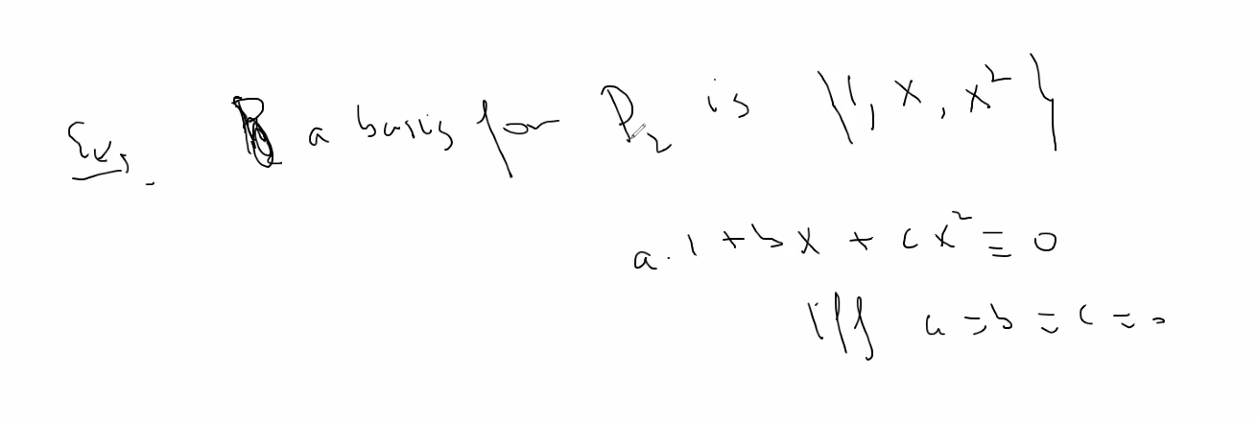
  + Above, the standard basis is of course linearly independent as shown, and can be represented by 3 vectors; thus the dimension of P­2 is 3.
  + You can also have a standard basis for an nxm matrix:
  + 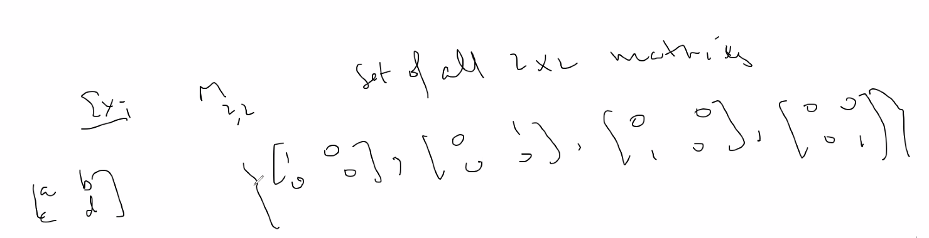
  + Above, you can define the standard basis of all 2x2 matrices using 4 matrices.
  + Also is linearly independent
* Eliminating linear combinations (redundant) vectors in a span, to leave only the vectors in the span that together in a system are linearly independent, and thus to get a basis for a vector space H:
  + 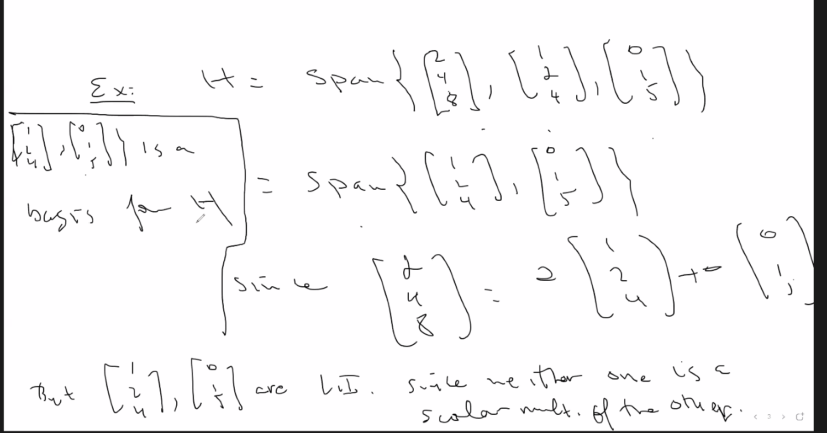
  + Note above, we only need to see about scalar multiple since there are only 2 vectors involved so it is easy to see if there are linear combination vectors of the other, if there were more then we have to see about other linear combination (for example: scalar * x1 + scalar * x2…etc..);
  + Theorem:
  + 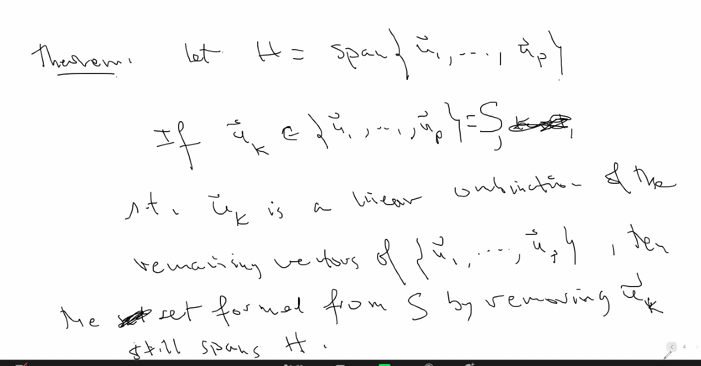
* Also remember: any non-0 vector by itself is linearly independent
* 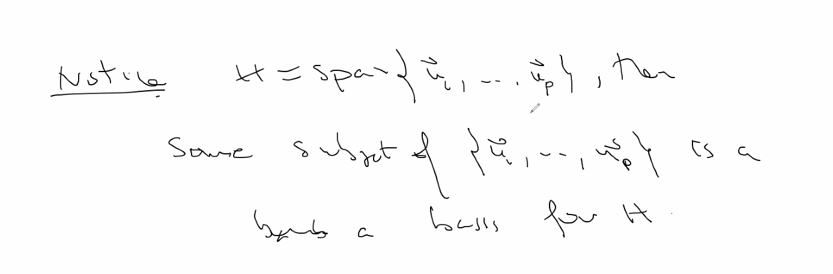
* A standard way to find the basis for a set of vectors (when it is not obvious that they are simply scalars of each other) is to put them in a matrix and apply the following:
  + 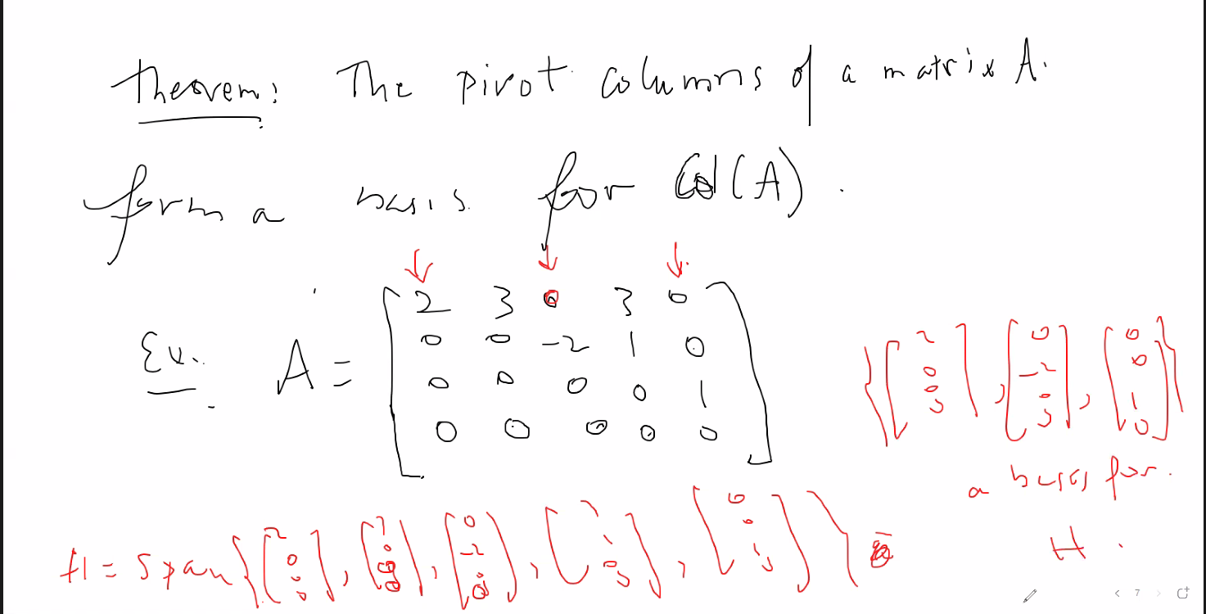
  + The pivot columns are the basis for H! 🡪 note, you only need to put matrix in **echelon form to find pivot columns; also make sure that when you find pivot columns, you must use the columns from the original matrix from which you reduced them in the matrix A to determine the basis of a vector span. So above, if A is the echelon form after performing some operations to find pivots, then find pivot columns, then go back to the original matrix and select the corresponding pivot columns to find the basis.**
* Basis and uniqueness
  + 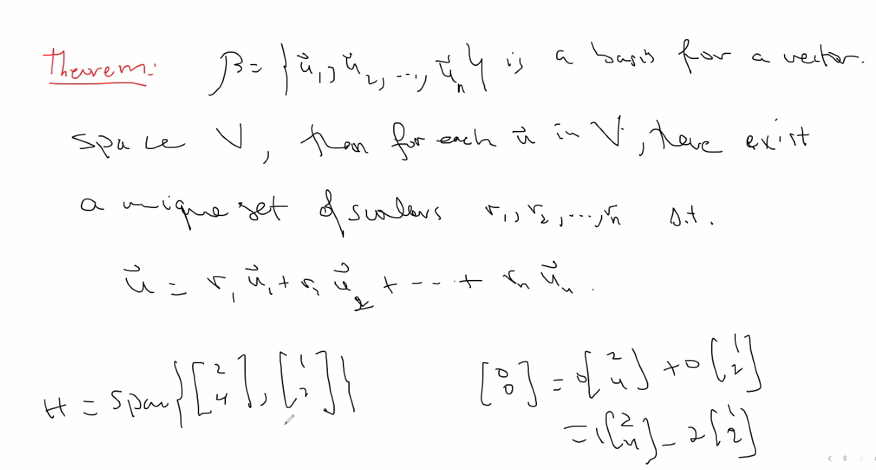
  + A basis for a vector space will be such that there is only one representation for a linear comb. Of the vectors that is equal to the 0 vector (aka, linear independence)
    - Notice above span of H is not the basis of H because there are several representations of lin. Comb. To equal 0 vector (linearly dependent); the unnecessary scalar or linear comb. Vector must be eliminated to get a span
* Coordinate vector
  + 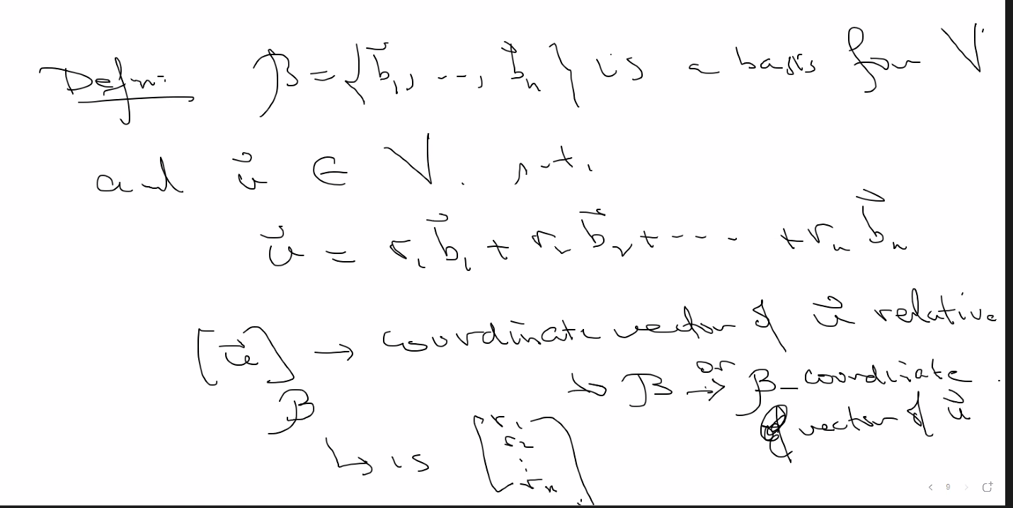
  + 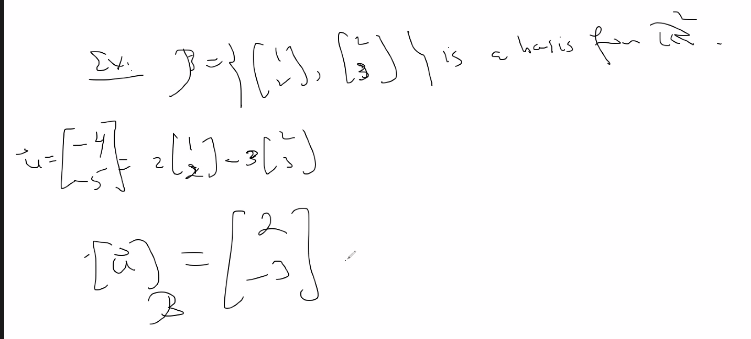
  + Above, notice u relative to b is the coordinate (vector) (2,-3) because u can only be formed from the basis B using scalars 2 and -3
  + 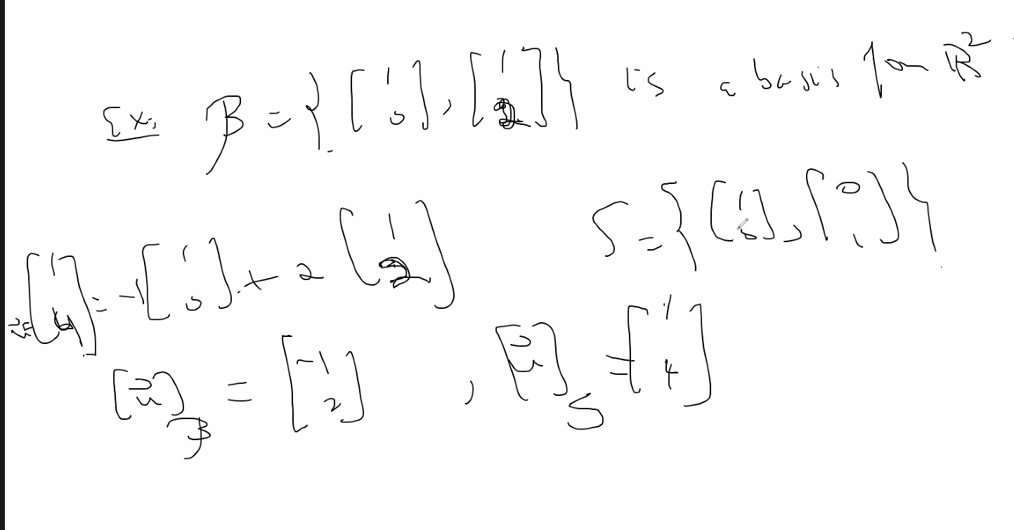
  + Above, notice another example, and also notice that for S (the standard vector space) will make it so that the u relative to S (the coordinate vector of u) is itself (u) because it can obviously be written as a linear combination of S
  + This coordinate vector can be used to make it easier to transform complicated shapes such as an ellipse by taking certain points and transforming it using the basis for relativity and it will transform the complicated shape more easily (less math involved)
  + In order to find the coordinate vector of a vector relative to a basis, simply set up a vector equation and use a matrix: so above do x[1,0] + y[1,2] = [1,4]] 🡪 lin comb. Of basis span = vector to which we are trying to find coordinate vector of relative to the basis given
  + Example:
  + 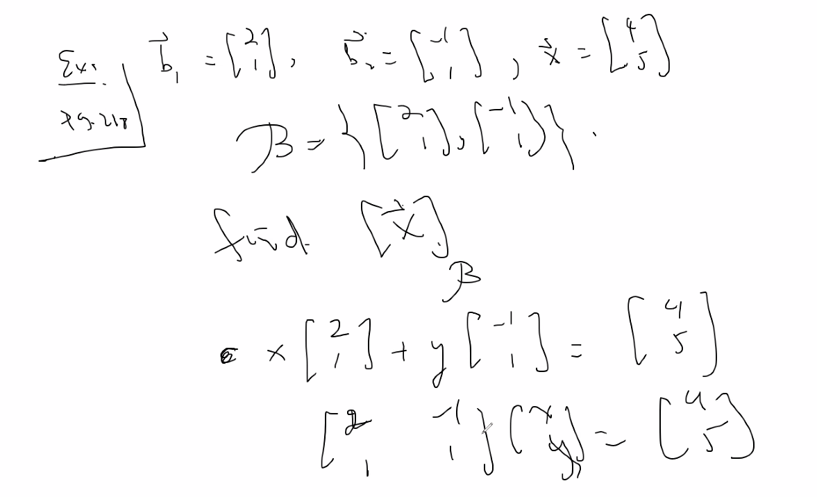
  + Above we can use shortcut because we have an nxn matrix that is invertible so we know system has a unique solution; so find inverse and multiply that result by [4,5] to find solution to x and y
  + 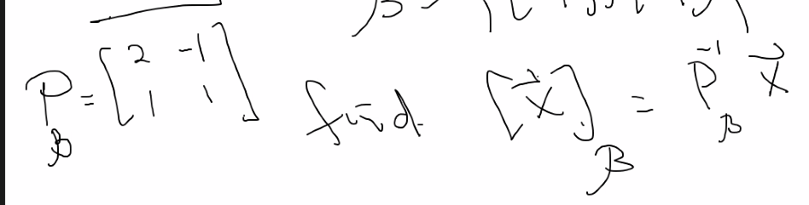
    - Alternatively you can then set up augmented matrix and reduce it to find x and y for all (non nxn, invertible) matrices
    - 

# Lecture 14 – 6/10/21 – chapter 4 – vector spaces (page 200 in textbook)

* Coordinate vectors basis
* 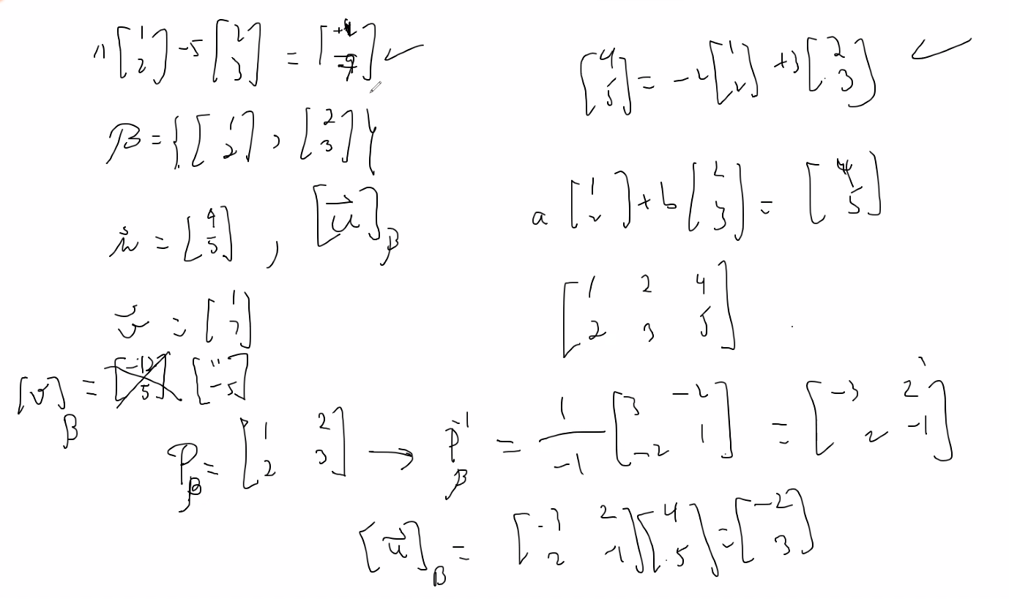
  + Above finding inverse of Pb (basis of b), then you can use that to multiply it by vectors to find the coordinate vector to which they represent the scalars for the linear combinations using space b to get the vector that was multiplied
  + Coordinate vector of u with respect to B is (-2, 3)
  + Coordinate vector of v with respect to B is (11, -5)
  + Or you could solve each using the classical augmented matrix method, but here is showing us another way by using inverse of Pb to find the coordinate vector that gives the same answer
* Basis theorem:
* 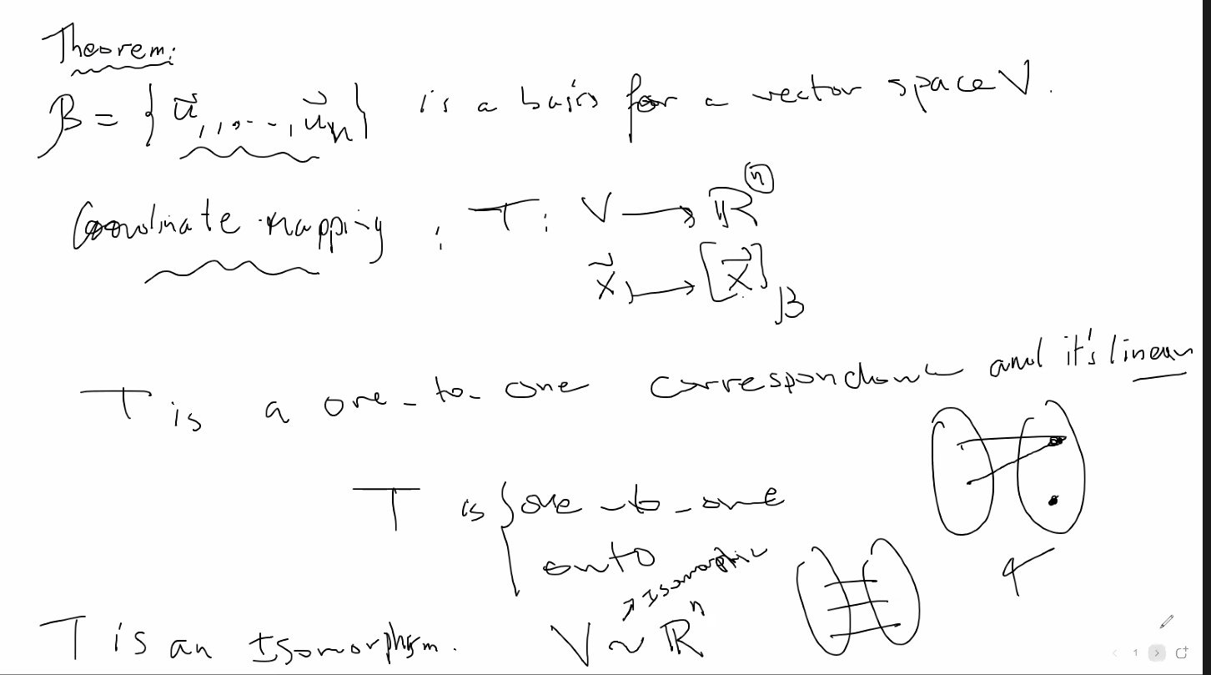
  + 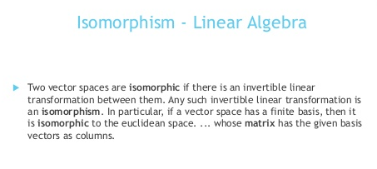
  + 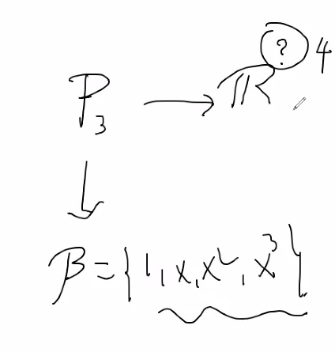
  + Above, two separate vector space representations, but they are isomorphic, so whatever you do to one space, the same affect will happen to the other space, thus they have the same properties; so you can choose whichever space/notation makes it easier to check certain transformations
  + 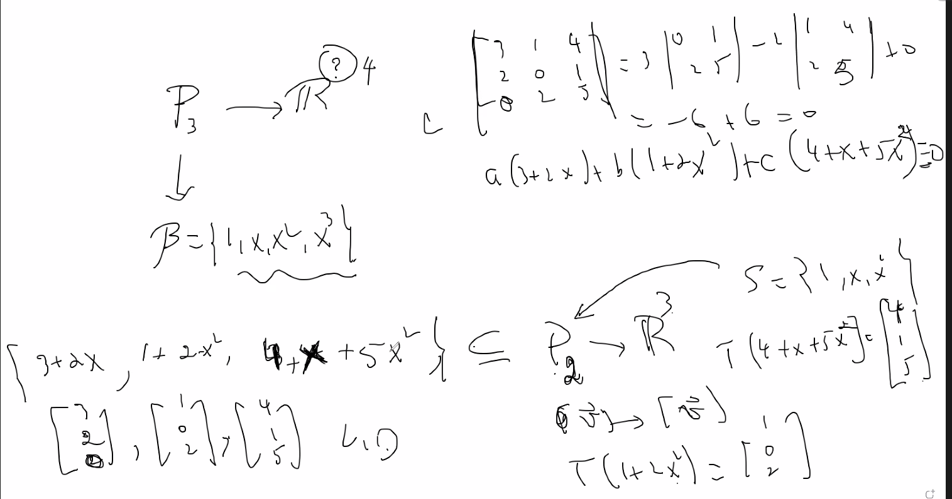
  + You can solve using the polynomial form using constants a b and c to see if the system is linearly independent or dependent, but it Is easier to translate it into its corresponding vector space, (which is always one space higher than the polynomial degree); then of course you can put it into a matrix A, and find its determinate, if determinate is 0 then we know that the vectors are linearly Dependent, and thus the corresponding polynomial space is also linearly dependent
  + **This is how you change polynomial equations with degrees into vector space form!! This is what makes linear algebra so powerful and useful for computation methods for computer architecture: Isomorphism! So even complicated functions with high degrees can be worked on using the corresponding vector space and input to a high-speed computer that will perform matrix linear algebra on the equation (and of course its only practical to use matrix algebra not only because it matches computer architecture but because computers are much faster and the intense matrix calculations are impractical to do by hand; it is mostly a language precisely for computers)**
* 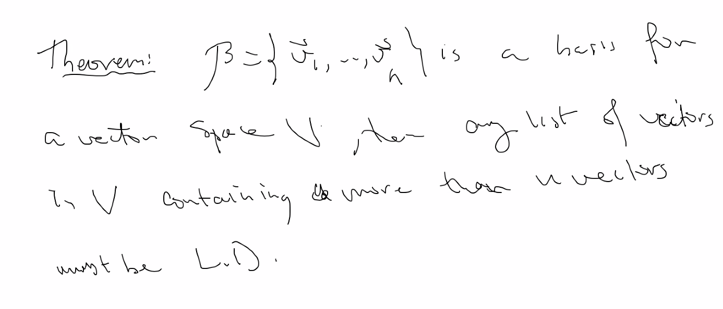
  + Above, this makes sense because if you add any vectors from space V into the basis B that you found of V, then you will have some scalar of one of the basis included, thus the set of vectors will be linearly dependent; the basis + additional vectors from V from which you got the basis will cause the linear independence of the basis to no longer be linearly independent (and thus not a basis)
  + 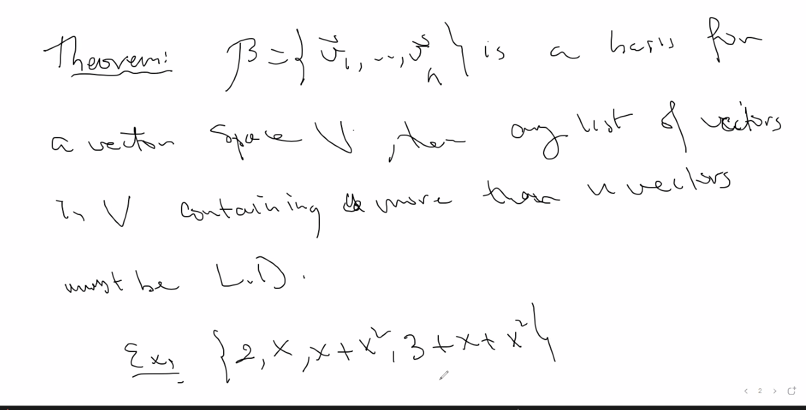
  + 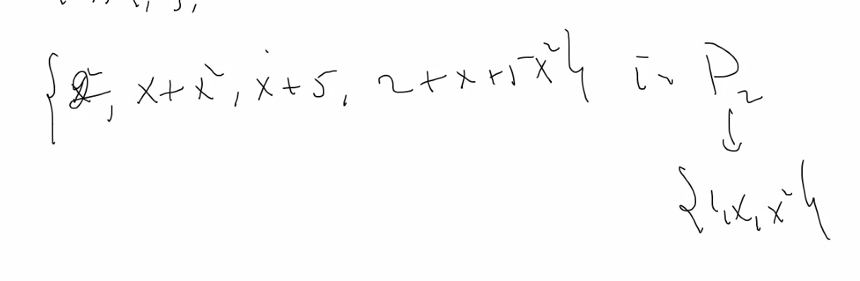
  + Above, finding the basis for the polynomial on P2 (degree to) 🡪of course R space will be 1+ degree = R3
* Describing dimensions from R space and P degree:
* 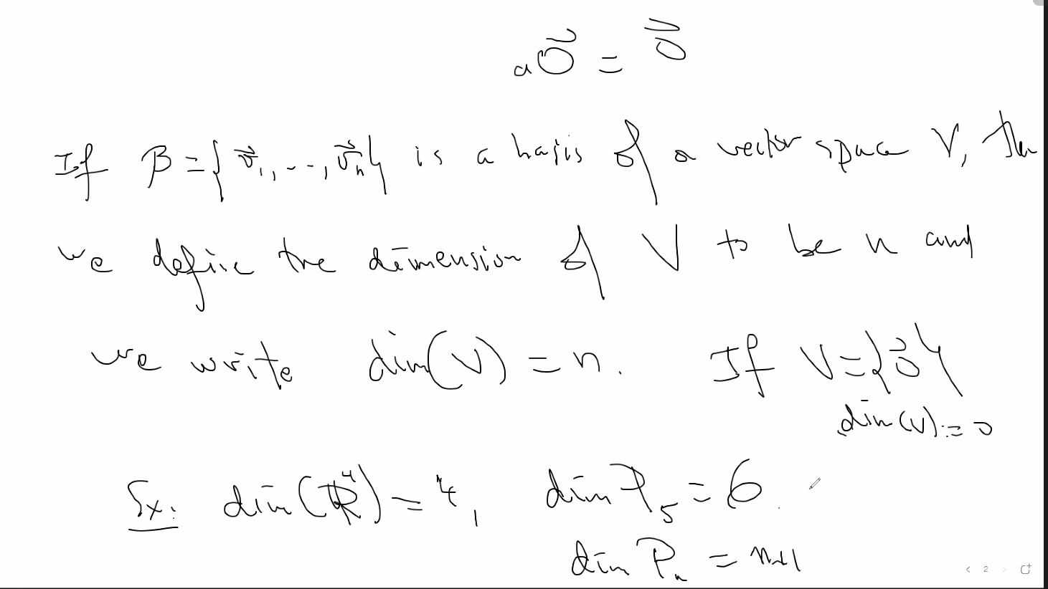
  + Notice if a vector space only has the 0 vector, it is LD, thus it has no basis; so we say dimension is 0
* Theorem of dimensions:
  + 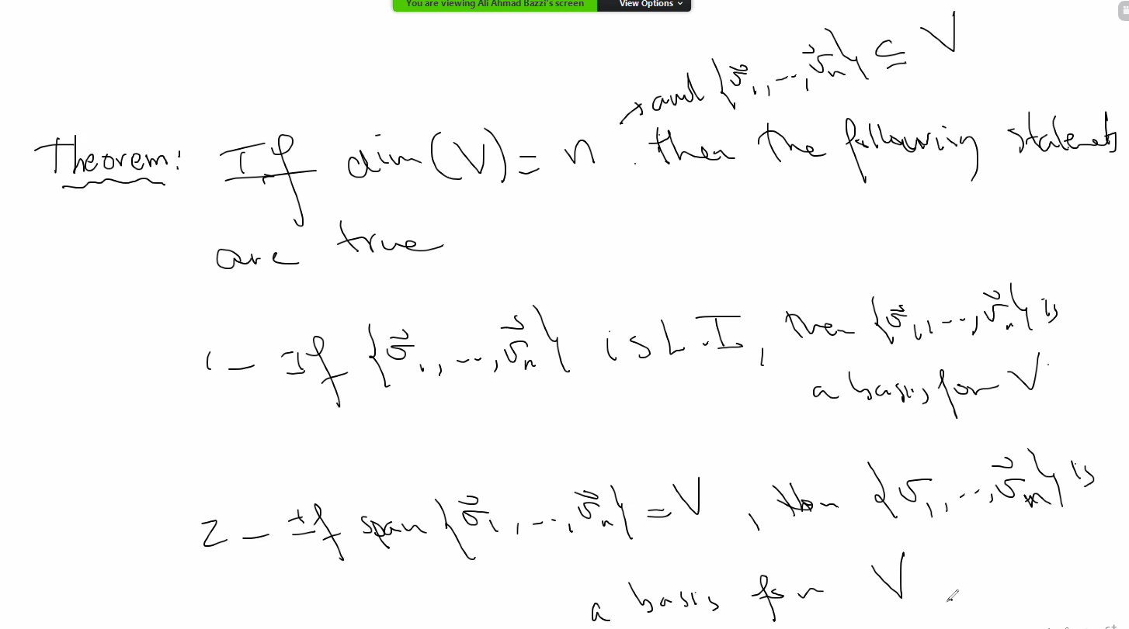
  + If you see that number of vectors is equal to dimension of space V, then check one of the above conditions to see if the vectors are a basis
  + Ex:
  + 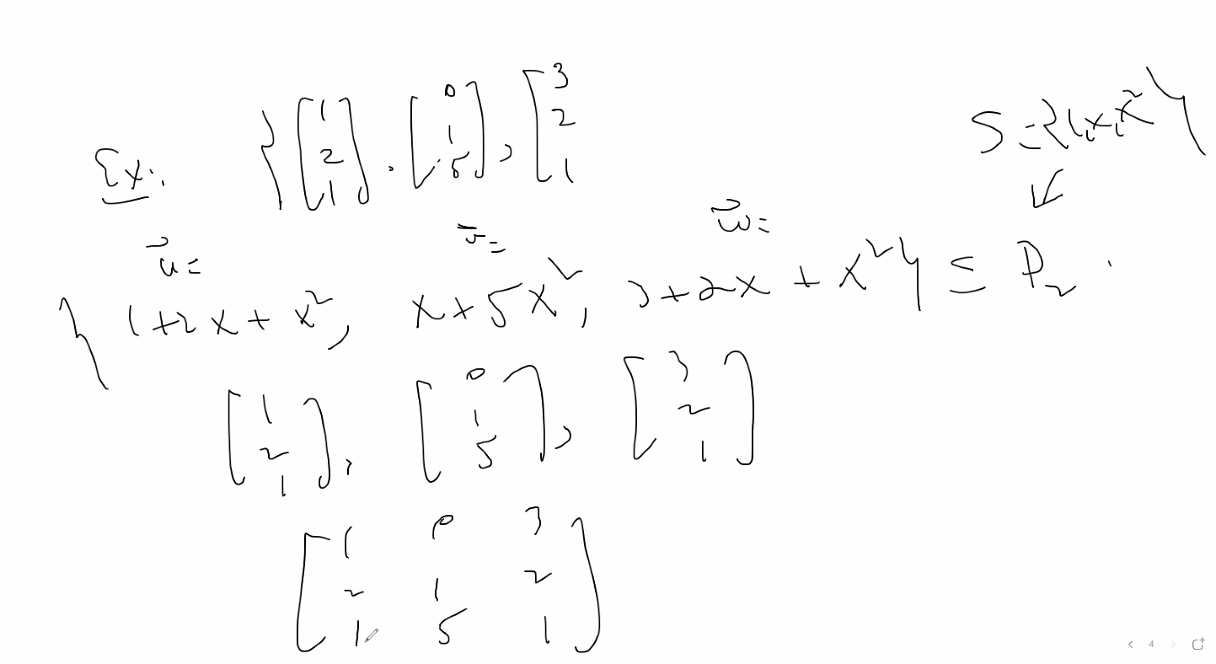
  + Above, S is the standard basis of the system of equations in P2, of course then the corresponding vector space is R3, and it is the standard basis of P2; thus we can represent each equation in P2 relative to the vector space as vectors in R3 (say vector u, v, and w), put them in a matrix, and then find determinate of the matrix, or simply reduce it and see if each column has a pivot and thus you can determine if the system is Linearly Independent
  + 
  + 
  + Remember column space is the pivot columns of A, and null space of A is the columns of free variables of A
* Section 4.6 will not be in the exam 2
* Exam will be: 3.1-4.5

# Lecture 14 – 6/14/21 – chapter 5: Eigenvalues and Eigenvectors

* Invertible matrix theorem:
* 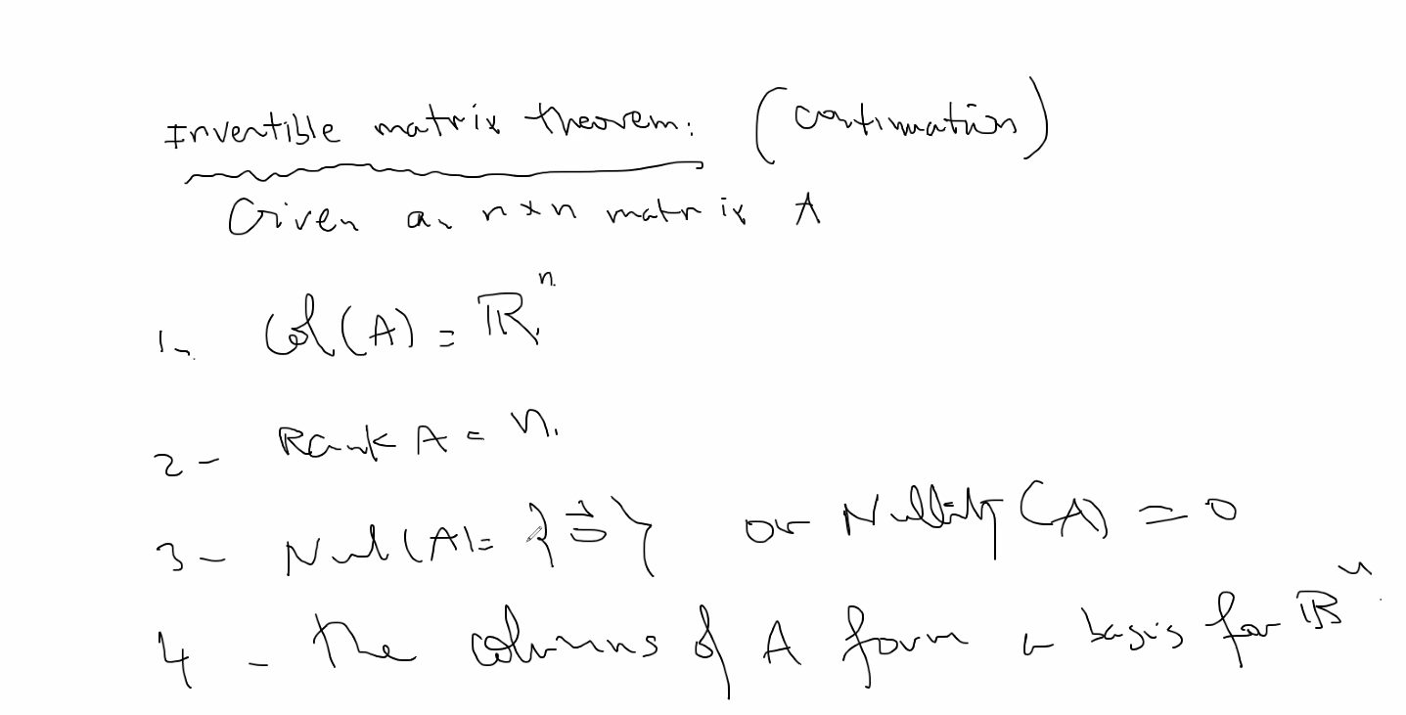
* Rank(A) + Nullity(A) = n, where A = nxn matrix
  + Nullity(A) == Nul(A)
  + Useful to determine if a matrix is one to one
* Remember row space of A (row(A)) = column space of A (col(A)) == Rank of a matrix (rank(A))
  + So pick whichever one is easiest to find for a given matrix
* **CHAPTER 5: EIGENVALUES AND EIGENVECTORS**
* 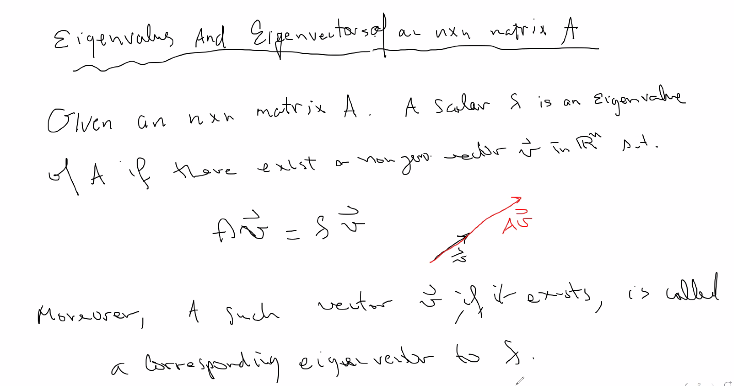
  + For computers, it is much easier to do a scalar times a vector than a matrix times a vector, so if there exists a scalar lambda to replace the matrix A that has the same effect on matrix A, then it is easier to use the scalar, which is called in such a case an Eigenvalue (non zero scalar that has same effect as multiplication to a vector by a matrix A)
  + The corresponding vector is called the corresponding eigenvector to lambda (the eigenvalue)
  + Ex:
  + 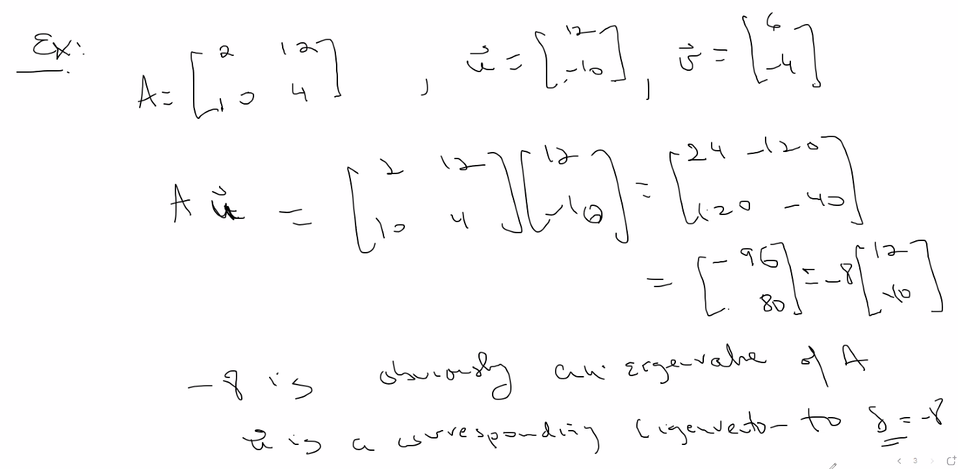
  + Above, we have an eigenvalue for Au
  + 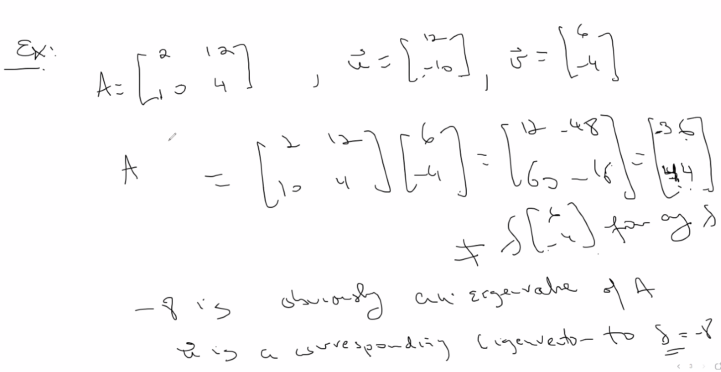
  + Above, Av does not have an eigenvalue
* Find all eigenvalues of a vector:
* 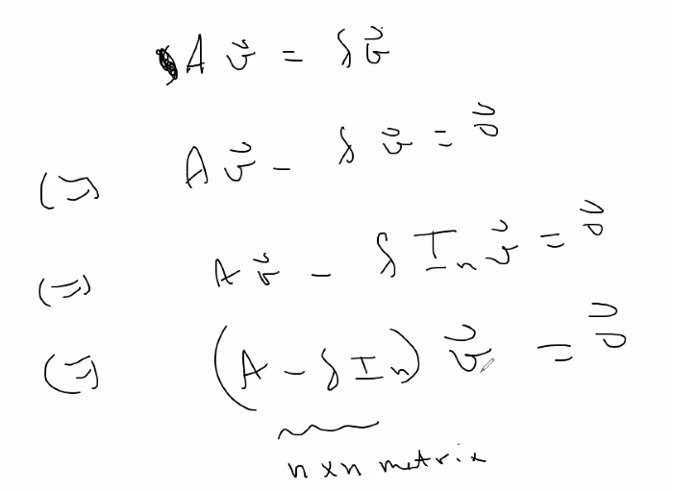
  + Now above, we have a homogeneous system that we can solve
  + Lambd * In represents the identity matrix, but with lambda in place of the 1s because you are multiplying the identity matrix by scalar lambda
  + Now, we could do the subtraction and then see if there is a pivot in every column to see if there is one solution, (and if not a pivot in every column, then there are infinitely many solutions)
    - Note: solving this and finding eigenvalue scalars is exactly the same as solving homogenous systems when finding a matrix A (other than a 0 matrix) which can be multiplied by the vector v to get the 0 vector, and trying to find how many matrices (linear combination vectors) can give you the 0 vector when multiplied by vector v; is there many solutions? Or only the trivial solution?
  + Or to easily determine, you could find the determinant; remember if determinant is 0 there are many solutions, if det != 0, there is only the trivial solution
  + Finding the characteristic polynomial:
  + 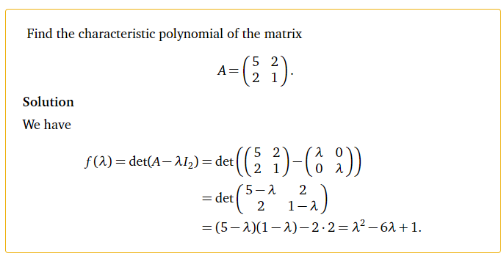
  + Another example:
  + 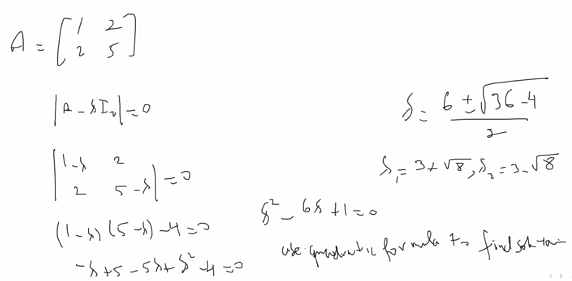
  + Now notice you can find roots with respect to lambda since we have a homogenous polynomial equation
  + Solution to lambda are the eigenvalues
  + Ex with 3x3 matrix:
  + 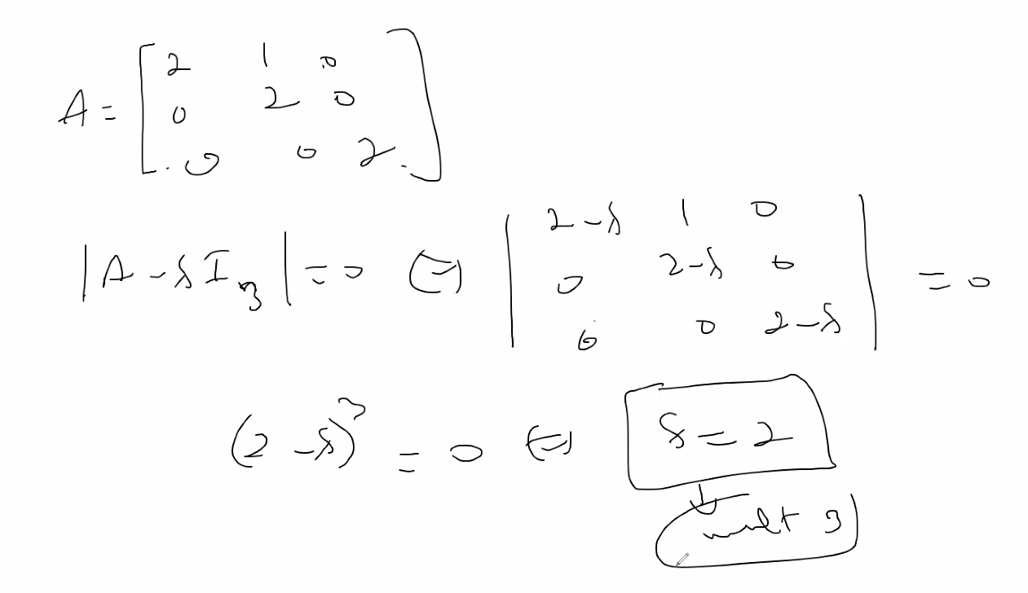
  + Notice above, solution is lambda = 2, with a multiplicity of 3 since (2-lambda)3 = 0; thus the solution is repeated 3 times
  + Also notice we have an triangular matrix, so we simply multiply the diagonals across and take the shortcut to find the solution
  + Now we can take the solution of lambda and plug it into matrix A, and then set up augmented matrix to the system and find solutions:
  + 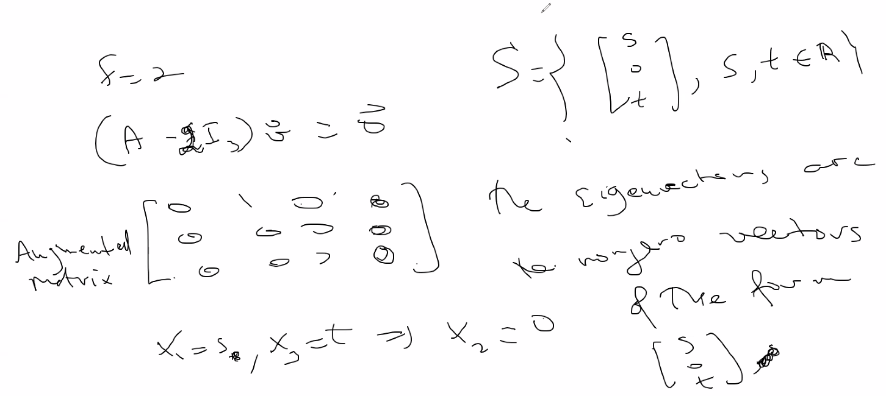
  + The set of all possible eigenvectors is the eigenvector subspace with respect to a matrix A
  + Notice x2, the only basic variable (with x1 and x3 are free), must be 0; s and t (the solution set to x1 and x3 in this solution set) can be any values as long as s and t and not both 0 at the same time (thus, the 0 vector then since all variables == 0 and is not included as an eigen vector)
  + 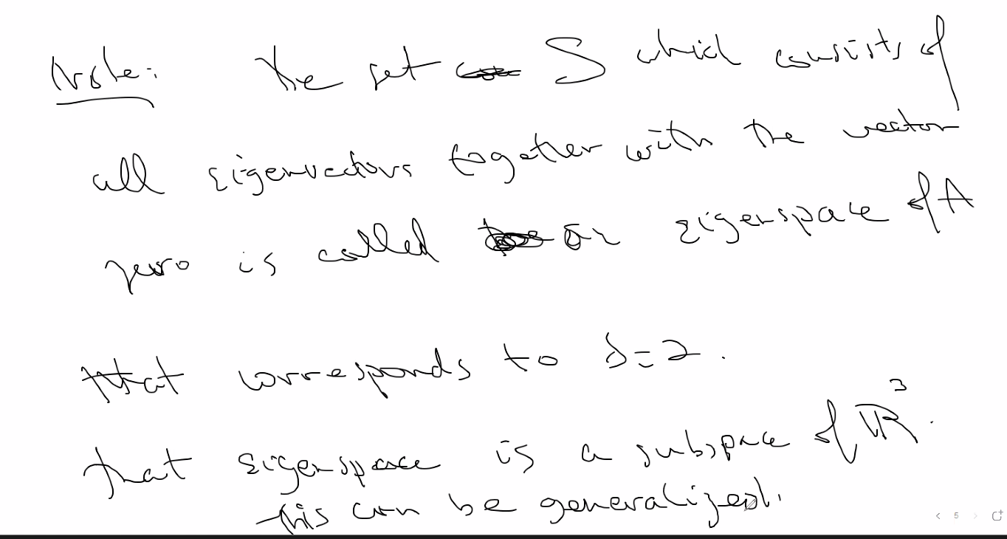
  + 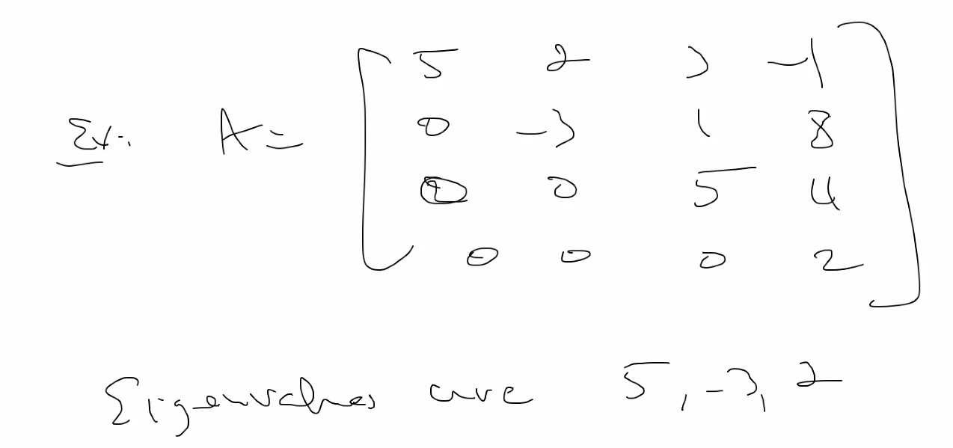
  + Notice above A is in echelon form and triangular matrix, so diagonals are simply the solutions because if you set up:
    - A-(lambda)In = (5-lambda) (-3-lambda) (5-lambda) (2-lambda) = 0
    - Notice: the roots are lambda = 5, -3, 5, 2; thus 5 has multiplicity 2, thus roots are just 5, -3, and 2
  + Shortcut Rule for triangular matrix:
  + 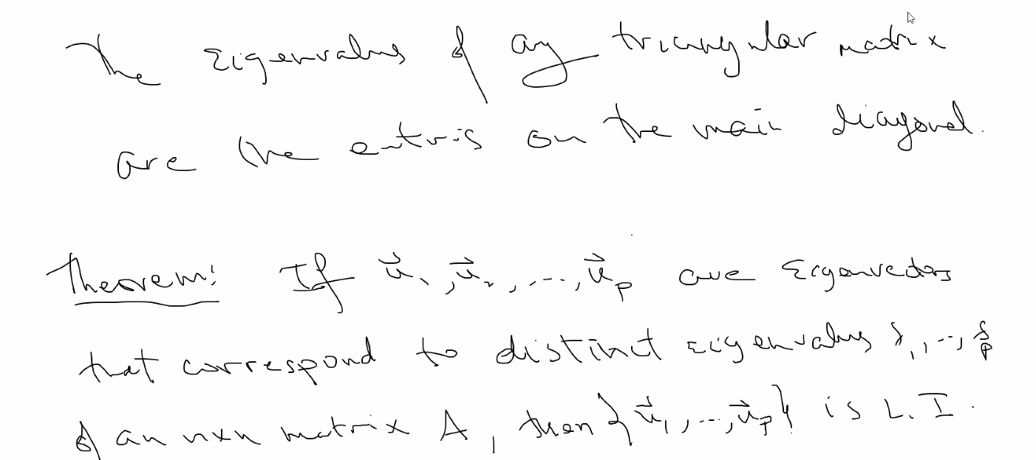
  + Also notice then, the eigenvalue subspace is linearly independent
* Invertible matrix theorem continued
  + 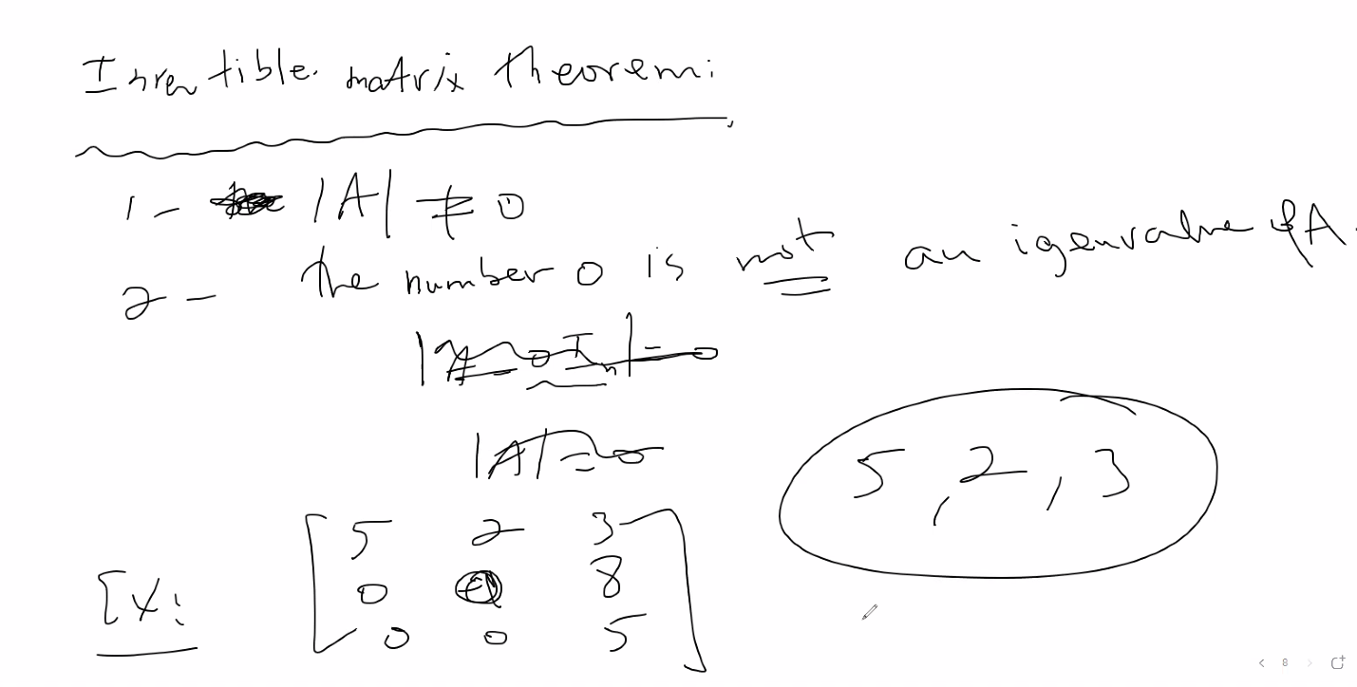
  + Notice determinant is 0 as we can see by using triangular matrix property and multiplying main diagonal to find determinant; thus A is not invertible; also solution to ex is 5, 0, 5; but 0 is not an eigenvalue of A; if it were 5, 2, 3 for example, then all values are eigenvalues
  + So if we find a solution set of eigen values where one of the values = 0; then we can determine if a matrix is invertible

# Lecture 15 – 6/17/21 – chapter 5: Eigenvalues and Eigenvectors (note this chapter only has to do with SQUARE MATRICES; these properties only hold always true for square matrices; think about it: when you transform square matrices, you are simply dilating or compressing and stretching each dimension by some factor or linear combination, you are changing some box or cubic/rectangular prism structure (3 DIMENSIONS, or 2 Dimensions with squares and rectangles)

* 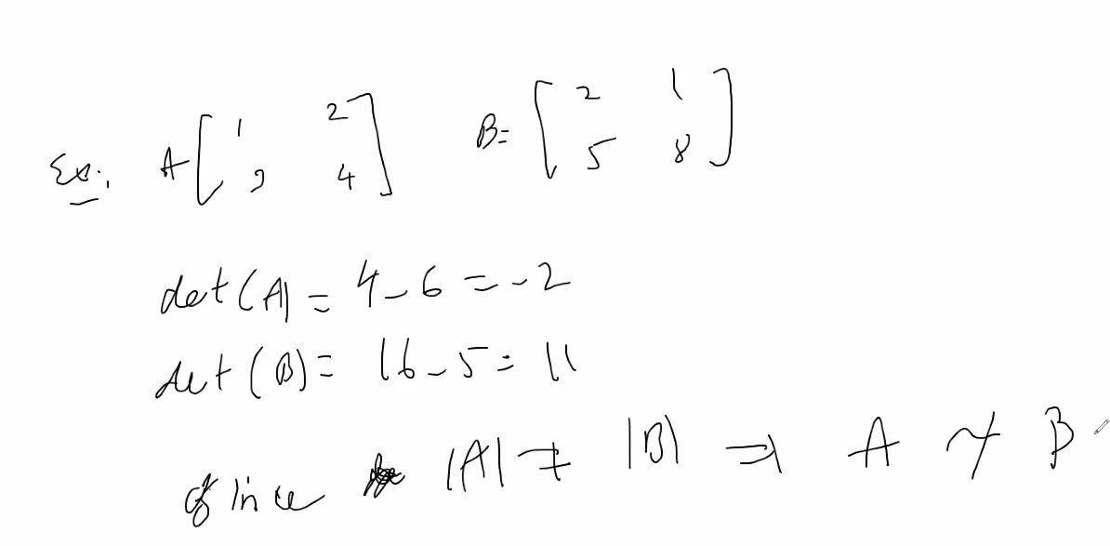
  + Above, if two matrices have different determinant values, they are for sure NOT similar; but this property is only one-way
  + Example:
  + 
  + Above, same determinant but then you cannot yet say they are similar (which above they are not), so you must still investigate further
* **Diagonalizable Matrices:**
* I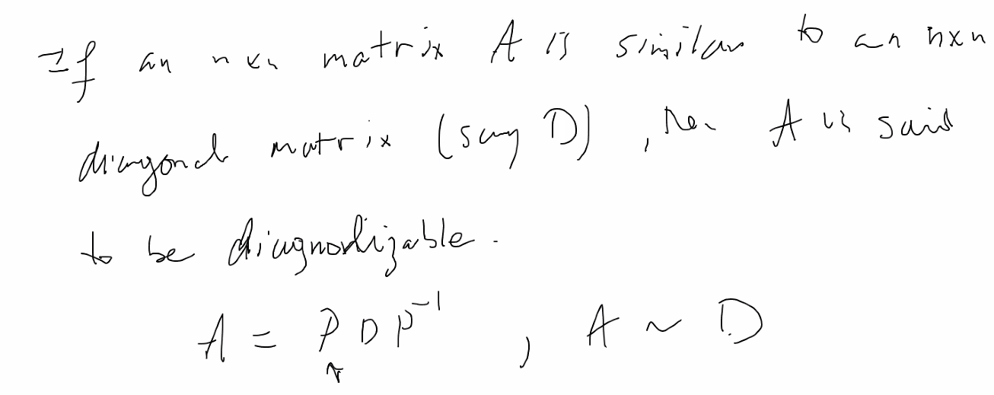
* 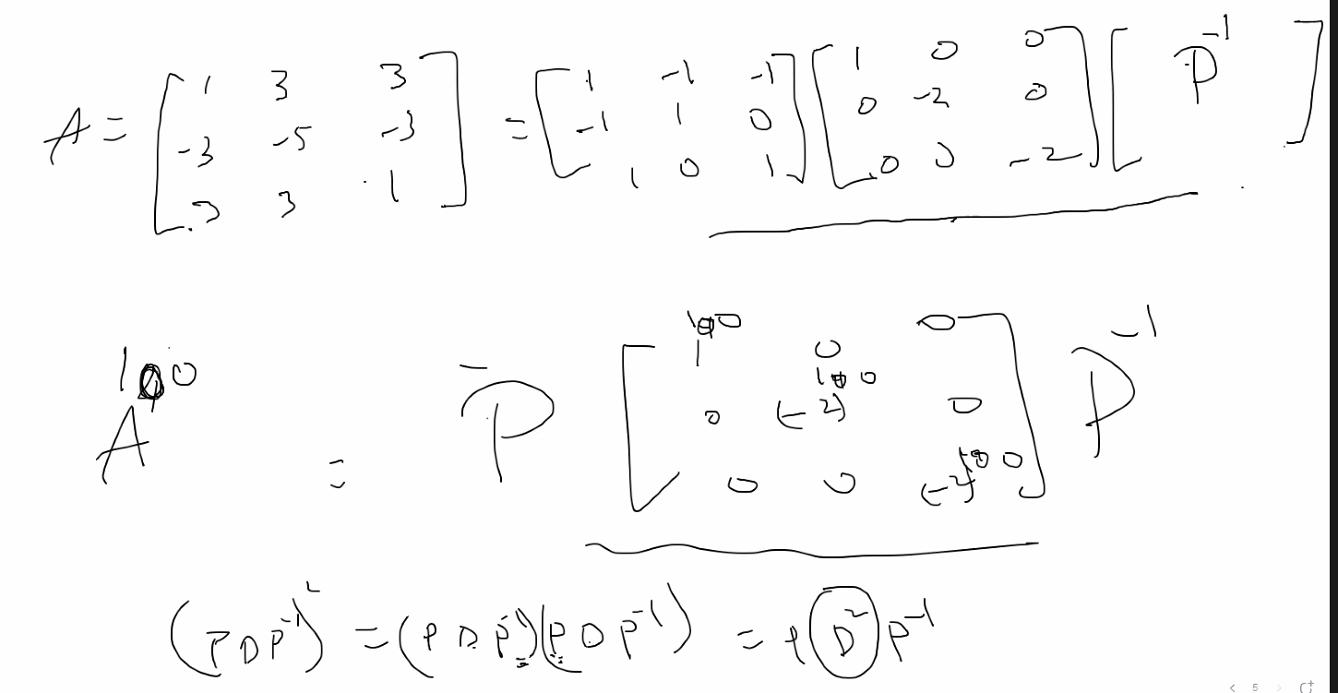
* Notice how much less work you need to do to raise a diagonalizable matrix to a power; do P*Diagonalized matrix*P_inverse; and think about a compute trying to compute something with a high power, if it is diagonalizable you will be able to save MANY MANY execution cycles using this property/formula
* **NOTE: if a matrix has n eigenvalues, then it is diagonalizable**
* 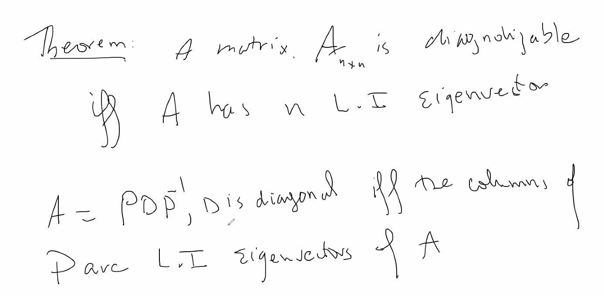
* Example from earlier example:
* 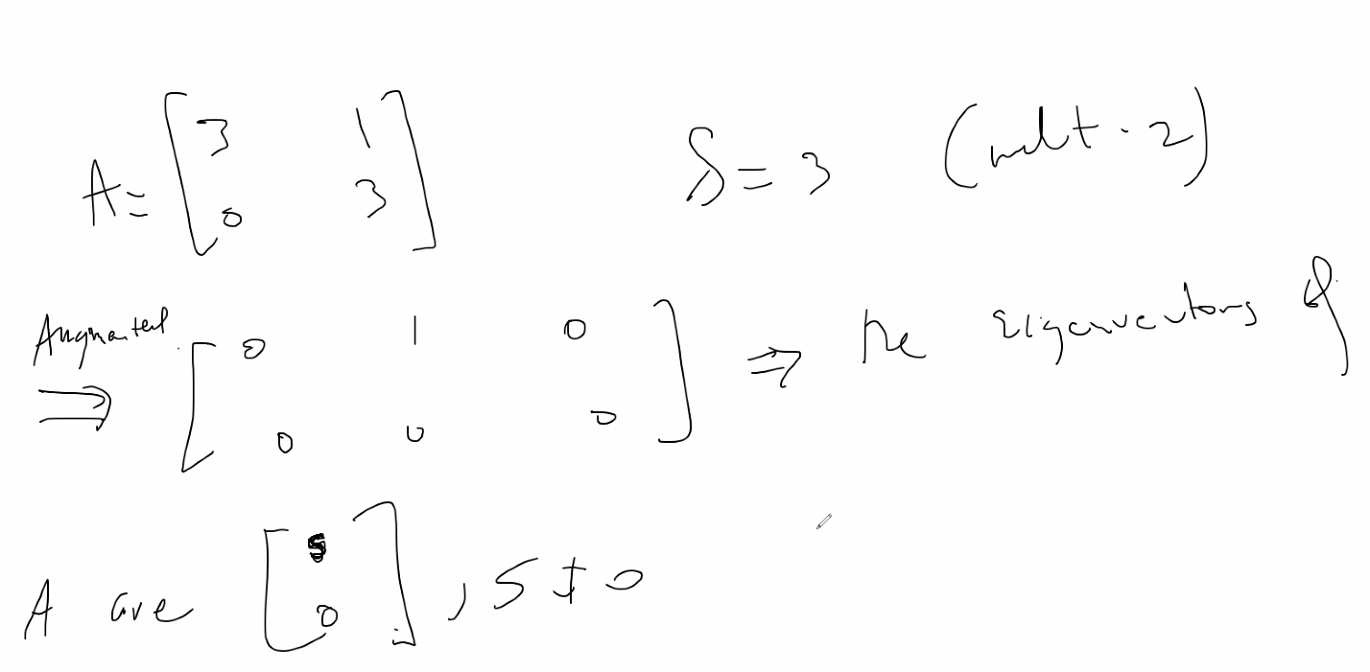
  + A doesn’t have 2 linearly independent eigenvectors; thus A is not diagonalizable.
* Ex2:
* 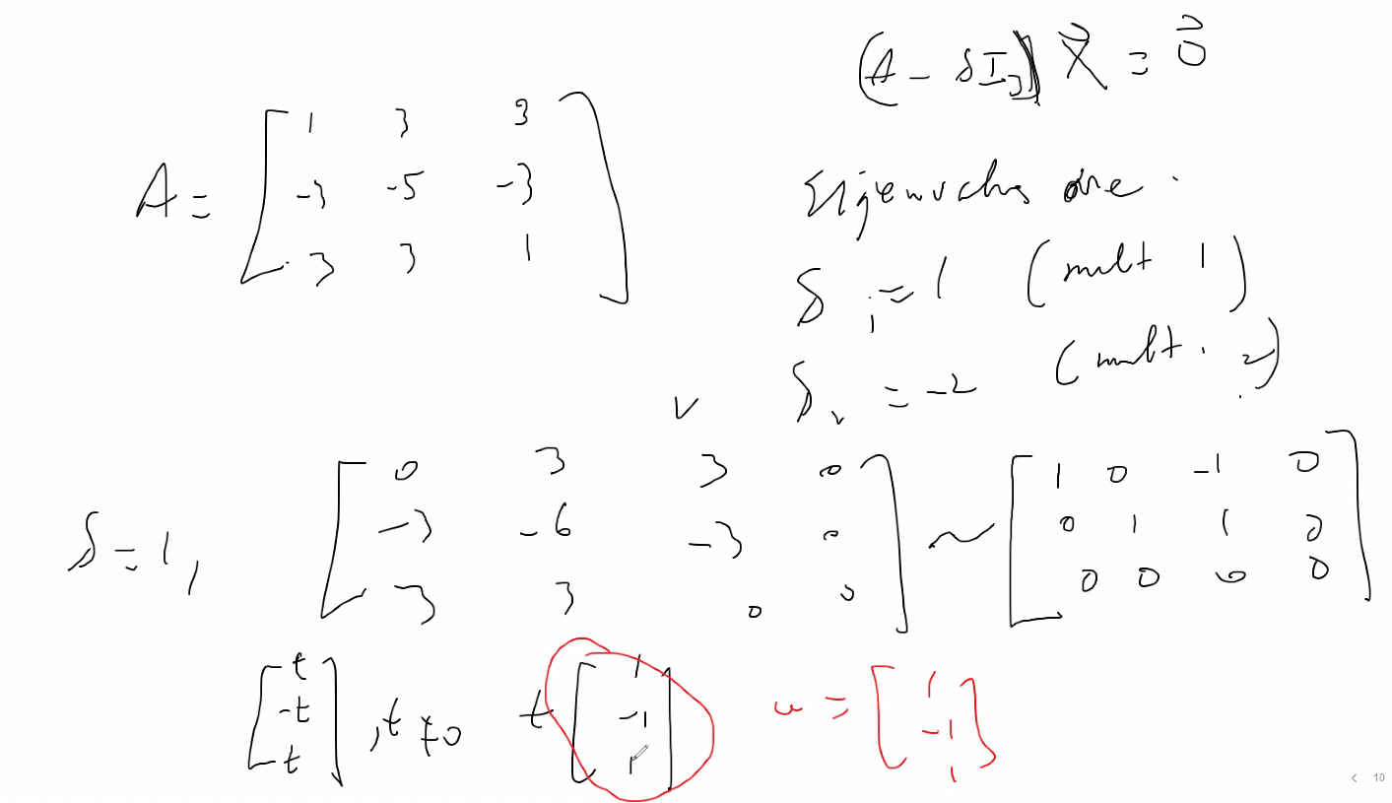
* 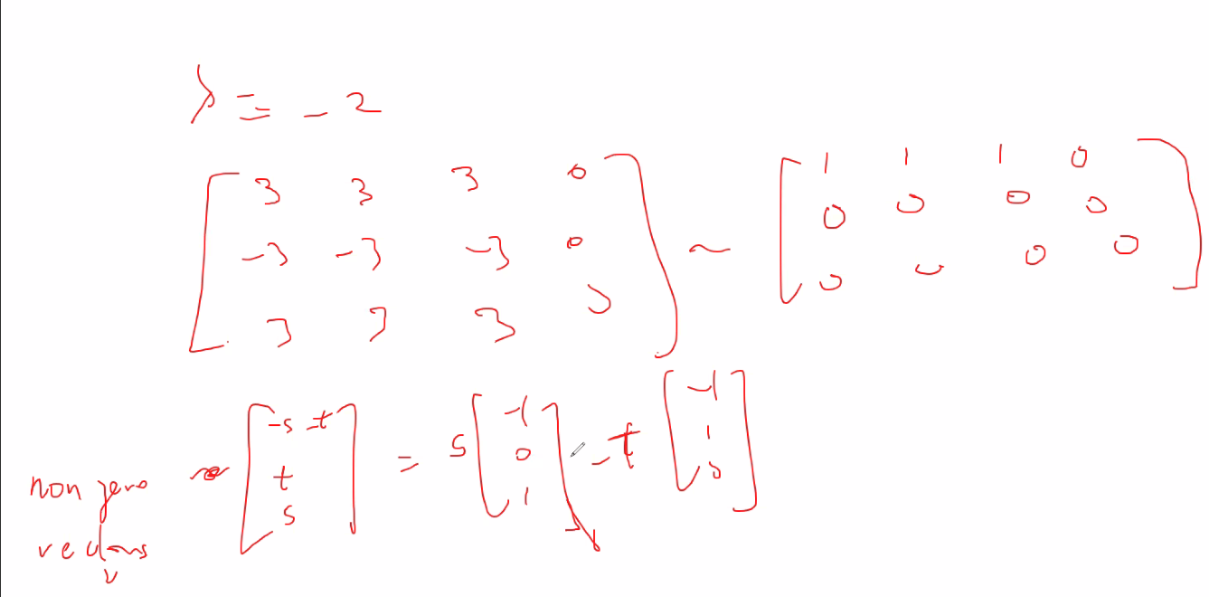
* 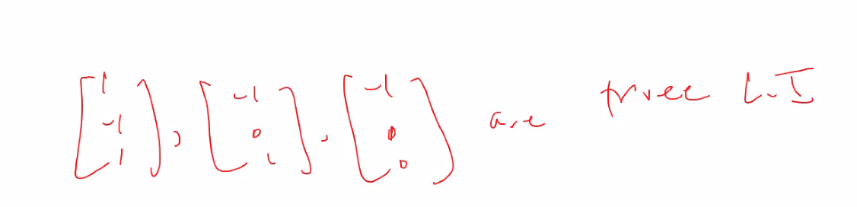
* So we have found 3 total eigenvectors (; 3 = n of the nxn vector; thus the matrix A is diagonalizable; since we have found 3 linearly independent eigenvectors
* 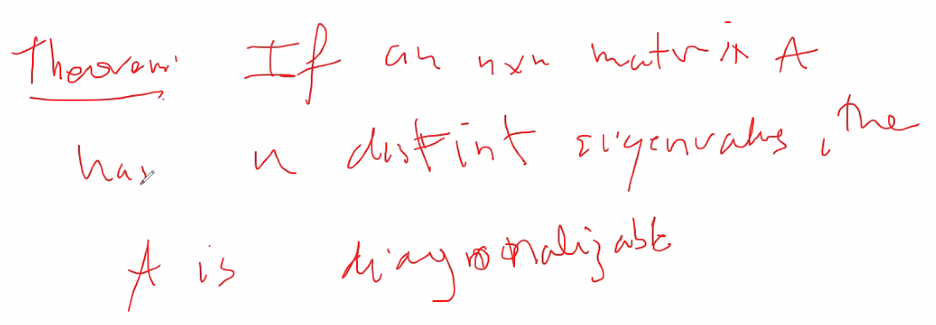
* Triangular matrices with 3 distinct values on the main diagonal is diagonalizable (because it has 3 distinct easily seen eigenvalues; thus you can for sure find 3 LI eigenvectors
* Theorem:
* 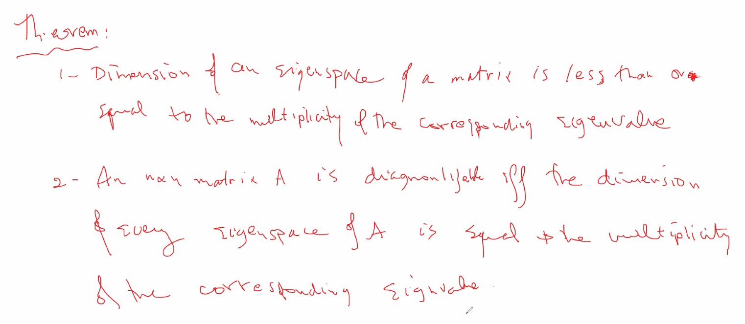
* 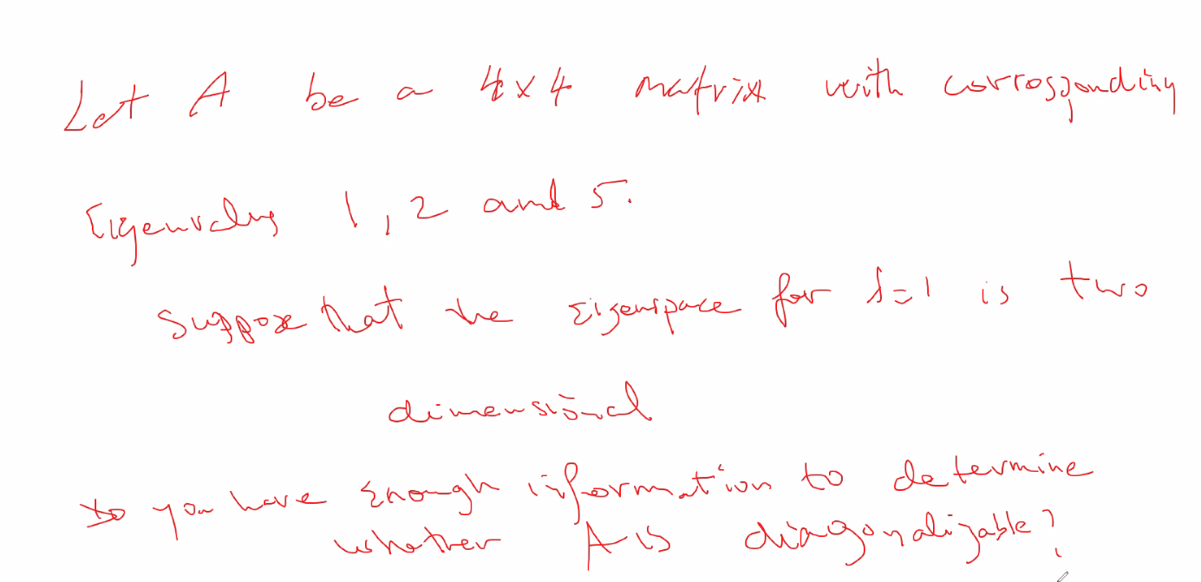
  + answer to above is YES; using the above theorem; 1, 2, and 5 have a multiplicity of at least 1, and they are distinct, thus that means at least we have dimension total of 3, but it says two has a dimension of 2, thus we then know total dimension is 4; and nxn is a 4x4 matrix, thus dimension = n; thus it is diagonalizable
* web work 3 rotations about axis for any given axis; this will not be on FINAL:
  + 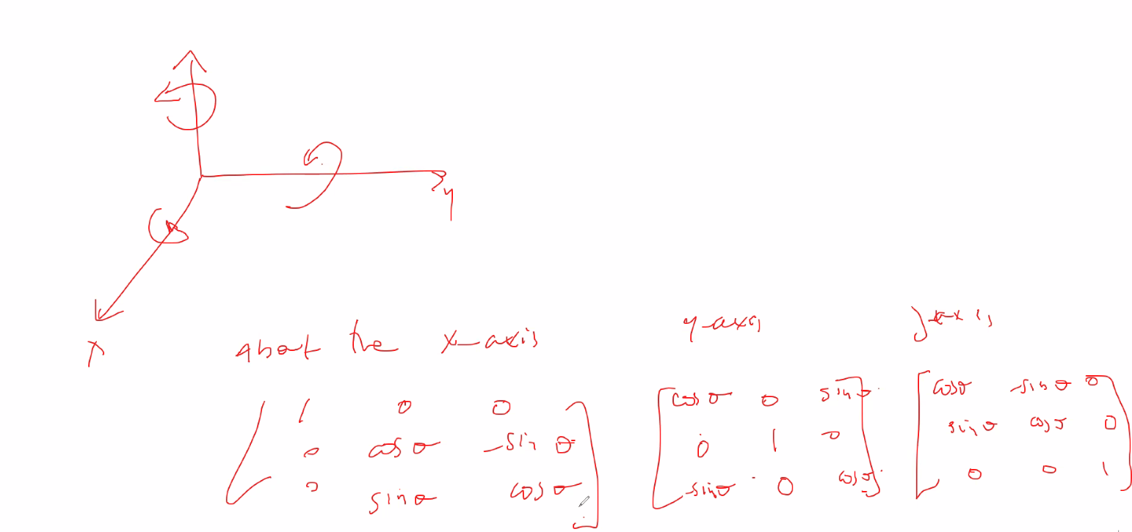
* FINAL EXAM
  + Part A (14 to 15 questions) and Part B will be longer (Part B will be 5 to 6 questions)
  + Exam opens 0600am WEDNESDAY; closes 0600am on Friday. (48 hr window)
    - Part B opens only on Thursday: 3pm-8pm
    - Part A is 3 attempts
    - More time on each part for longer test
    - Monday: extra credit problem will be released that goes towards final **exam** (section from book; relating to application of linear algebra with matrices in real world fields; i.e. computer science)
* Side notes:
  + You can only do elementary operations on both rows and Columns when finding the determinant; otherwise you can only do ROW operations in order to construct equivalent matrices when reducing.

# Lecture 16: last lecture – 6/21/21 – chapter 5: Eigenvalues and Eigenvectors

* Chapter 4 extra credit problem from final exam, it’ll be released Tuesday!!! I will have to read 2 to 3 pages of the textbook in chapter 4: section 4.9, question 2 ( both parts a and b, pg. 260).
* 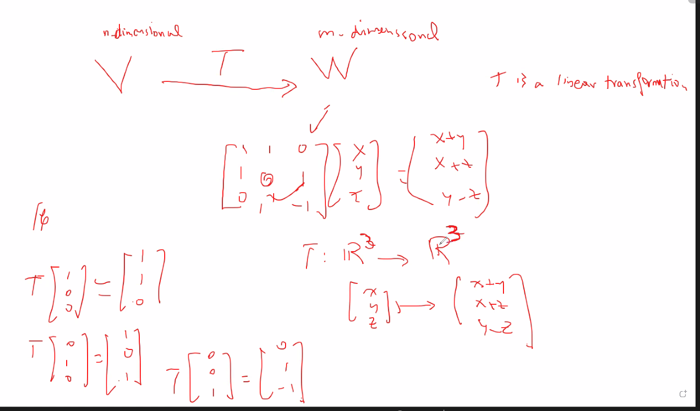
* Remember if det of the transformation matrix A is 0; Transformation is 1 to 1 (and thus invertible)
  + Also if the nul(A) is only the 0 vector (trivial solution), then transformation is 1 to 1 and is invertible
  + See invertible matrix theorem
  + So above, we found transformation matrix that defines the transformation; then we check to see if that matrix is invertible to determine if it is a 1 to 1 transformation
* Remember isomorphic: different functions/matrices that will do the same transformation to some set of vectors; so talking about the properties of one, is the same as talking about properties of the corresponding isomorphic function/matricx/vector
* Also remember coordinate mapping relative to some Basis (standard or not)
* 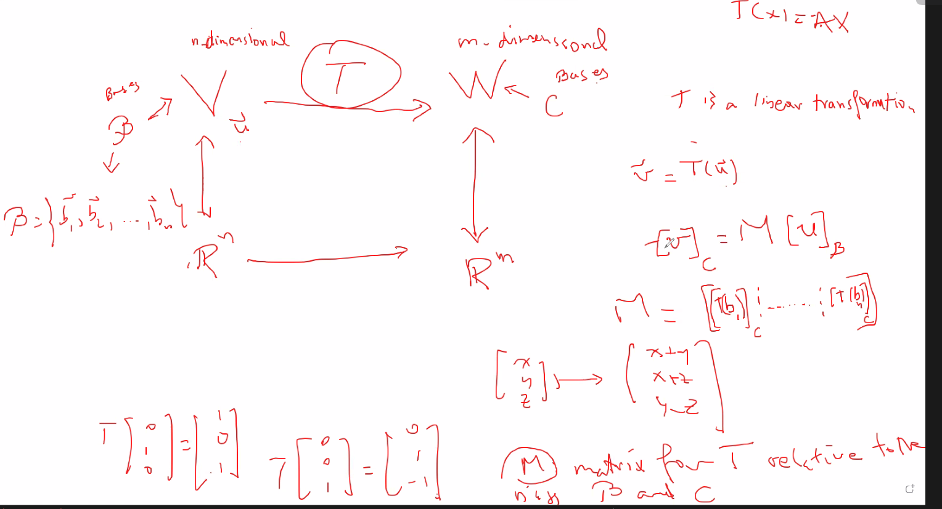
  + Above, M is called the matrix for T relative to the basis B and C
  + So it is essentially the isomorphic transformation relative to the isomorphic vector spaces
  + Special rule:
  + 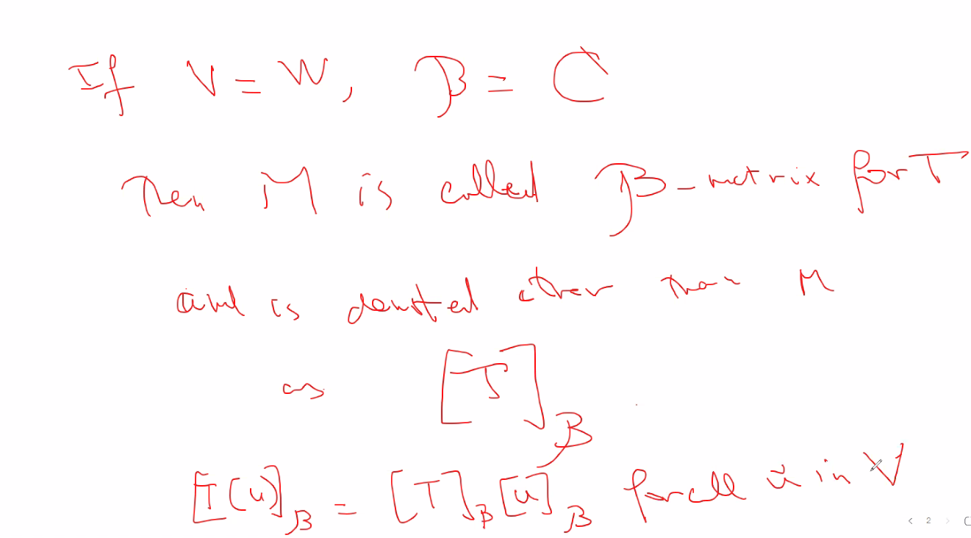
  + So finding the transformation for a given vector in V and W (say u and v) is simply finding the specific Transformation relative to the specific vectors; so instead of T = [x+y, z-y, 2z], you actually find the values for x y and z that are plugged in to get a given vector from V to W; that’s why you need the basis
* Ex(from book, pg 290):
* 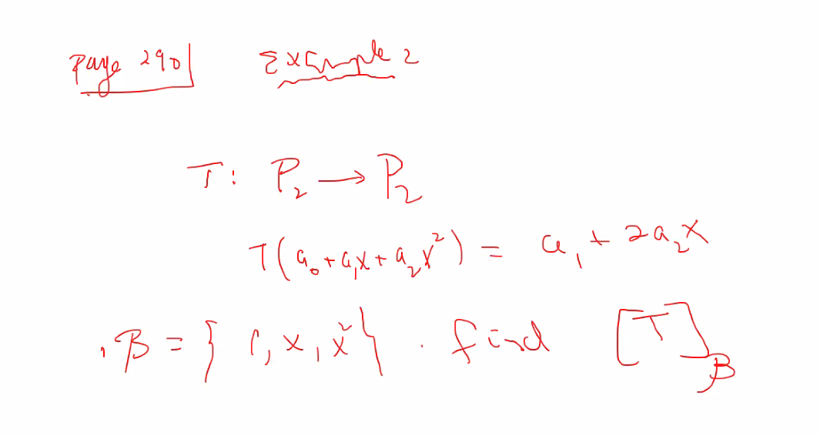
* B= basis
* 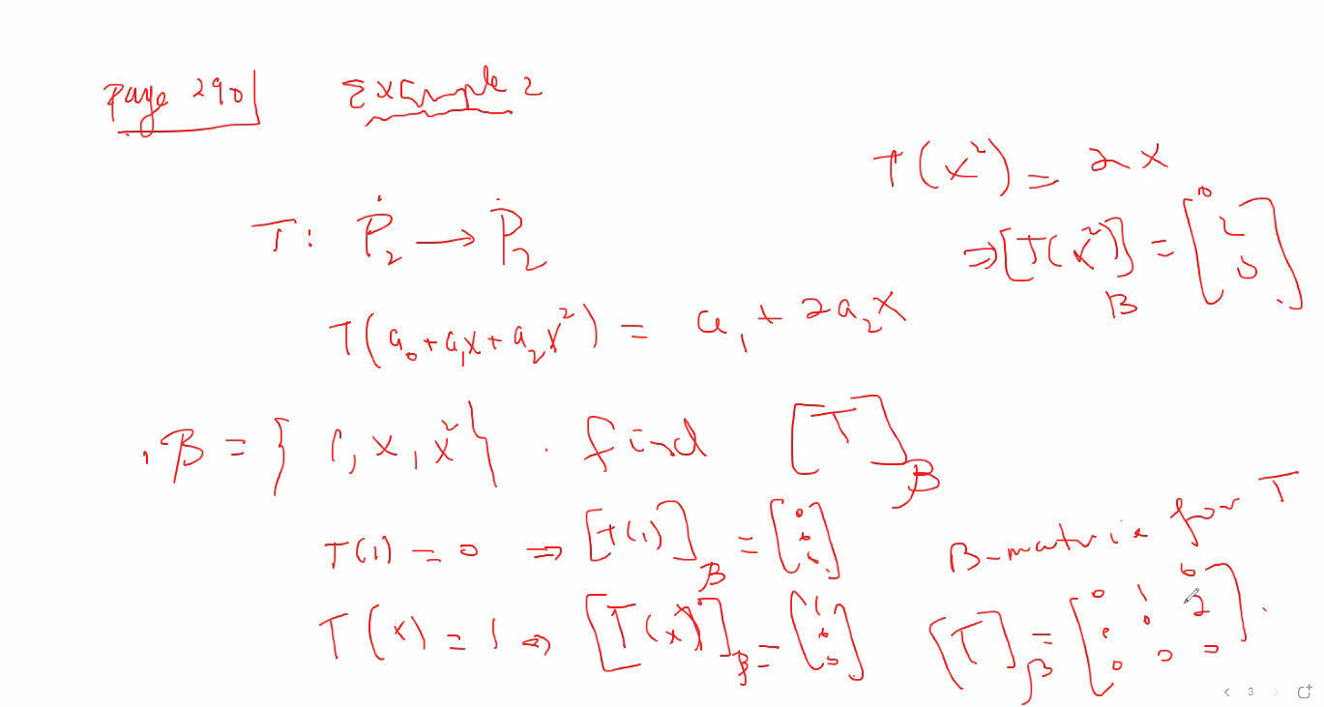
* Above, find linear transformations by plugging in the basis
* Verify the above results:
* 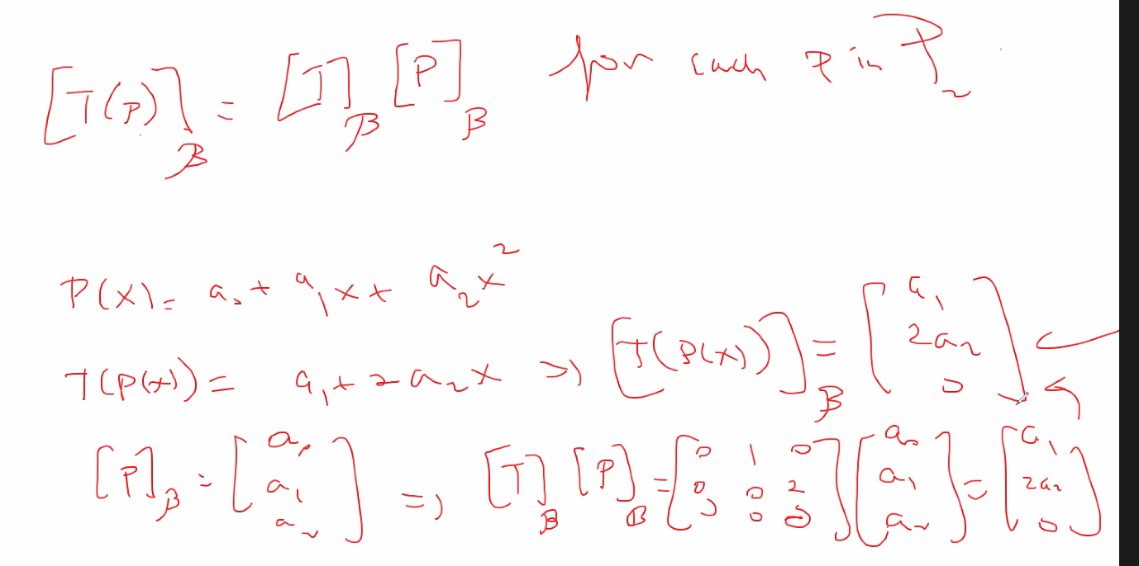
* PDP-1 Diagonalizing a matrix that is diagonalizable
* 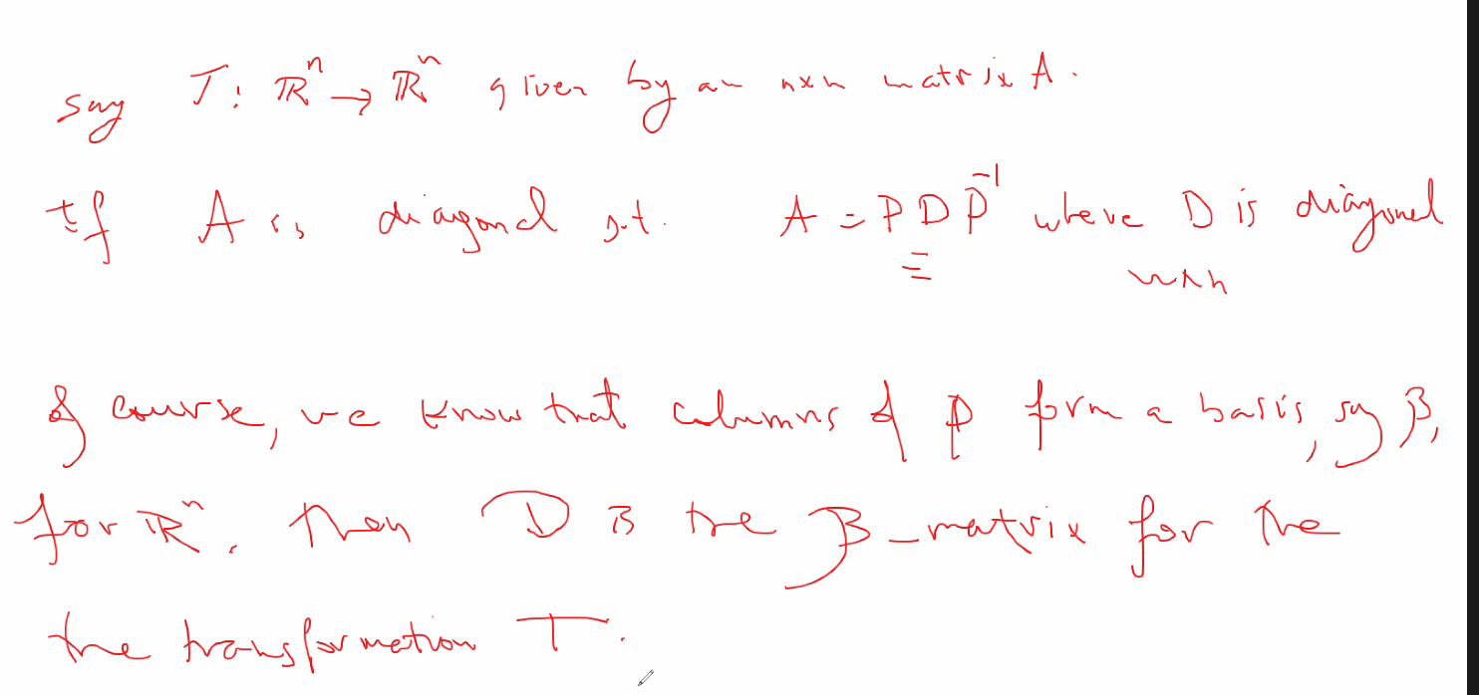
* Ex 3, pg 292:
* 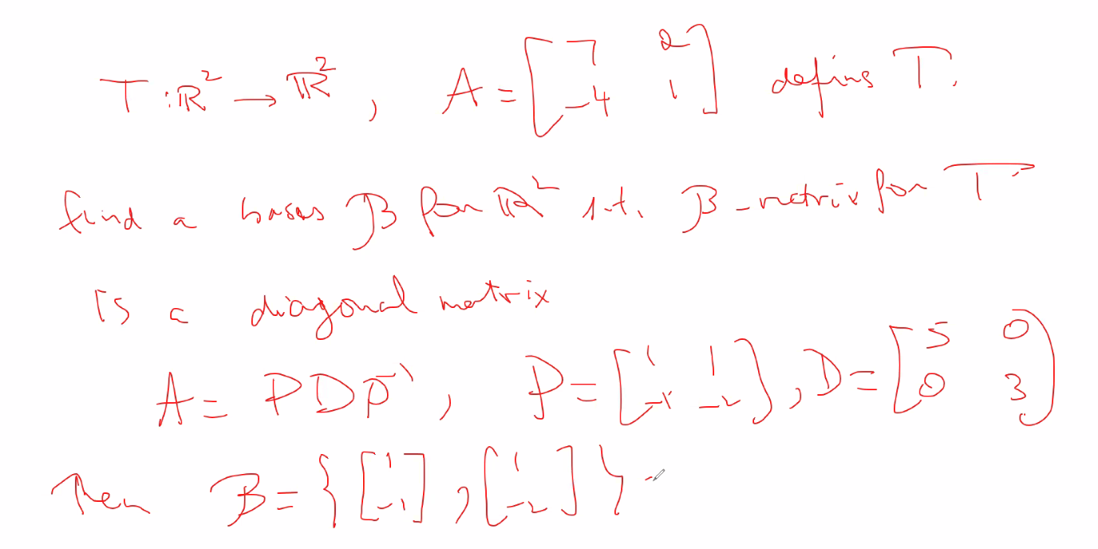

# Supplementary, chapter 4 (section 4.7):

* Basis
* 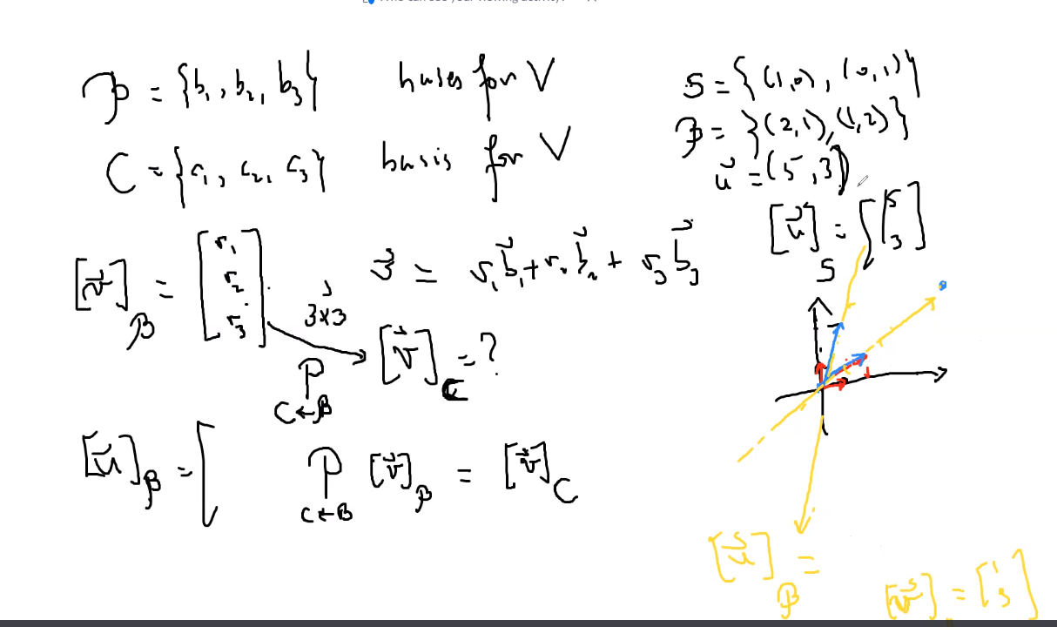
* Above, notice standard basis, is simply relative to the x-y plane; so simply go along x-axis (line equation y = 0) for x-coordinate, and then go along y-axis (line equation x = 0)for y-coordinate, to reach final x-y coordinate.
* However, in yellow, that is another basis that is not standard: for x-coordinates you have to move along the line y = ½ x (or x = 2y), and then move along y =2x for the y-coordinates; then you will reach your final destination of a coordinate relative to the given basis.
  + So notice: for standard basis, vectors (1,0) and (0,1) are the vectors we use for x and y respectively; they are the unit vectors for the system; but for a different basis, say B from above, the unit vector used in that system is (2,1) and (1,2) for x and y coordinates respectively.
* Also, above talks about changing from one base to another base for a given vector using a special equation (matrix P) instead of having to translate a coordinate into its standard basis coordinates, then translate it to the new basis.
* One reason why we use basis is if the basis is something strange that you are not used to, so if you can find that basis and then find another basis to write the points relative to, it may be easier to see or study.
  + So moving from one coordinate system to another can be very useful
* Remember in order to have a basis: vectors in a subspace must be linearly independent an must span the whole space of whichever dimension a basis is attempted to be formed in; i.e.: test the properties of scalar multiplication, scalar addition, and if the 0 vector is contained in the set.
  + But also if number of vectors in basis is equal to dimension and are linearly independent, that is enough to know that it is indeed a basis for the given dimension.
* Example of finding a vector if you know its coordinate vector relative to another basis other than the standard basis; and also finding a coordinate vector relative to another basis if you know the coordinates relative to the standard basis:
* 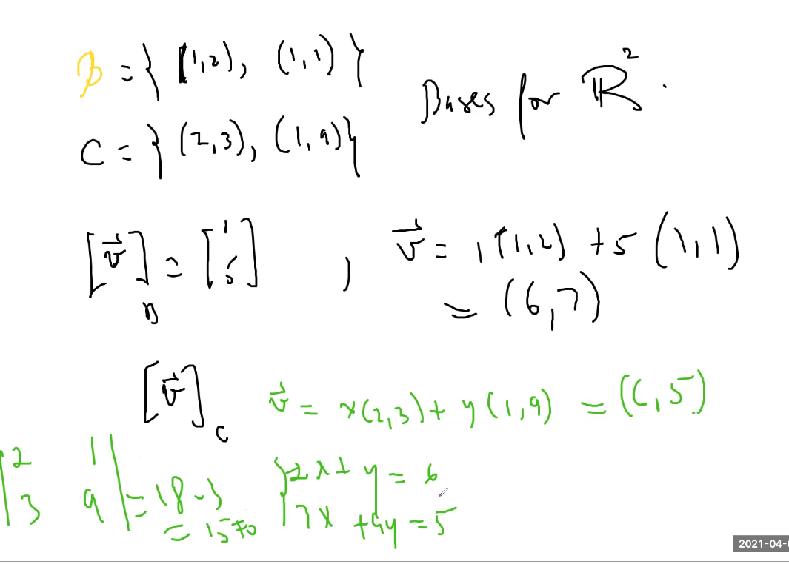
  + So for finding v relative to c, simply solve the system (also note he put (6,5) but we see that v was solved for relative to standard basis as (6,7), so he meant to use (6,7) in the system when finding v relative to c); solve for x and y in the system and that will give the coordinate vector of v relative to c.
* Also note: you will always get a unique solution when finding the coordinate vector of a vector relative to some basis when solving the system because the vectors used from the basis are linearly independent; so you now the coordinates that you will solve for will always give a unique solution to the system (aka: one-to-one relationship between each coordinate in one basis, to the other)
  + Also if you calculate determinate of the system it no doubt will not be 0; thus the system consists of all columns being linearly independent as expected since the basis used should contain linearly independent vectors.
* But for basis in R_4 and above, it can take a lot of time; so now we use a special method of going from one basis to another; Solve the transition matrix:
* 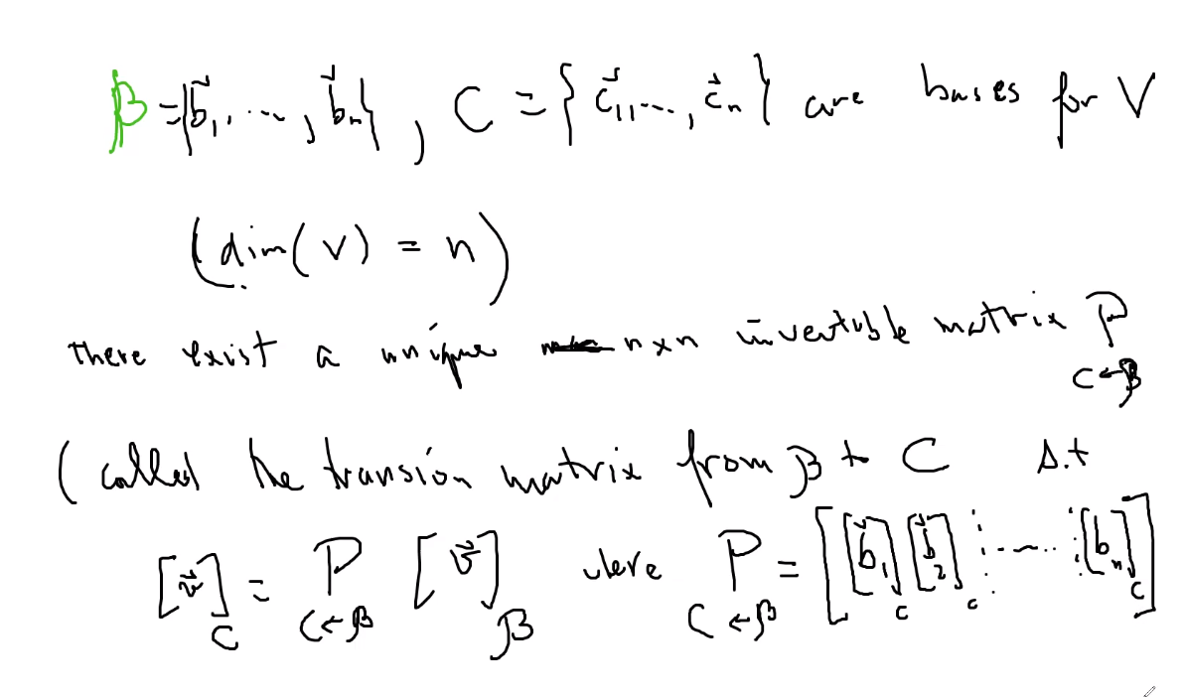
* Above, notice the formula is simply finding a basis C relative to B.
* P matrix has all of it columns as the vectors of basis B set relative to c using the standard method we used when translating from standard basis to another basis.
  + But then that only gives you Basis B relative to Basis C, we want v relative to C; thus we multiply P matrix times v relative to B; or in other words since the P matrix has B relative to C, then if we multiply that by v relative to B, it will cancel out the B, and leave us with just v relative to C!
* ALSO MAKE SURE YOU KEEP THE ORDER OF THE BASIS VECTORS THE SAME IN THE P MATRIX
* Example from 4.7, finding the transition matrix from B to C:
* 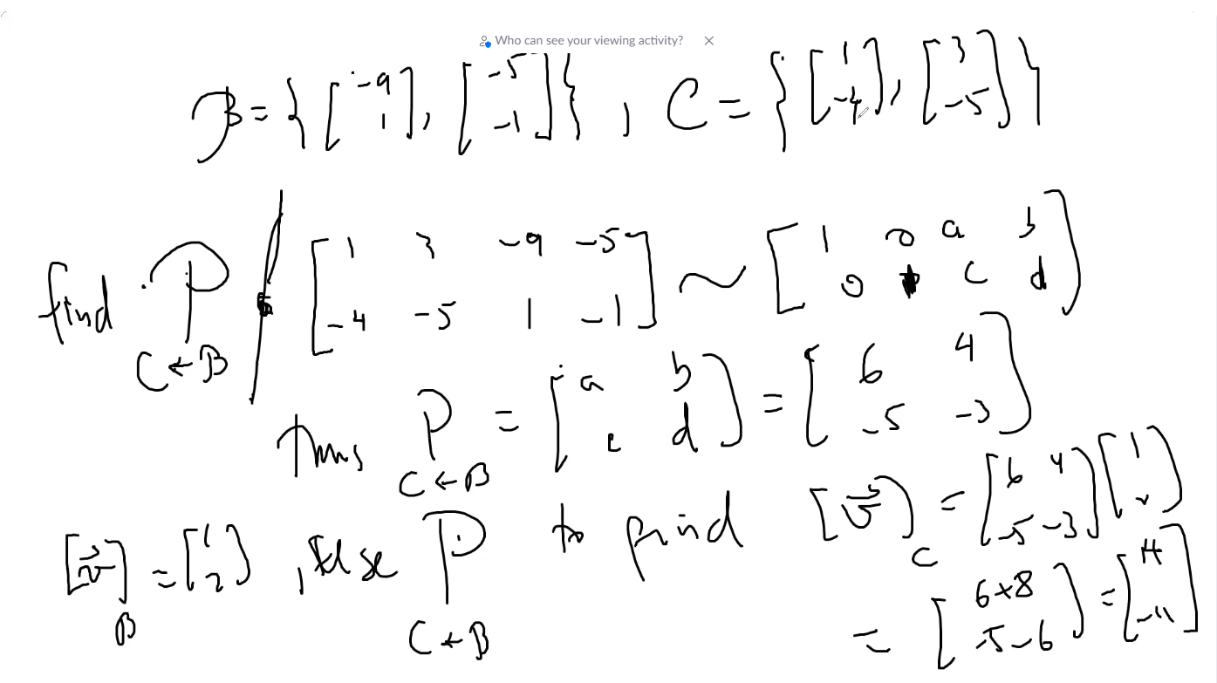
* Notice, since we are finding the P matrix B->C, we put C first in a ordered column matrix of the B and C, and then reduce into reduced echelon form; this will give us the matrix P (abcd) of B relative to C which we then use to multiply it by the v coordinate relative to B to find v coordinate relative to C.